Year 9
English Work Pack 4
Parents/Carers – only complete as much, or as little, of these booklets as your circumstances allow at this difficult time.

Welcome to this week’s English topic!

Reciprocal Reading Techniques
We will have fun learning to read by:

- Predicting
- Clarifying
- Questioning
- Summarising

Choose your own task level (green = easy, amber = slightly harder, red = challenge)

LO: To be able to use techniques to understand what we read – Predict
In this booklet, we will learn to have a better understanding of what we read by using the following techniques:

Predict | Clarify | Question | Summarise

What do these words really mean? Let’s look at the first one:

Predict A prediction is what someone thinks will happen.

Pre means ‘before’, so if we predict what a text will be about, it means that we should try to decide what it could be about before we read it.
How do we predict before we read?

We could use the following things as clues:

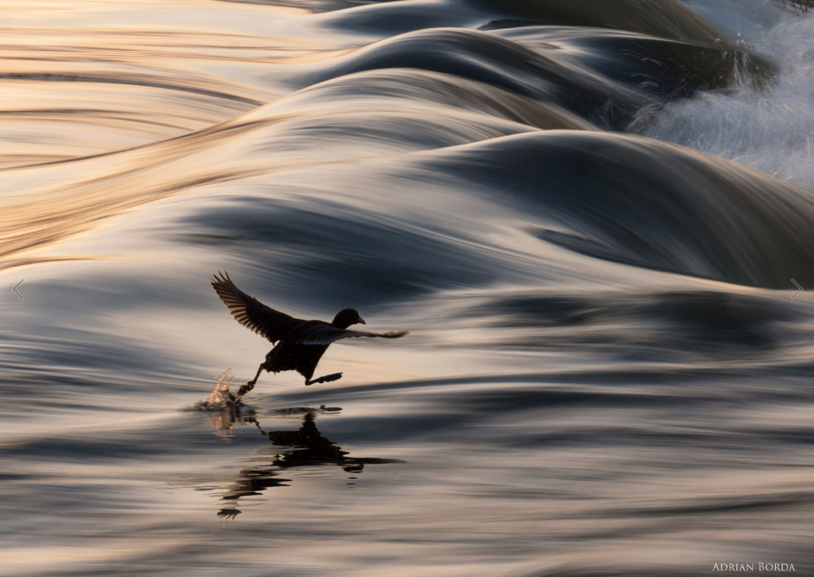
Pictures
Title
I believe I can

To predict what this book could be about using the picture, you could ask yourself questions such as:
- What is happening here?
- Is the bird walking on the water? How? Why?
- Is this bird special? Can it fly?
- Do you think this is the first time the bird has walked on water?
- The title is ‘I Believe I Can’. If the bird doubted itself, do you think it would still be able to walk across the water?
- How important is self-belief?
- Have you ever ‘failed’ because you lacked confidence?
- Have you ever succeeded because you believed you could?
- What does failure feel like? What about success?
10.How do you overcome failure?
11.Has anyone ever achieved something other people thought to be impossible?
12.What qualities did they have?

Task 1a (Green) Look at the picture carefully and answer questions 1-5 below.
1.-------------------------------------------------------------------------------------------------------------------------------------------------------------------------------------------------------------------------------------------------------------------------------------------------------------------------------------------------------------------------------------------------------------------------------------------------------------------------

2. ------------------------------------------------------------------------------------------------------------------------------------------------------------------------------------------------------------------------------------------------------------------------------------------------------------------------------------------------------------------------------------------------------------------------------------------------------------------------

3. ------------------------------------------------------------------------------------------------------------------------------------------------------------------------------------------------------------------------------------------------------------------------------------------------------------------------------------------------------------------------------------------------------------------------------------------------------------------------

4. ------------------------------------------------------------------------------------------------------------------------------------------------------------------------------------------------------------------------------------------------------------------------------------------------------------------------------------------------------------------------------------------------------------------------------------------------------------------------
5. -------------------------------------------------------------------------------------------------------------------------------------------------------------------------------------------------------------------------------------------------------------------------------------------------------------------------------------------------------------------------------------------------------------------------------------------------------------------------

Task 2a (Amber) Look at the picture carefully and answer questions 1-9 below.
For extra challenge, try predicting by including modal verbs in your answers (may, might, could) e.g. I predict that… might… because…, I think… may…because …, I imagine that … could… because

1.-------------------------------------------------------------------------------------------------------------------------------------------------------------------------------------------------------------------------------------------------------------------------------------------------------------------------------------------------------------------------------------------------------------------------------------------------------------------------

2. ------------------------------------------------------------------------------------------------------------------------------------------------------------------------------------------------------------------------------------------------------------------------------------------------------------------------------------------------------------------------------------------------------------------------------------------------------------------------

3. ------------------------------------------------------------------------------------------------------------------------------------------------------------------------------------------------------------------------------------------------------------------------------------------------------------------------------------------------------------------------------------------------------------------------------------------------------------------------

4. ------------------------------------------------------------------------------------------------------------------------------------------------------------------------------------------------------------------------------------------------------------------------------------------------------------------------------------------------------------------------------------------------------------------------------------------------------------------------
5. -------------------------------------------------------------------------------------------------------------------------------------------------------------------------------------------------------------------------------------------------------------------------------------------------------------------------------------------------------------------------------------------------------------------------------------------------------------------------

6. ------------------------------------------------------------------------------------------------------------------------------------------------------------------------------------------------------------------------------------------------------------------------------------------------------------------------------------------------------------------------------------------------------------------------------------------------------------------------

7. ------------------------------------------------------------------------------------------------------------------------------------------------------------------------------------------------------------------------------------------------------------------------------------------------------------------------------------------------------------------------------------------------------------------------------------------------------------------------

8. ------------------------------------------------------------------------------------------------------------------------------------------------------------------------------------------------------------------------------------------------------------------------------------------------------------------------------------------------------------------------------------------------------------------------------------------------------------------------

9. ------------------------------------------------------------------------------------------------------------------------------------------------------------------------------------------------------------------------------------------------------------------------------------------------------------------------------------------------------------------------------------------------------------------------------------------------------------------------

Task 3a (Red) In addition to completing task 2, answer questions 11 and 12 and try using a range of adverbs and modal verbs to show how likely something is to happen, since there could be several possibilities. Complete your work using the writing lines for task 2. Remember:

Adverbs – show how the action is performed  e.g. I think the villagers would run quickly because they would be afraid.  definitely  certainly  clearly  obviously  surely  quite  likely  probably  possibly  maybe  hardly  undoubtedly | Modal Verbs – a verb added to another one to show how likely, possible, permissible, or obligatory it is for the action to occur  e.g. I predict that the villagers might try to stop the rock sphere from rolling down the hillside.  will  must  shall  ought to  should  can  would  may  might  could

11.-----------------------------------------------------------------------------------------------------------------------------------------------------------------------------------------------------------------------------------------------------------------------------------------------------------------------------------------------------------------------------------------------------------------------------------------------------------------------------------------------------------------------------------------------------------------------------------------------------------------------------------------------------------------------------------------------------------------------------------------------------------------------------------------------------------------------------------------------------------------------------------------------------------------------------------------------------------------------------------------------------------------------------------------------

12.. ----------------------------------------------------------------------------------------------------------------------------------------------------------------------------------------------------------------------------------------------------------------------------------------------------------------------------------------------------------------------------------------------------------------------------------------------------------------------------------------------------------------------------------------------------------------------------------------------------------------------------------------------------------------------------------------------------------------------------------------------------------------------------------------------------------------------------------------------------------------------------------------------------------------------------------------------------------------------------------------------------------------------------------------------

A further way in which we could predict what a text may be about is by using the title to help us.

Task 1b (Green) Look at the titles and pictures of the following book covers, then answer the questions below.

- What do you think the text will be about, and why do you think that?
- What clues are there?
- What might happen in this story?

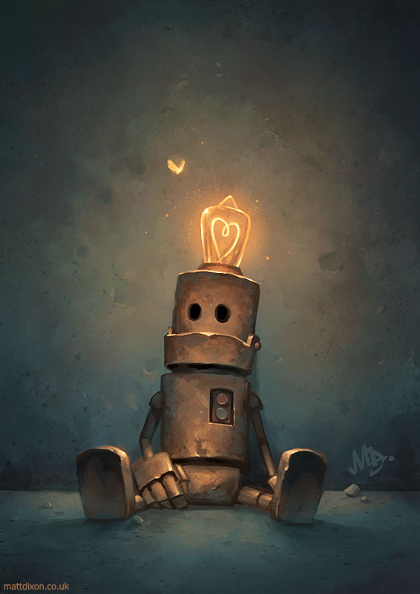
Patience

----------------------------------------------------------------------------------------------------------------------------------------------------------------------------------------------------------------------------------------------------------------------------------------------------------------------------------------------------------------------------------------------------------------------------------------------------------------------------------------------------------------------------------------------------------------------------------------------------------------------------------------------------------------------------------------------------------------------------------------------------------------
----------------------------------------------------------------------------------------------------------------------------------------------------------------------------------------------------------------------------------------------------------------------------------------------------------------------------------------------------------------------------------------------------------------------------------------------------------------------------------------------------------------------------------------------------------------------------------------------------------------------------------------------------------------------------------------------------------------------------------------------------------------------------------------------------------------------------------------------------------------------------------------------------------------------------------------------------------------------------------------------------------------------------------------------------
------------------------------------------------------------------------------------------------------------------------------------------------------------------------------------------------------------------------------------------------------------------------------------

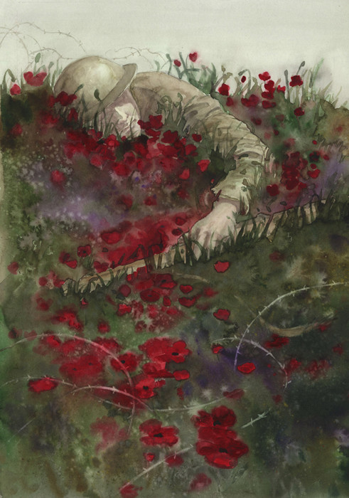
Remembrance

----------------------------------------------------------------------------------------------------------------------------------------------------------------------------------------------------------------------------------------------------------------------------------------------------------------------------------------------------------------------------------------------------------------------------------------------------------------------------------------------------------------------------------------------------------------------------------------------------------------------------------------------------------------------------------------------------------------------------------------------------------------
----------------------------------------------------------------------------------------------------------------------------------------------------------------------------------------------------------------------------------------------------------------------------------------------------------------------------------------------------------------------------------------------------------------------------------------------------------------------------------------------------------------------------------------------------------------------------------------------------------------------------------------------------------------------------------------------------------------------------------------------------------------------------------------------------------------------------------------------------------------------------------------------------------------------------------------------------------------------------------------------------------------------------------------------------
------------------------------------------------------------------------------------------------------------------------------------------------------------------------------------------------------------------------------------------------------------------------------------

Task 2b (Amber) Look at the titles and pictures of the following book covers, then answer the questions below.

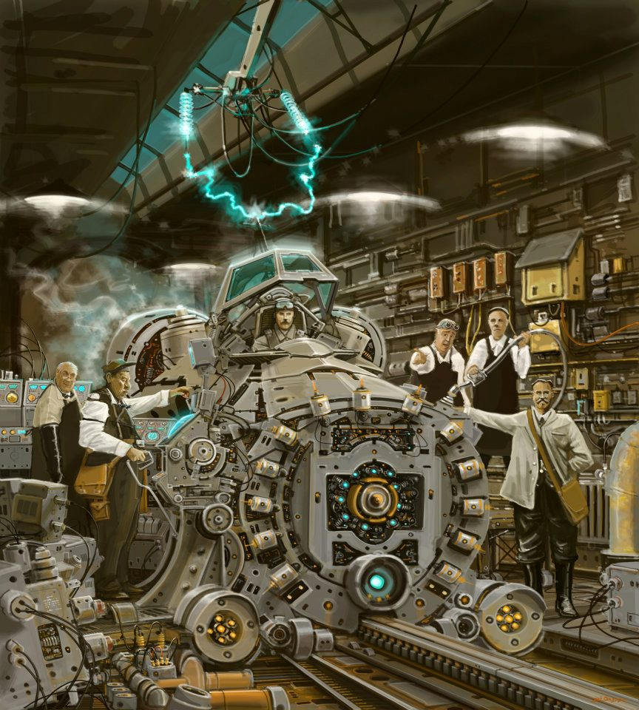
The Machine

- What is this? Where is this? Describe the image and explain what is happening.
- What do you think the text will be about?
- Is this what you thought a time-machine would look like? Why/why not?
- How does it work?
- How long did it take them to build it?
- Why are there so many people in the image? What are their roles?
- Is this the first time-machine?
- How does the man inside the time machine feel? Has he had special training? How was he selected for this job?
- When (in time) is he going to travel to? Why?
- If you could use a time machine, which period in history would you most like to travel to and why?
- If you could use a time machine to change an historical event, which would you change and why?
- If you could use a time machine to meet a person from the past, who would you like to meet? What would you ask them?

---------------------------------------------------------------------------------------------------------------------------------------------------------------------------------------------------------------------------------------------------------------------------------------------------------------------------------------------------------------------------------------------------------------------------------------------------------------------------------------------------------------------------------------------------------------------------------------------------------------------------------------------------------------------------------------------------------------------------------------------------------------
---------------------------------------------------------------------------------------------------------------------------------------------------------------------------------------------------------------------------------------------------------------------------------------------------------------------------------------------------------------------------------------------------------------------------------------------------------------------------------------------------------------------------------------------------------------------------------------------------------------------------------------------------------------------------------------------------------------------------------------------------------------
---------------------------------------------------------------------------------------------------------------------------------------------------------------------------------------------------------------------------------------------------------------------------------------------------------------------------------------------------------------------------------------------------------------------------------------------------------------------------------------------------------------------------------------------------------------------------------------------------------------------------------------------------------------------------------------------------------------------------------------------------------------------------------------------------------------------------------------------------------------------------------------------------------------------------------------------------------------------------------------------------------------------------------------------------------------------------------------------------------------------------------------------------------------------------------------------------------------------------------------------------------------------------------------------------------------------------------------------------------------------------------------------------------------------------------------------------------------------------------------------------------------------------------------------------------------------------------------------------------------------------------------
--------------------------------------------------------------------------------------------------------------------------------------------------------------------------------------------------------------------------------------------------------------------------------------------------------------------------------------------------------------------------------------------------------------------------------------------------------------------------------------------------------------------------------------------------------------------------------------------------------------------------------------------------------------------------------------------------------------------------------------------------------------

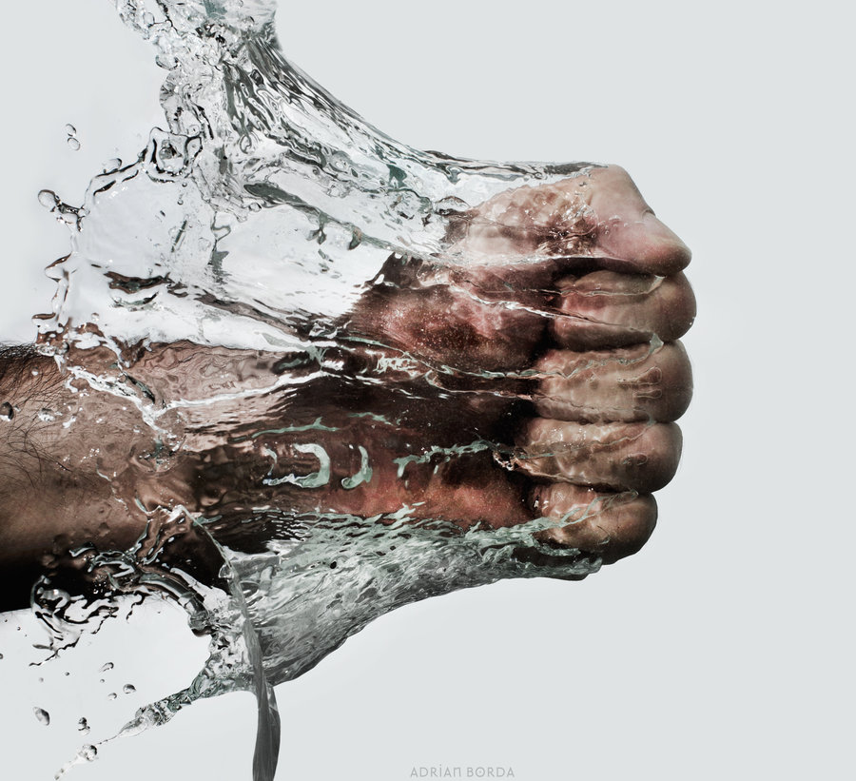
Resistance

- What do you think the text will be about?
- How does this photograph illustrate resistance?
- We also use the term ‘resistance’ in Science (e.g. air resistance, water resistance). What do you know about these forces?
- Can you think of (or find out about) any examples of people resisting something? Are there any famous examples? (WWII, Rosa Parks)
- Have you ever resisted something?
- Is resistance a good or bad thing? Try to think of arguments for both sides.
---------------------------------------------------------------------------------------------------------------------------------------------------------------------------------------------------------------------------------------------------------------------------------------------------------------------------------------------------------------------------------------------------------------------------------------------------------------------------------------------------------------------------------------------------------------------------------------------------------------------------------------------------------------------------------------------------------------------------------------------------------------
---------------------------------------------------------------------------------------------------------------------------------------------------------------------------------------------------------------------------------------------------------------------------------------------------------------------------------------------------------------------------------------------------------------------------------------------------------------------------------------------------------------------------------------------------------------------------------------------------------------------------------------------------------------------------------------------------------------------------------------------------------------------------------------------------------------------------------------------------------------------------------------------------------------------------------------------------------------------------------------------------------------------------------------------------------------------------------------------------------------------------------------------------------------------------------------------------------------------------------------------------------------------------------------------------------------------------------------------------------------------------------------------------------------------------------------------------------------------------------------------------------------------------------------------------------------------------------------------------------------------------------------
------------------------------------------------------------------------------------------------------------------------------------------------------------------------------------------------------------------------------------------------------------------------------------------------------------------------------------------------------------------------------------------------------------------------------------------------------------------------------------------------------------------------------------------------------------------------------------------------------------------------------------------------------------------------------------------------------------------------------------------------------------------------------------------------------------------------------------------------------------------------------------------------------------------------------------------------------------------------------------------------------------------------------------------------------------------------------------------------------------------------------------------------------------------------------------------------------------------------------------------------------------------------------------------------------------

Task 3b (Red) Look at the titles and pictures of the following book covers, then answer the questions below.

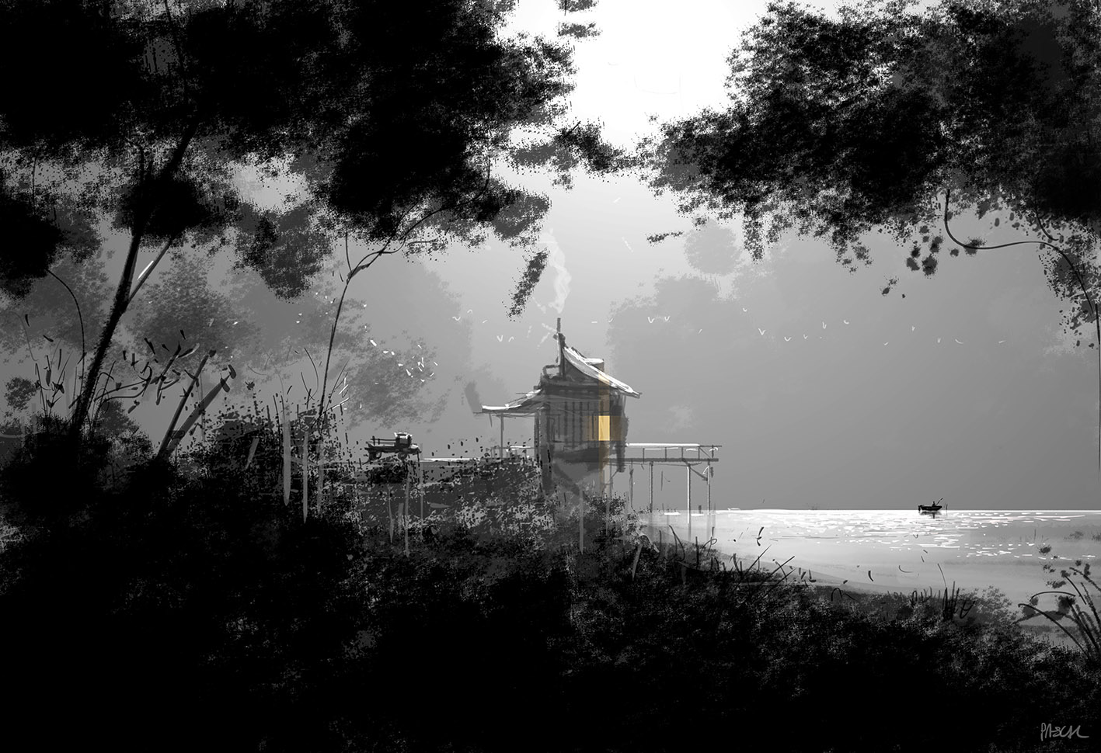
Needs

- What do you think the text will be about?
- Describe this setting. What is the focus? Can you look further to find something you didn’t see at first glance?
- If you were to use this setting in a story, what type of story would it be? Why?
- Why did Pascal Campion choose to only use colour in the window of the building?
- Why do you think Pascal Campion gave this image the title ‘Needs’?
- What do people need? What do they need the most?
- Is there a difference between a ‘need’ and a ‘want’?
- Do you have everything you need? Do you have everything you want? How do you feel about this?
---------------------------------------------------------------------------------------------------------------------------------------------------------------------------------------------------------------------------------------------------------------------------------------------------------------------------------------------------------------------------------------------------------------------------------------------------------------------------------------------------------------------------------------------------------------------------------------------------------------------------------------------------------------------------------------------------------------------------------------------------------------
------------------------------------------------------------------------------------------------------------------------------------------------------------------------------------------------------------------------------------------------------------------------------------------------------------------------------------------------------------------------------------------------------------------------------------
---------------------------------------------------------------------------------------------------------------------------------------------------------------------------------------------------------------------------------------------------------------------------------------------------------------------------------------------------------------------------------------------------------------------------------------------------------------------------------------------------------------------------------------------------------------------------------------------------------------------------------------------------------------------------------------------------------------------------------------------------------------
------------------------------------------------------------------------------------------------------------------------------------------------------------------------------------------------------------------------------------------------------------------------------------------------------------------------------------------------------------------------------------------------------------------------------------
---------------------------------------------------------------------------------------------------------------------------------------------------------------------------------------------------------------------------------------------------------------------------------------------------------------------------------------------------------------------------------------------------------------------------------------------------------------------------------------------------------------------------------------------
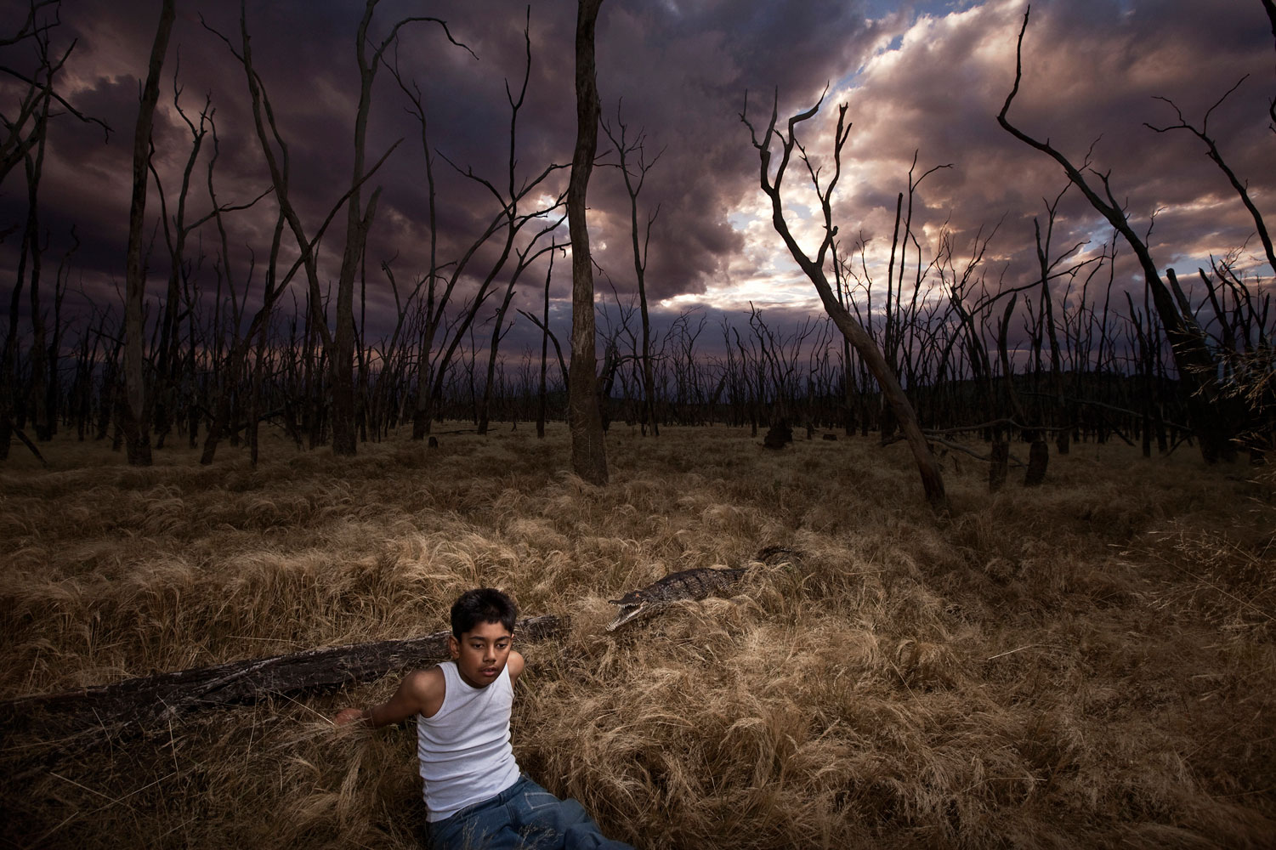
Trees

- What do you think the text will be about? Think beyond the obvious.
- How does this photograph make you feel? Why?
- Who is the boy? Why is he there? How is he feeling?
- Why aren’t there any leaves on the trees?
- Look at the sky. What is the effect of the colours?
- Is there a message behind this picture?

---------------------------------------------------------------------------------------------------------------------------------------------------------------------------------------------------------------------------------------------------------------------------------------------------------------------------------------------------------------------------------------------------------------------------------------------------------------------------------------------------------------------------------------------------------------------------------------------------------------------------------------------------------------------------------------------------------------------------------------------------------------
------------------------------------------------------------------------------------------------------------------------------------------------------------------------------------------------------------------------------------------------------------------------------------------------------------------------------------------------------------------------------------------------------------------------------------
---------------------------------------------------------------------------------------------------------------------------------------------------------------------------------------------------------------------------------------------------------------------------------------------------------------------------------------------------------------------------------------------------------------------------------------------------------------------------------------------------------------------------------------------------------------------------------------------------------------------------------------------------------------------------------------------------------------------------------------------------------------
------------------------------------------------------------------------------------------------------------------------------------------------------------------------------------------------------------------------------------------------------------------------------------------------------------------------------------------------------------------------------------------------------------------------------------
------------------------------------------------------------------------------------------------------------------------------------------------------------------------------------------------------------------------------------------------------------------------------------------------------------------------------------------------------------------------------------------------------------------------------------------------------------------------------------------------------------------------------------------------------------------------------------------------------------------------------------------------------------------------------------------------------------------------------------------------------------------------------------------------------------------------------------------------------------------------------------------------------------------------------------------------------------------------------------------------------------------------------------------------------------------------------------------------------------------------------------------------------------------------------------------------------------------------------------------------------------------------------------------------------------
Extension – (All)

- Do any of the stories, from any level, remind you of other stories you’ve read? Which ones and why?
- How did you predict what each story may be about?
- Look at books, magazines and newspaper articles in your house (that you haven’t read), and using the cover only, predict what they could be about. If you don’t have any, use the covers below:

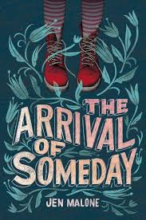 | 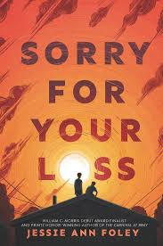 | 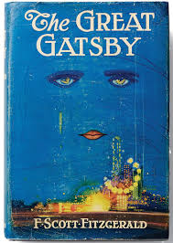
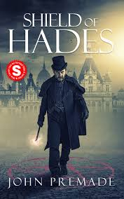 | 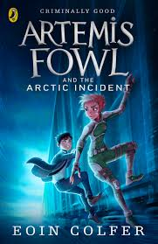 | 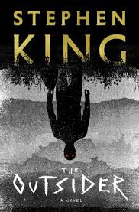
---------------------------------------------------------------------------------------------------------------------------------------------------------------------------------------------------------------------------------------------------------------------------------------------------------------------------------------------------------------------------------------------------------------------------------------------------------------------------
---------------------------------------------------------------------------------------------------------------------------------------------------------------------------------------------------------------------------------------------------------------------------------------------------------------------------------------------------------------------------------------------------------------------------------------------------------------------------
----------------------------------------------------------------------------------------------------------------------------------------------------------------------------------------------------------------------------------------------------------------------------------------------------------------------------------------------------------------------------------------------------------------------------------------------------------------------------
-----------------------------------------------------------------------------------------------------------------------------------------------------------------------------------------------------------------------------------------------------------------------------------------------------------------------------------------------------------------------------------------------------------------------------------------------------------------------------------------------------------------------------------------------------------------------
--------------------------------------------------------------------------------------------
--------------------------------------------------------------------------------------------------------------------------------------------------------------------------------------------------------------------------------------------------------------------------------------------------------------------------------------------------------------------------------

LO: To be able to use techniques to understand what we read – Clarify

We have considered our first technique in helping us to understand what we are reading – predicting what the text may be about before we read it.
In this lesson, we will learn to clarify our understanding of what we read before, or during, our reading. What does this mean?

Clarify – To make clear or easier to understand

Therefore, to predict what a text may be about using the picture and the title, we may need to check we understand the words in the title first. We may need to clarify our understanding.
For example, look at the following book cover and title:
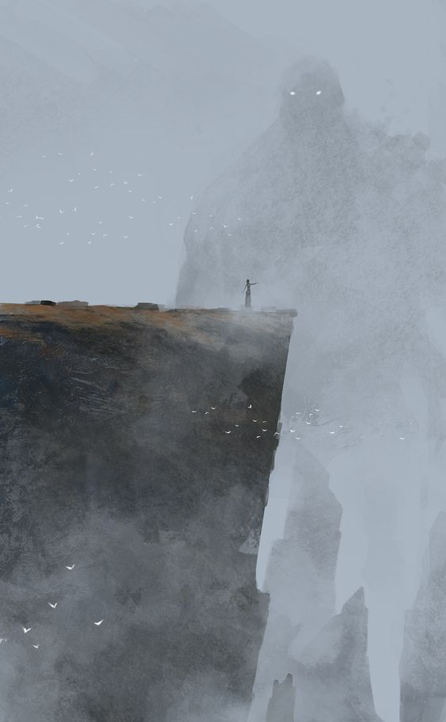
The Summoner
You may have an idea what this book will be about by examining the picture, but if you clarify your understanding of the word ‘insurgent’, by checking the definition in the dictionary, your prediction may be much more accurate.
Task 1a (Green) Using the picture only, predict what you think this story could be about by answering the questions below:
- In the picture, who is good and who is bad?
------------------------------------------------------------------------------------------------------------------------------------------------------------------------------------------------------------------------------------------------------------------------------------------------------------------------------------------------------------------------------------------------------------------------------------------------------------------------------------------------------------------------------------------------

- What is the man doing? Why?
------------------------------------------------------------------------------------------------------------------------------------------------------------------------------------------------------------------------------------------------------------------------------------------------------------------------------------------------------------------------------------------------------------------------------------------------------------------------------------------------------------------------------------------------

- What do you think this book is about?
--------------------------------------------------------------------------------------------------------------------------------------------------------------------------------------------------------------------------------------------------------------------------------------------------------------------------------------------------------------------------------------------------------------------------------------------------------------------------------------------------------------------------------------------------------------------------------------------------------------------------------------------------------------------------------------------------------------------------------
Task 1b (Green) Use a dictionary to look up the word in the title, then answer the following questions below the table:
Title | Definition (Meaning)
Summon

- What do you think is going to happen next?
- How did clarifying the meaning of the word in the title help you to answer?
- Has your answer changed from your response in question 3 on page 22?
-------------------------------------------------------------------------------------------------------------------------------------------------------------------------------------------------------------------------------------------------------------------------------------------------------------------------------------------------------------------------------------------------------------------------------------------------------------------------------------------------------------------------------------------------------------------------------------------------------------------------------------------------------------------
----------------------------------------------------------------------------------------------------------------------------------------------------------------------------------------------------------------------------------------------------------------------------------------------------------------------------------------------------------------------------------------------------------------------------------------------------------------------------
Task 2a (Amber) Complete task 1a in the space provided in green, then answer the additional questions below:
- What do you think happened before the situation in the picture?
---------------------------------------------------------------------------------------------------------------------------------------------------------------------------------------------------------------------------------------------------------------------------------------------------------------------------------------------------------------------------------------------------------------------------------------------------------------------------
- Do you think there are any people hiding behind the man on the rock? What are they thinking/doing?
---------------------------------------------------------------------------------------------------------------------------------------------------------------------------------------------------------------------------------------------------------------------------------------------------------------------------------------------------------------------------------------------------------------------------------------------------------------------------
Task 2b (Amber) Use a dictionary to look up the words in the title, then answer the following questions:
- What do you think is going to happen next?
- How did clarifying the meaning of the words in the title help you to answer?
- Has your answer changed from your response in question 3 on page 19?
Words in Title | Definition (Meaning)
Summon

--------------------------------------------------------------------------------------------------------------------------------------------------------------------------------------------------------------------------------------------------------------------------------------------------------------------------------------------------------------------------------------------------------------------------------------------------------------------------------------------------------------------------------------------------------------------------------------------------------------------------------------------------------------------------------------------------------------------------------------------------------------------------------------------------------------------------------------------------------------------------------------------------------------------------------------------------------
Task 3a (Red) Complete task 2a and 2b (in the spaces provided above), but ensure answers are written:

- in full sentences with capital letters, full stops and correct spelling
- using modal verbs e.g. may, might, could, will
- using adverbs e.g. quickly, silently, eerily

Extension – (All) Using the titles only, clarify your understanding of what the following books may be about by checking the meanings of the words in the titles. Use a dictionary to help you.

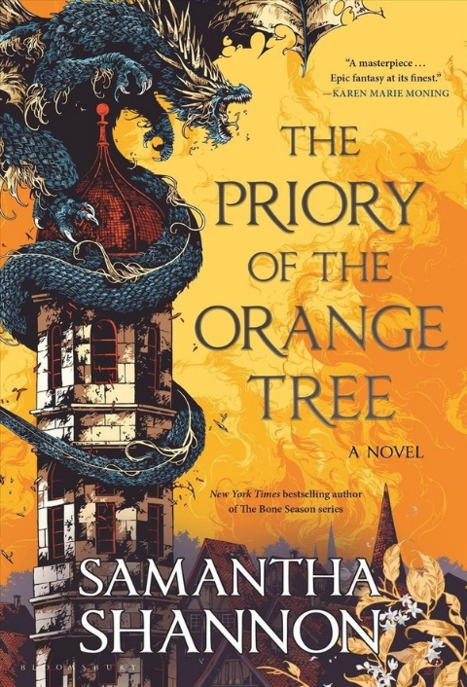 | 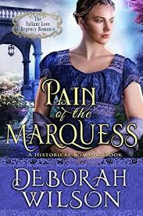 | 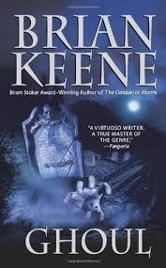
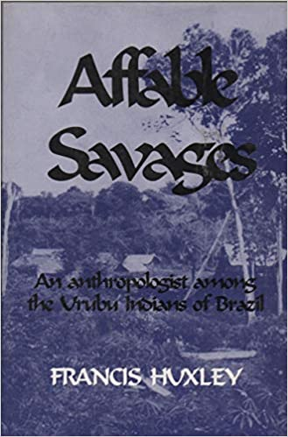 | 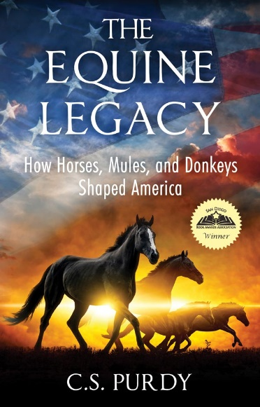 | 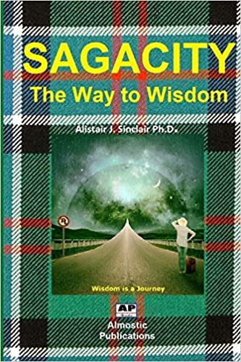
- The Priory of the Orange Tree

Difficult Words in Title | Definition of Word
Priory

What the book may be about:
--------------------------------------------------------------------------------------------------------------------------------------------------------------------------------------------------------------------------------------------------------------------------------------------------------------------------------------------------------------------------------------------------------------------------------------------------------------------------------------------------------------------------------------------------------------------------------------------------------------------------------------------------------------------

- Pain of the Marquess
Difficult Words in Title | Definition of Word
Marquess

What the book may be about:
--------------------------------------------------------------------------------------------------------------------------------------------------------------------------------------------------------------------------------------------------------------------------------------------------------------------------------------------------------------------------------------------------------------------------------------------------------------------------------------------------------------------------------------------------------------------------------------------------------------------------------------------------------------------
- Ghoul
Difficult Words in Title | Definition of Word
Ghoul

What the book may be about:
--------------------------------------------------------------------------------------------------------------------------------------------------------------------------------------------------------------------------------------------------------------------------------------------------------------------------------------------------------------------------------------------------------------------------------------------------------------------------------------------------------------------------------------------------------------------------------------------------------------------------------------------------------------------

- Affable Savages
Difficult Words in Title | Definition of Word
Affable

What the book may be about:
--------------------------------------------------------------------------------------------------------------------------------------------------------------------------------------------------------------------------------------------------------------------------------------------------------------------------------------------------------------------------------------------------------------------------------------------------------------------------------------------------------------------------------------------------------------------------------------------------------------------------------------------------------------------
- The Equine Legacy
Difficult Words in Title | Definition of Word
Equine
Legacy

What the book may be about:
--------------------------------------------------------------------------------------------------------------------------------------------------------------------------------------------------------------------------------------------------------------------------------------------------------------------------------------------------------------------------------------------------------------------------------------------------------------------------------------------------------------------------------------------------------------------------------------------------------------------------------------------------------------------

- Sagacity – The Way to Wisdom
Difficult Words in Title | Definition of Word
Sagacity

What the book may be about:
--------------------------------------------------------------------------------------------------------------------------------------------------------------------------------------------------------------------------------------------------------------------------------------------------------------------------------------------------------------------------------

LO: To be able to use techniques to understand what we read – Question
After we read a text, we need to make sure that we really understand what we have read. How can we do this?

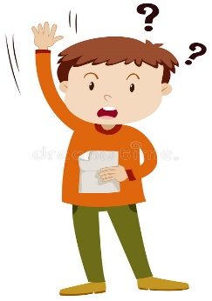
Ask Questions

There are different types of questions we could ask. Some are about what is obvious; what is happening in the text. These are called:

Literal Questions

Other types of questions are about what is less obvious. The text doesn’t tell us the answers to these directly, but we can work out the answer from clues in the text. These are called:

Inferential Questions

Practise answering both types of questions after reading the following text.

Task (All) Before answering the questions for your level, define the following words in the article to help you understand your reading more fully. Highlight the words in the text.

Task 1 (Green) After reading the text above, answer the following questions. The first set of questions are literal questions (the answer will be in the text and you can simply find and copy it), and the second set of questions (highlighted in green) are inferential questions. Inferential questions require you to say what you think may be the answer based on your own knowledge and clues in the text.

9.If you lived in Antarctica for a year, how would you feel? Would the experience be a positive or negative one? Explain.
------------------------------------------------------------------------------------------------------------------------------------------------------------------------------------------------------------------------------------------------------------------------------------------------------------------------------------------------------------------------------------------------------------------------------------------------------------------------------------------------------------------------------------------------------------------------------------------------------------------------------------------------------------------------------------------------------------------------------------------------------------------------------------------------------------------------------------------------------------------------------------------------------------------------------------------------------------------------------------------------------------------------------------------------------------------------------------------------------------------------------------------------------------------------------------------------------------------------------------------------------------------------------------------------------------------------------------------------------------------------------------------------------------------------------------------------------------------------------------------------------------------------------------------------------------------------------------------------------------------------------------------------------------------------------------------------------------------------------------------------------------------------------------------------------------------------------------------------------------------------------------------------------

- Emilio Marcos Palma was born in Antarctica. What do you think he missed out on by growing up there? Did he gain anything?
------------------------------------------------------------------------------------------------------------------------------------------------------------------------------------------------------------------------------------------------------------------------------------------------------------------------------------------------------------------------------------------------------------------------------------------------------------------------------------------------------------------------------------------------------------------------------------------------------------------------------------------------------------------------------------------------------------------------------------------------------------------------------------------------------------------------------------------------------------------------------------------------------------------------------------------------------------------------------------------------------------------------------------------------------------------------------------------------------------------------------------------------------------------------------------------------------------------------------------------------------------------------------------------------------------------------------------------------------------------------------------------------------------------------------------------------------------------------------------------------------------------------------------------------------------------------------------------------------------------------------------------------------------------------------------------------------------------------------------------------------------------------------------------------------------------------------------------------------------------------------------------------------

Task 2 (Amber) Answer the questions below. The first set of questions are literal questions (the answer will be in the text and you can simply find and copy it), and the second set of questions (highlighted in amber) are inferential questions. Inferential questions require you to say what you think may be the answer based on your own knowledge and clues in the text.
-------------------------------------------------------------------------------------------------------------------------------------------------------------------------------------------------------------------------------------------------------------------------------------------------------------------------------------------------------------------------------------------------------------------------------------------------------------------------------------------------------------------------------------------
-------------------------------------------------------------------------------------------------------------------------------------------------------------------------------------------------------------------------------------------------------------------------------------------------------------------------------------------------------------------------------------------------------------------------------------------------------------------------------------------------------------------------------------------
-------------------------------------------------------------------------------------------------------------------------------------------------------------------------------------------------------------------------------------------------------------------------------------------------------------------------------------------------------------------------------------------------------------------------------------------------------------------------------------------------------------------------------------------
-------------------------------------------------------------------------------------------------------------------------------------------------------------------------------------------------------------------------------------------------------------------------------------------------------------------------------------------------------------------------------------------------------------------------------------------------------------------------------------------------------------------------------------------

11.The article states that the research stations have ‘state-of-the-art scientific equipment’. Do you think antarctica is a worthy place in which to pour considerable scientific research funding, or do you think there are worthier causes e.g. cancer research?
-------------------------------------------------------------------------------------------------------------------------------------------------------------------------------------------------------------------------------------------------------------------------------------------------------------------------------------------------------------------------------------------------------------------------------------------------------------------------------------------------------------------------------------------
--------------------------------------------------------------------------------------------------------------------------------------------------------------------------------------------------------------------------------------------------------------------------------------------------------------------------------------------------------------------------------------------------------------------------------------------------------------------------------------------------------------------------------------------------------------------------------------------------------------------------------------------------------------------------------------------------------------------------------------------------------------------------------------------------------------------------------------------------------------------------------------------------------------------------------------------------------------------------------
------------------------------------------------------------------------------------------------------
Task 3 (Red) Answer the questions below. The first set of questions are literal questions (the answer will be in the text and you can simply find and copy it), and the second set of questions (the extension) are inferential questions. Inferential questions require you to say what you think may be the answer based on your own knowledge and clues in the text.
Do you agree with parents who decide to raise a family in Antarctica? Is it fair to their children? Is it safe for their children? What could be the advantages or disadvantages of growing up there. Explain your answers.
--------------------------------------------------------------------------------------------------------------------------------------------------------------------------------------------------------------------------------------------------------------------------------------------------------------------------------------------------------------------------------------------------------------------------------------------------------------------------------------------------------------------------------------------------------------------------------------------------------------------------------------------------------------------------------------------------------------------------------------------------------------------------------------------------------------------------------------------------------------------------------------------------------------------------------------------------------------------------------
--------------------------------------------------------------------------------------------------------------------------------------------------------------------------------------------------------------------------------------------------------------------------------------------------------------------------------------------------------------------------------------------------------------------------------------------------------------------------------------------------------------------------------------------
--------------------------------------------------------------------------------------------------------------------------------------------------------------------------------------------------------------------------------------------------------------------------------------------------------------------------------------------------------------------------------------------------------------------------------------------------------------------------------------------------------------------------------------------
--------------------------------------------------------------------------------------------------------------------------------------------------------------------------------------------------------------------------------------------------------------------------------------------------------------------------------------------------------------------------------------------------------------------------------------------------------------------------------------------------------------------------------------------
--------------------------------------------------------------------------------------------------------------------------------------------------------------------------------------------------------------------------------------------------------------------------------------------------------------------------------------------------------------------------------------------------------------------------------------------------------------------------------------------------------------------------------------------

LO: To be able to use techniques to understand what we read – Summarise
To demonstrate that we really understand a text, we need to be able to summarise it.
What does this mean?
Summarise - to express the most important facts or ideas about something in a short and clear form
Therefore, after reading a text, you need to be able to explain the key facts.
For example, look at this summary of the well-known ‘Three Little Pigs’ story.
Key Fact = Three pigs that were brothers
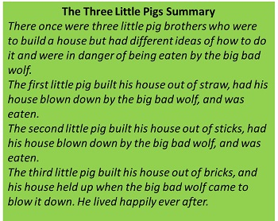
Key Fact = The brick house was strongest
And protected them from the wolf
Key Fact = Each house built of different material
Key Fact = Different ideas about how to build their house

To help us summarise, we sometimes need to think about what we know already so we can:
- Be clear and concise and summarise only the part we have been asked to
- Avoid writing too much (re-writing)

Here is an example of un-summarised text:
“500 years ago, the world was a very different place. European people had only just made contact with the Americans. England and Scotland were separate kingdoms, each with their own royal family. During this time, the Tudor family ruled England and Wales from 1485 to 1603. They encouraged new religious ideas, exploration and colonisation. There were six different monarchs during the 118 years of the Tudor reign.”
This is an example of the same text summarised:
The Tudors reigned England and Wales from 1485 to 1603.
England and Scotland were separate kingdoms.
There were six different monarchs during their reign.

Task (Green):
- Read the following text.
- Clarify the meaning of difficult words in the dictionary.
- Answer the questions to identify the main points.
- Write a summary outlining the key facts about spiders.

Difficult Word | Definition
Arachnid
Exoskeleton
Invertebrates
Abdomen
Camouflage
Predator

- What sort of insect is a spider? Explain.
--------------------------------------------------------------------------------------------------------------------------------------------------------------------------------------------------------------------------------------------------------------------------------------------------------------------------------------------------------------------------------Where do spiders live? Explain.
--------------------------------------------------------------------------------------------------------------------------------------------------------------------------------------------------------------------------------------------------------------------------------------------------------------------------------------------------------------------------------
- How big are spiders? Explain.
--------------------------------------------------------------------------------------------------------------------------------------------------------------------------------------------------------------------------------------------------------------------------------------------------------------------------------------------------------------------------------
- What sort of body do spiders have? Explain.
----------------------------------------------------------------------------------------------------------------------------------------------------------------------------------------------------------------------------------------------------------------------------------------------------------------------------------------------------------------------------------------------------------------------------------------------------------------------------
Spiders - Summary
--------------------------------------------------------------------------------------------------------------------------------------------------------------------------------------------------------------------------------------------------------------------------------------------------------------------------------------------------------------------------------------------------------------------------------------------------------------------------------------------------------------------------------------------------------------------------------------------------------------------------------------------------------------------------------------------------------------------------------------------------------------------------------------------------------------------------------------------------------------------------------------------------------------------------------------------------------

Task (Amber):
- Read the following text.
- Highlight and clarify the meaning of difficult words if you need to.
- Answer the questions to identify the main points.
- Write a summary outlining the key facts about cyclones.
- What is a cyclone?
----------------------------------------------------------------------------------------------------------------------------------------------------------------------------------------------------------------------------------------------------------------------------------------------------------------------------------------------------------------------------------------------------------------------------------------------------------------------------

- What is the ‘eye’ of the cyclone?
----------------------------------------------------------------------------------------------------------------------------------------------------------------------------------------------------------------------------------------------------------------------------------------------------------------------------------------------------------------------------------------------------------------------------------------------------------------------------

- What do cyclones need to maintain their energy?
----------------------------------------------------------------------------------------------------------------------------------------------------------------------------------------------------------------------------------------------------------------------------------------------------------------------------------------------------------------------------------------------------------------------------------------------------------------------------

- What effect do cyclones sometimes have?
----------------------------------------------------------------------------------------------------------------------------------------------------------------------------------------------------------------------------------------------------------------------------------------------------------------------------------------------------------------------------------------------------------------------------------------------------------------------------

Cyclones - Summary
--------------------------------------------------------------------------------------------------------------------------------------------------------------------------------------------------------------------------------------------------------------------------------------------------------------------------------------------------------------------------------------------------------------------------------------------------------------------------------------------------------------------------------------------------------------------------------------------------------------------------------------------------------------------------------------------------------------------------------------------------------------------------------------------------------------------------------------------------------------------------------------------------------------------------------------------------------
Task (Red):
- Read the following text.
- Highlight and clarify the meaning of difficult words if you need to.
- Write a summary outlining the key facts about the circulatory system.
The Circulatory System - Summary
------------------------------------------------------------------------------------------------------------------------------------------------------------------------------------------------------------------------------------------------------------------------------------------------------------------------------------------------------------------------------------------------------------------------------------------------------------------------------------------------------------------------------------------------------------------------------------------------------------------------------------------------------------------------------------------------------------------------------------------------------------------------------------------------------------------------------------------------------------ --------------------------------------------------------------------------------------------------------------------------------------------------------------------------------------------------------------------------------------------------------------------------------------------------------------------------------------------------------------------------------------------------------------------------------------------------------------------------------------------------------------------------------------------------------------------------------------------------------------------------------------------------------------------------------------------------------------------------------------------------------------------------------------------------------------------------------------------------------------------------------------------------------------------------------------------------------

Task (All) Can you remember the four techniques to help us understand what we read? Check back in this booklet and define each term below:

Predict  ------------------------------------------------------------------------------------------------------------------------------------------------------------------------------------------------------------------  ------------------------------------------------------------------------------------------------------------------------------------------------------------------------------------------------------------------  ------------------------------------------------------------------------------------------------------------------------------------------------------------------------ | Clarify  ---------------------------------------------------------------------------------------------------------------------------------------------------------------------------------------------------------------------------------  ---------------------------------------------------------------------------------------------------------------------------------------------------------------------------------------------------------------------------------  ------------------------------------------------------------------------------------------------------------------------------------------------------------------------------------
Question  ------------------------------------------------------------------------------------------------------------------------------------------------------------------------------------------------------------------  ------------------------------------------------------------------------------------------------------------------------------------------------------------------------------------------------------------------  ------------------------------------------------------------------------------------------------------------------------------------------------------------------------ | Summarise  ---------------------------------------------------------------------------------------------------------------------------------------------------------------------------------------------------------------------------------  ---------------------------------------------------------------------------------------------------------------------------------------------------------------------------------------------------------------------------------  ------------------------------------------------------------------------------------------------------------------------------------------------------------------------------------

