Year 8
English Work Pack 4
Parents/Carers – only complete as much, or as little, of these booklets as your circumstances allow at this difficult time.

Welcome to this week’s English topic!

Reciprocal Reading Techniques
We will have fun learning to read by:

- Predicting
- Clarifying
- Questioning
- Summarising

Choose your own task level (green = easy, amber = slightly harder, red = challenge)

LO: To be able to use techniques to understand what we read – Predict
In this booklet, we will learn to have a better understanding of what we read by using the following techniques:

Predict | Clarify | Question | Summarise

What do these words really mean? Let’s look at the first one:

Predict A prediction is what someone thinks will happen.

Pre means ‘before’, so if we predict what a text will be about, it means that we should try to decide what it could be about before we read it.
How do we predict before we read?

We could use the following things as clues:

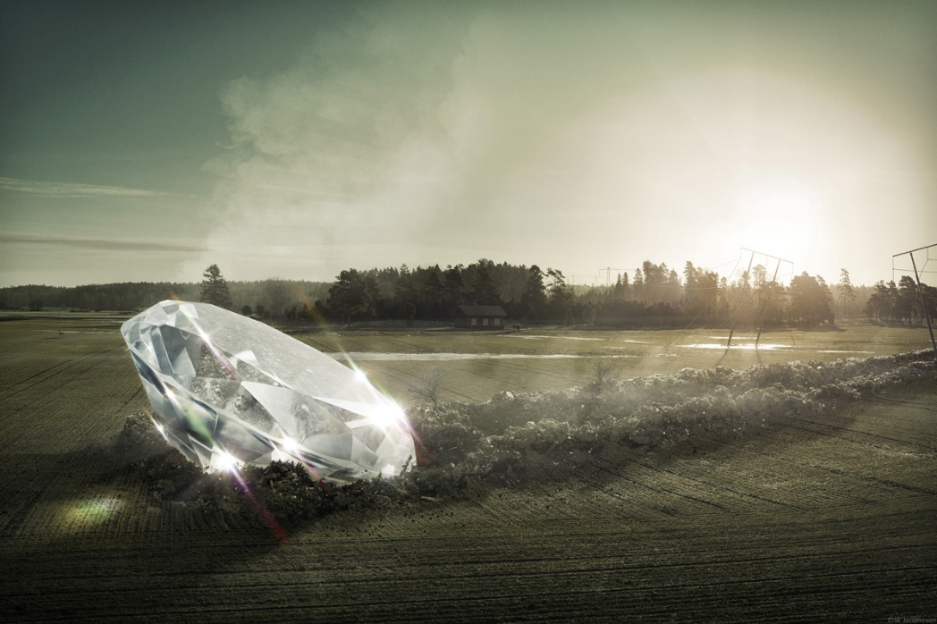
Pictures
Title
Diamond in the Rough

To predict what this book could be about using the picture, you could ask yourself questions such as:

- What has happened here?
- Where did the diamond come from?
- How long has it been here?
- Has anyone seen in it yet?
- Did anyone see where it came from?
- Who might be the first person to discover it?
- What do you think they will do?
- What would you do if you discovered this?

Task 1a (Green) Look at the picture carefully and answer questions one and two below.
1.-------------------------------------------------------------------------------------------------------------------------------------------------------------------------------------------------------------------------------------------------------------------------------------------------------------------------------------------------------------------------------------------------------------------------------------------------------------------------

2. ------------------------------------------------------------------------------------------------------------------------------------------------------------------------------------------------------------------------------------------------------------------------------------------------------------------------------------------------------------------------------------------------------------------------------------------------------------------------

Task 2a (Amber) Look at the picture carefully and answer questions 1-8 below.
For extra challenge, try predicting by including modal verbs in your answers (may, might, could) e.g. I predict that… might… because…, I think… may…because …, I imagine that … could… because

1.-------------------------------------------------------------------------------------------------------------------------------------------------------------------------------------------------------------------------------------------------------------------------------------------------------------------------------------------------------------------------------------------------------------------------------------------------------------------------

2. ------------------------------------------------------------------------------------------------------------------------------------------------------------------------------------------------------------------------------------------------------------------------------------------------------------------------------------------------------------------------------------------------------------------------------------------------------------------------

3. ------------------------------------------------------------------------------------------------------------------------------------------------------------------------------------------------------------------------------------------------------------------------------------------------------------------------------------------------------------------------------------------------------------------------------------------------------------------------

4. ------------------------------------------------------------------------------------------------------------------------------------------------------------------------------------------------------------------------------------------------------------------------------------------------------------------------------------------------------------------------------------------------------------------------------------------------------------------------
5. -------------------------------------------------------------------------------------------------------------------------------------------------------------------------------------------------------------------------------------------------------------------------------------------------------------------------------------------------------------------------------------------------------------------------------------------------------------------------

6. ------------------------------------------------------------------------------------------------------------------------------------------------------------------------------------------------------------------------------------------------------------------------------------------------------------------------------------------------------------------------------------------------------------------------------------------------------------------------

7. ------------------------------------------------------------------------------------------------------------------------------------------------------------------------------------------------------------------------------------------------------------------------------------------------------------------------------------------------------------------------------------------------------------------------------------------------------------------------

8. ------------------------------------------------------------------------------------------------------------------------------------------------------------------------------------------------------------------------------------------------------------------------------------------------------------------------------------------------------------------------------------------------------------------------------------------------------------------------
Task 3a (Red) In addition to completing task 2, try using a range of adverbs and modal verbs to show how likely something is to happen since there could be several possibilities. Complete your work using the writing lines for task 2. Remember:

Adverbs – show how the action is performed  e.g. I think the villagers would run quickly because they would be afraid.  definitely  certainly  clearly  obviously  surely  quite  likely  probably  possibly  maybe  hardly  undoubtedly | Modal Verbs – a verb added to another one to show how likely, possible, permissible, or obligatory it is for the action to occur  e.g. I predict that the villagers might try to stop the rock sphere from rolling down the hillside.  will  must  shall  ought to  should  can  would  may  might  could

A further way in which we could predict what a text may be about is by using the title to help us.

Task 1b (Green) Look at the titles and pictures of the following book covers, then answer the questions below, next to each picture.

- What do you think the text will be about, and why do you think that?
- What clues are there?
- What might happen in this story?

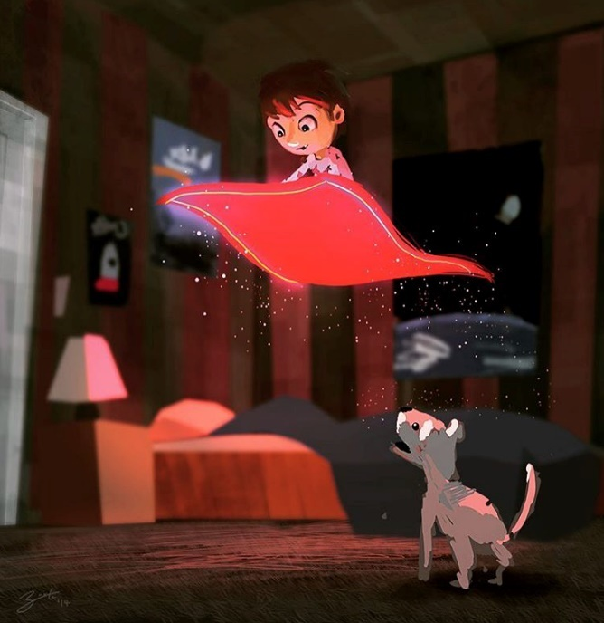
Magic Carpet

----------------------------------------------------------------------------------------------------------------------------------------------------------------------------------------------------------------------------------------------------------------------------------------------------------------------------------------------------------------------------------------------------------------------------------------------------------------------------------------------------------------------------------------------------------------------------------------------------------------------------------------------------------------------------------------------------------------------------------------------------------------
------------------------------------------------------------------------------------------------------------------------------------------------------------------------------------------------------------------------------------------------------------------------------------
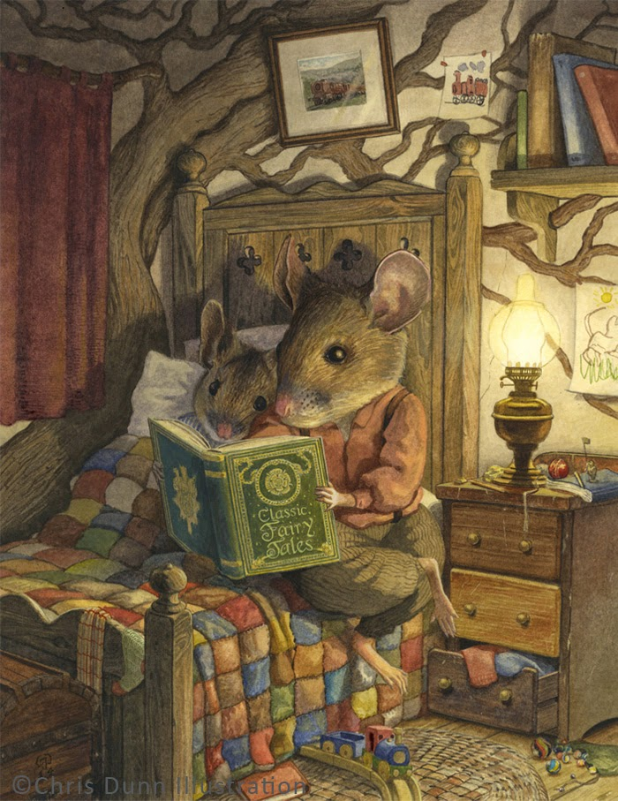
Bedtime Story

----------------------------------------------------------------------------------------------------------------------------------------------------------------------------------------------------------------------------------------------------------------------------------------------------------------------------------------------------------------------------------------------------------------------------------------------------------------------------------------------------------------------------------------------------------------------------------------------------------------------------------------------------------------------------------------------------------------------------------------------------------------
------------------------------------------------------------------------------------------------------------------------------------------------------------------------------------------------------------------------------------------------------------------------------------

Task 2b (Amber) Look at the titles and pictures of the following book covers, then answer the questions below, next to each picture.

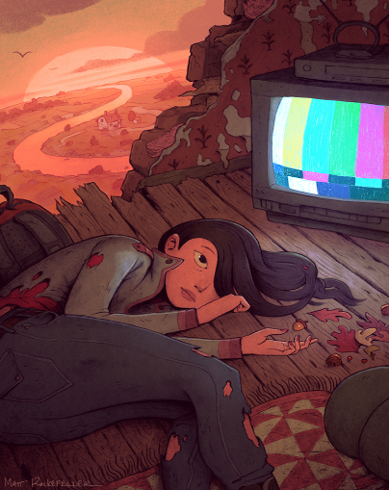
Adrift

- What is the woman doing?
- Where is she?
- Why is she lying on the floor? How is she feeling? Why?
- What happened to her clothes? What happened to the building?
- Why is the TV off?
- Are the leaves and acorns important? Is the house in the distance important?
---------------------------------------------------------------------------------------------------------------------------------------------------------------------------------------------------------------------------------------------------------------------------------------------------------------------------------------------------------------------------------------------------------------------------------------------------------------------------------------------------------------------------------------------------------------------------------------------------------------------------------------------------------------------------------------------------------------------------------------------------------------
---------------------------------------------------------------------------------------------------------------------------------------------------------------------------------------------------------------------------------------------------------------------------------------------------------------------------------------------------------------------------------------------------------------------------------------------------------------------------------------------------------------------------------------------------------------------------------------------------------------------------------------------------------------------------------------------------------------------------------------------------------------
---------------------------------------------------------------------------------------------------------------------------------------------------------------------------------------------------------------------------------------------------------------------------------------------------------------------------------------------------------------------------------------------------------------------------------------------------------------------------------------------------------------------------------------------------------------------------------------------------------------------------------------------------------------------------------------------------------------------------------------------------------------------------------------------------------------------------------------------------------------------------------------------------------------------------------------------------------------------------------------------------------------------------------------------------------------------------------------------------------------------------------------------------------------------------------------------------------------------------------------------------------------------------------------------------------------------------------------------------------------------------------------------------------------------------------------------------------------------------------------------------------------------------------------------------------------------------------------------------------------------------------------
--------------------------------------------------------------------------------------------------------------------------------------------------------------------------------------------------------------------------------------------------------------------------------------------------------------------------------------------------------------------------------------------------------------------------------------------------------------------------------------------------------------------------------------------------------------------------------------------------------------------------------------------------------------------------------------------------------------------------------------------------------------
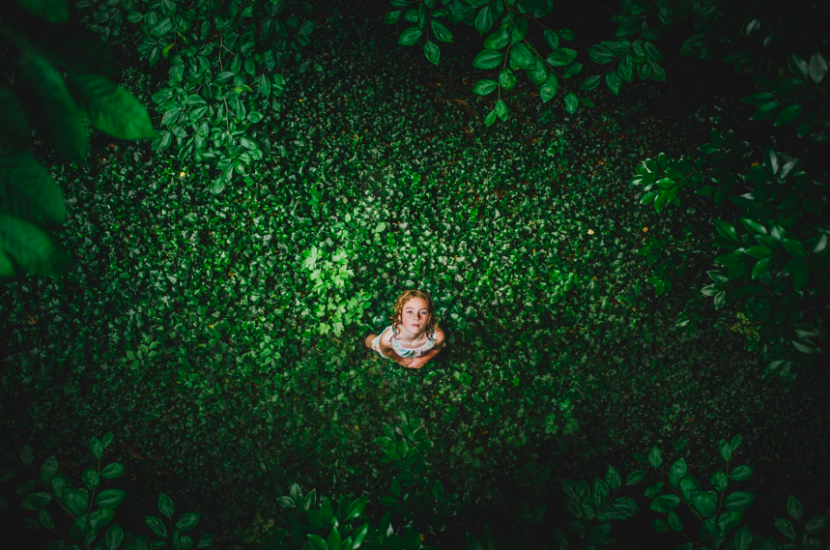
Green
- Where is this?
- Why is the girl there?
- How did she get there?
- Does anyone know that she’s there?
- What is she doing?
- What is she looking at?
- What time of day is it?
- How is she feeling?
- Why is she feeling this way?
- Tell the ‘before and after’ of this picture
--------------------------------------------------------------------------------------------------------------------------------------------------------------------------------------------------------------------------------------------------------------------------------------------------------------------------------------------------------------------------------------------------------------------------------------------------------------------------------------------------------------------------------------------------------------------------------------------------------------------------------------------------------------------------------------------------------------------------------------------------------------------------------------------------------------------------------------------------------------------------------------------------------------------------------------------------------------------------------------------------------------------------------------------------------------------------------------------------------------------------------------------------------------------------------------------------------------------------------------------------------------------------------------------------------------------------------------------------------------------------------------------------------------------------------------------------------------------------------------------------------------------------------------------------------------------------------------------------------------------------------------------------------------------------------------------------------------------------------------------------------------------------------------------------------------------------------------------------------------------------------------------------------------------------------------------------------------------------------------------------------------------------------------------------------------------------------------------------------------------------------------------------------------------------------------------------------------------------------------------------------------------------------------------------------------------------------------------------------------------------------------------------------------------------------------------------------------------------------------------------------------------------------------------------------------------------------------------------------------------------------------------------------------------------------------------------------------------------------------------------------------------------------------------------------------------------------------------------------------------------------------------------------------------------------------------------------------------------------------------------------------------------------------------------------------------------------------------------------------------------------------------------------------------------------------------------------------------------------------------------------------------------------------------------------------------------------------------------------------------------------------------------------------------------------------------------------------------------------------------------------------------------------------------------------------------------------------------------------------------------------------------------------------------------------------------------------------------------------------------------------------------------------------------------------------------------
Task 3b (Red) Look at the titles and pictures of the following book covers, then answer the questions below, next to each picture.

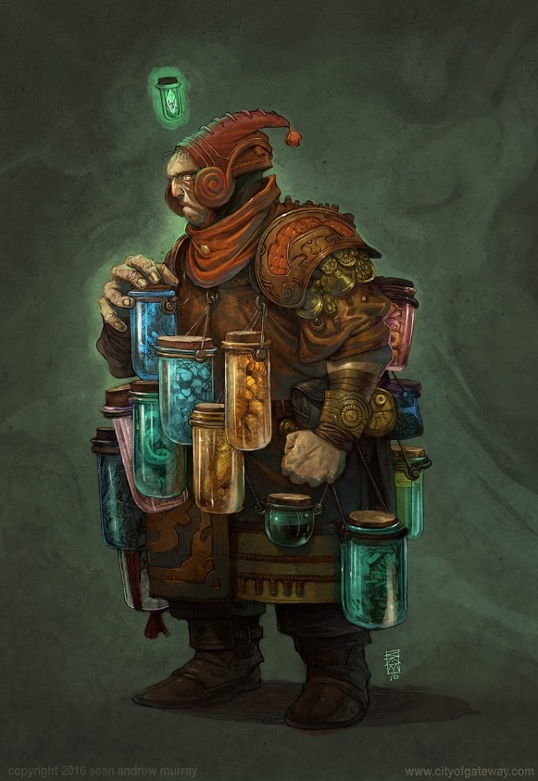
The Jar Wizard

- Who do you think this is?
- Why is he carrying jars?
- What is inside them?
- Why are they attached to his clothing?
- Why is he wearing this clothing?
- Is he going to open the blue jar? Why?
- Why is his other fist clenched?
- What does his body language tell you about his thoughts and feelings?
- Choose three words to describe this character. Justify your choices.
---------------------------------------------------------------------------------------------------------------------------------------------------------------------------------------------------------------------------------------------------------------------------------------------------------------------------------------------------------------------------------------------------------------------------------------------------------------------------------------------------------------------------------------------------------------------------------------------------------------------------------------------------------------------------------------------------------------------------------------------------------------
------------------------------------------------------------------------------------------------------------------------------------------------------------------------------------------------------------------------------------------------------------------------------------------------------------------------------------------------------------------------------------------------------------------------------------
---------------------------------------------------------------------------------------------------------------------------------------------------------------------------------------------------------------------------------------------------------------------------------------------------------------------------------------------------------------------------------------------------------------------------------------------------------------------------------------------------------------------------------------------------------------------------------------------------------------------------------------------------------------------------------------------------------------------------------------------------------------
------------------------------------------------------------------------------------------------------------------------------------------------------------------------------------------------------------------------------------------------------------------------------------------------------------------------------------------------------------------------------------------------------------------------------------
---------------------------------------------------------------------------------------------------------------------------------------------------------------------------------------------------------------------------------------------------------------------------------------------------------------------------------------------------------------------------------------------------------------------------------------------------------------------------------------------------------------------------------------------------------------------------------------------------------------------------------------------------------------------------------------------------------------------------------------------------------------
---------------------------------------------------------------------------------------------------------------------------------------------------------------------------------------------------------------------------------------------------------------------------------------------------------------------------
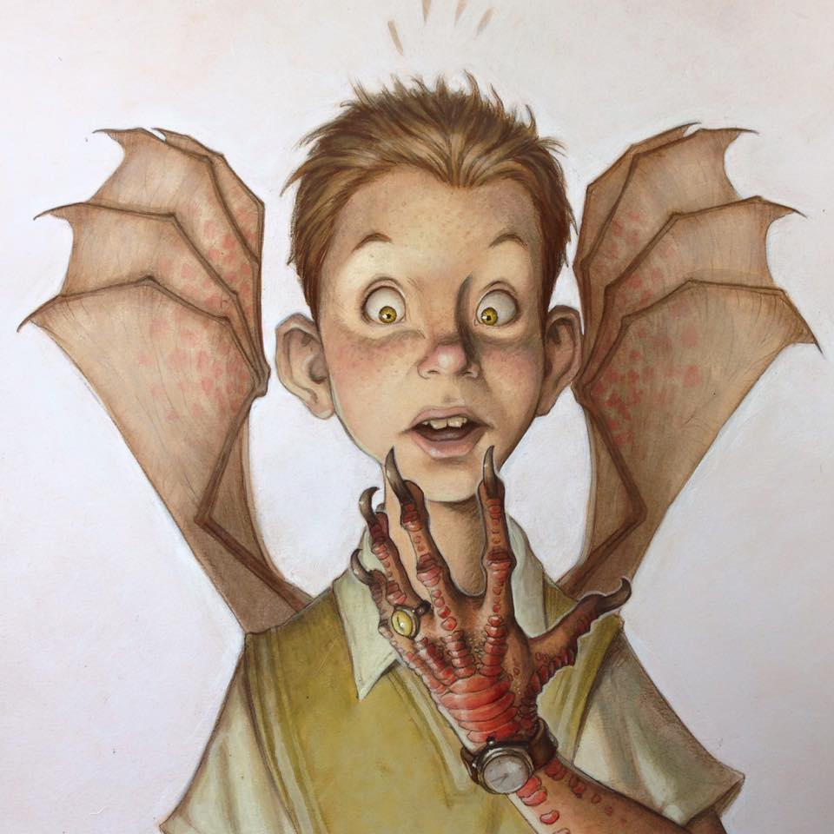
The Monster’s Ring
- What is ‘The Monster’s Ring’?
- Is the boy wearing it?
- What is special about it?
- What has happened to the boy?
- Which change happened first?
- Will he always be this way?
- How is he feeling?
- What might he be thinking?

---------------------------------------------------------------------------------------------------------------------------------------------------------------------------------------------------------------------------------------------------------------------------------------------------------------------------------------------------------------------------------------------------------------------------------------------------------------------------------------------------------------------------------------------------------------------------------------------------------------------------------------------------------------------------------------------------------------------------------------------------------------
------------------------------------------------------------------------------------------------------------------------------------------------------------------------------------------------------------------------------------------------------------------------------------------------------------------------------------------------------------------------------------------------------------------------------------
---------------------------------------------------------------------------------------------------------------------------------------------------------------------------------------------------------------------------------------------------------------------------------------------------------------------------------------------------------------------------------------------------------------------------------------------------------------------------------------------------------------------------------------------------------------------------------------------------------------------------------------------------------------------------------------------------------------------------------------------------------------
------------------------------------------------------------------------------------------------------------------------------------------------------------------------------------------------------------------------------------------------------------------------------------------------------------------------------------------------------------------------------------------------------------------------------------
---------------------------------------------------------------------------------------------------------------------------------------------------------------------------------------------------------------------------------------------------------------------------------------------------------------------------------------------------------------------------------------------------------------------------------------------------------------------------------------------------------------------------------------------------------------------------------------------------------------------------------------------------------------------------------------------------------------------------------------------------------------
---------------------------------------------------------------------------------------------------------------------------------------------------------------------------------------------------------------------------------------------------------------------------------------------------------------------------

Extension – (All)

- Do any of the stories, from any level, remind you of other stories you’ve read? Which ones and why?
- How did you predict what each story may be about?
- Look at books, magazines and newspaper articles in your house (that you haven’t read), and using the cover only, predict what they could be about. If you don’t have any, use the covers below:

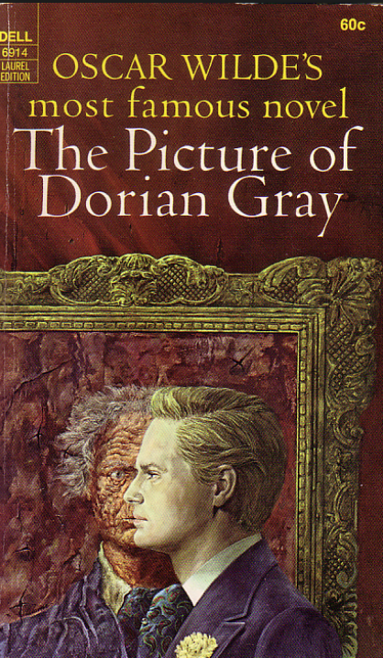 | 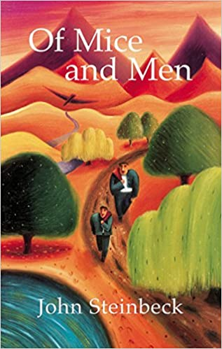 | 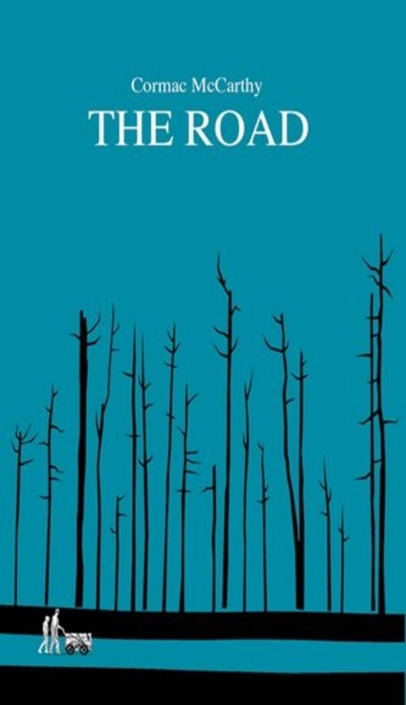
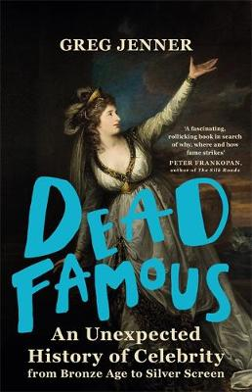 | 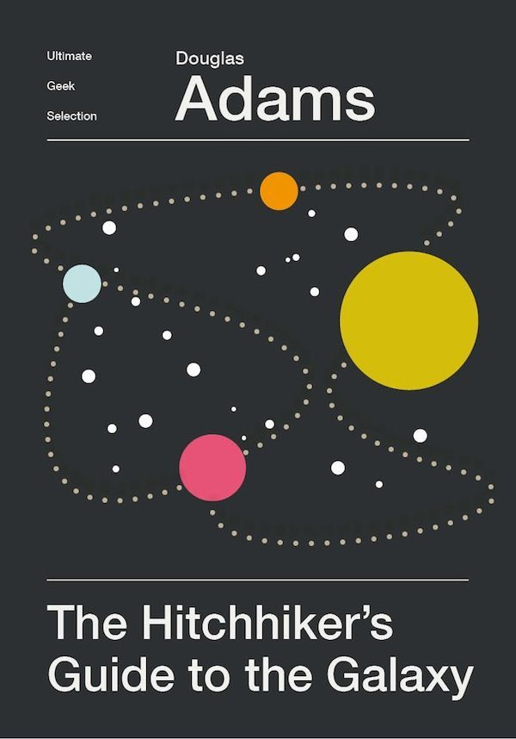 | 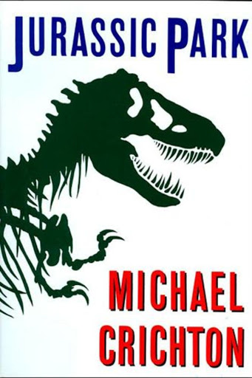

------------------------------------------------------------------------------------------------------------------------------------------------------------------------------------------------------------------------------------------------------------------------------------------------------------------------------------------------------------------------------------------------------------------------------------
------------------------------------------------------------------------------------------------------------------------------------------------------------------------------------------------------------------------------------------------------------------------------------------------------------------------------------------------------------------------------------------------------------------------------------
------------------------------------------------------------------------------------------------------------------------------------------------------------------------------------------------------------------------------------------------------------------------------------------------------------------------------------------------------------------------------------------------------------------------------------
------------------------------------------------------------------------------------------------------------------------------------------------------------------------------------------------------------------------------------------------------------------------------------------------------------------------------------------------------------------------------------------------------------------------------------
------------------------------------------------------------------------------------
------------------------------------------------------------------------------------------------------------------------------------------------------------------------------------------------------------------------------------------------------------
LO: To be able to use techniques to understand what we read – Clarify

We have considered our first technique in helping us to understand what we are reading – predicting what the text may be about before we read it.
In this lesson, we will learn to clarify our understanding of what we read before, or during, our reading. What does this mean?

Clarify – To make clear or easier to understand

Therefore, to predict what a text may be about using the picture and the title, we may need to check we understand the words in the title first. We may need to clarify our understanding.
For example, look at the following book cover and title:

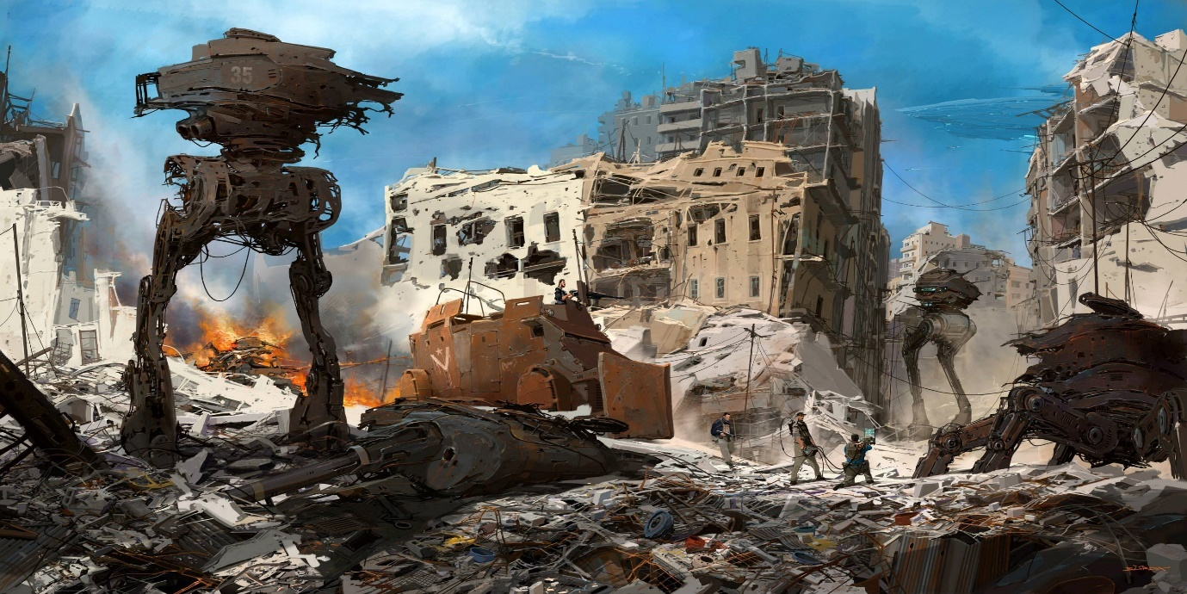
Insurgents
You may have an idea what this book will be about by examining the picture, but if you clarify your understanding of the word ‘insurgent’, by checking the definition in the dictionary, your prediction may be much more accurate.
Task 1a (Green) Using the picture only, predict what you think this story could be about by answering the questions below:

- In the picture, who is good and who is bad?
------------------------------------------------------------------------------------------------------------------------------------------------------------------------------------------------------------------------------------------------------------------------------------------------------------------------------------------------------------------------------------------------------------------------------------------------------------------------------------------------------------------------------------------------

- What are the men doing? Why?
------------------------------------------------------------------------------------------------------------------------------------------------------------------------------------------------------------------------------------------------------------------------------------------------------------------------------------------------------------------------------------------------------------------------------------------------------------------------------------------------------------------------------------------------

- What do you think this book is about?
--------------------------------------------------------------------------------------------------------------------------------------------------------------------------------------------------------------------------------------------------------------------------------------------------------------------------------------------------------------------------------------------------------------------------------------------------------------------------------------------------------------------------------------------------------------------------------------------------------------------------------------------------------------------------------------------------------------------------------
Task 1b (Green) Use a dictionary to look up the word in the title, then answer the following questions below the table:
Title | Definition (Meaning)
Insurgent

- What do you think is going to happen next?
- How did clarifying the meaning of the word in the title help you to answer?
- Has your answer changed from your response in question 3 on page 19?
-------------------------------------------------------------------------------------------------------------------------------------------------------------------------------------------------------------------------------------------------------------------------------------------------------------------------------------------------------------------------------------------------------------------------------------------------------------------------------------------------------------------------------------------------------------------------------------------------------------------------------------------------------------------
----------------------------------------------------------------------------------------------------------------------------------------------------------------------------------------------------------------------------------------------------------------------------------------------------------------------------------------------------------------------------------------------------------------------------------------------------------------------------
Task 2a (Amber) Complete task 1a in the space provided in green, then answer the additional questions below:
- What do you think happened before the situation in the picture?
---------------------------------------------------------------------------------------------------------------------------------------------------------------------------------------------------------------------------------------------------------------------------------------------------------------------------------------------------------------------------------------------------------------------------------------------------------------------------
- Do you think there are any people hiding in the derelict buildings? What are they thinking/doing?
---------------------------------------------------------------------------------------------------------------------------------------------------------------------------------------------------------------------------------------------------------------------------------------------------------------------------------------------------------------------------------------------------------------------------------------------------------------------------
Task 2b (Amber) Use a dictionary to look up the words in the title, then answer the following questions:
- What do you think is going to happen next?
- How did clarifying the meaning of the words in the title help you to answer?
- Has your answer changed from your response in question 3 on page 19?
Words in Title | Definition (Meaning)
Insurgent

--------------------------------------------------------------------------------------------------------------------------------------------------------------------------------------------------------------------------------------------------------------------------------------------------------------------------------------------------------------------------------------------------------------------------------------------------------------------------------------------------------------------------------------------------------------------------------------------------------------------------------------------------------------------------------------------------------------------------------------------------------------------------------------------------------------------------------------------------------------------------------------------------------------------------------------------------------
Task 3a (Red) Complete task 2a and 2b (in the spaces provided above), but ensure answers are written:

- in full sentences with capital letters, full stops and correct spelling
- using modal verbs e.g. may, might, could, will
- using adverbs e.g. quickly, silently, eerily

Extension – (All) Using the titles only, clarify your understanding of what the following books may be about by checking the meanings of the words in the titles. Use a dictionary to help you.

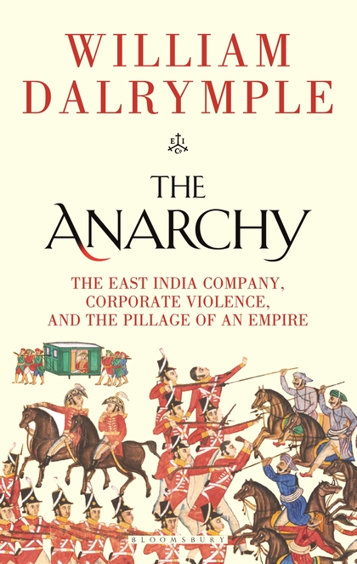 | 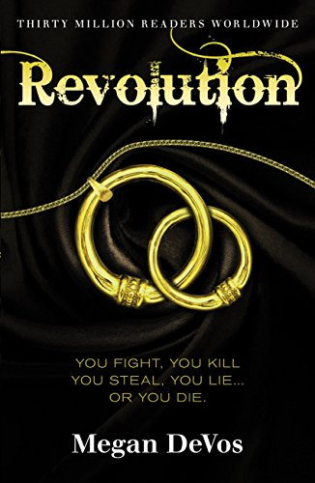 | 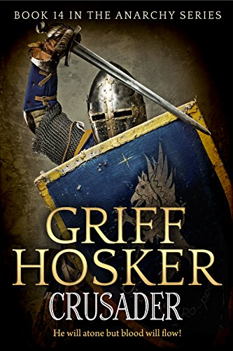
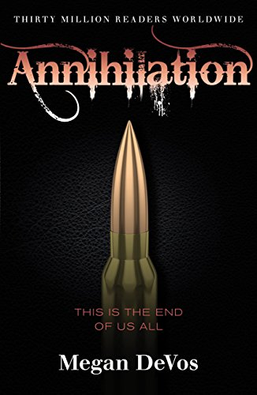 | 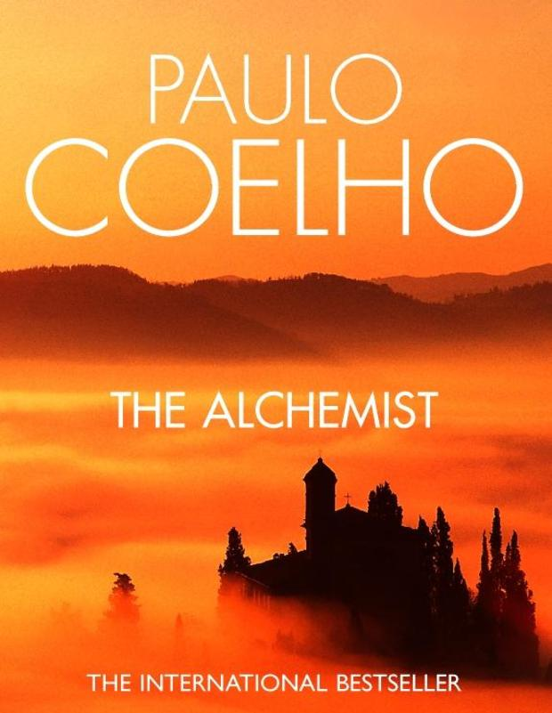 | 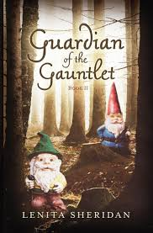
- The Anarchy

Difficult Words in Title | Definition of Word
Anarchy

What the book may be about:
--------------------------------------------------------------------------------------------------------------------------------------------------------------------------------------------------------------------------------------------------------------------------------------------------------------------------------------------------------------------------------------------------------------------------------------------------------------------------------------------------------------------------------------------------------------------------------------------------------------------------------------------------------------------

- Revolution
Difficult Words in Title | Definition of Word
Revolution

What the book may be about:
--------------------------------------------------------------------------------------------------------------------------------------------------------------------------------------------------------------------------------------------------------------------------------------------------------------------------------------------------------------------------------------------------------------------------------------------------------------------------------------------------------------------------------------------------------------------------------------------------------------------------------------------------------------------
- Crusader
Difficult Words in Title | Definition of Word
Crusader

What the book may be about:
--------------------------------------------------------------------------------------------------------------------------------------------------------------------------------------------------------------------------------------------------------------------------------------------------------------------------------------------------------------------------------------------------------------------------------------------------------------------------------------------------------------------------------------------------------------------------------------------------------------------------------------------------------------------

- Annihilation
Difficult Words in Title | Definition of Word
Annihilation

What the book may be about:
--------------------------------------------------------------------------------------------------------------------------------------------------------------------------------------------------------------------------------------------------------------------------------------------------------------------------------------------------------------------------------------------------------------------------------------------------------------------------------------------------------------------------------------------------------------------------------------------------------------------------------------------------------------------
- The Alchemist
Difficult Words in Title | Definition of Word
Alchemist

What the book may be about:
--------------------------------------------------------------------------------------------------------------------------------------------------------------------------------------------------------------------------------------------------------------------------------------------------------------------------------------------------------------------------------------------------------------------------------------------------------------------------------------------------------------------------------------------------------------------------------------------------------------------------------------------------------------------

- Guardian of the Gauntlet
Difficult Words in Title | Definition of Word
Guardian

Gauntlet

What the book may be about:
--------------------------------------------------------------------------------------------------------------------------------------------------------------------------------------------------------------------------------------------------------------------------------------------------------------------------------------------------------------------------------
LO: To be able to use techniques to understand what we read – Question
After we read a text, we need to make sure that we really understand what we have read. How can we do this?

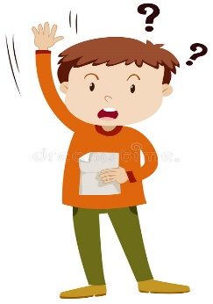
Ask Questions

There are different types of questions we could ask. Some are about what is obvious; what is happening in the text. These are called:

Literal Questions

Other types of questions are about what is less obvious. The text doesn’t tell us the answers to these directly, but we can work out the answer from clues in the text. These are called:

Inferential Questions

Let’s practise answering both types of questions after reading the following text. (Green level text first)

Task 1 (Green) After reading the text above, answer the following questions. They are labelled ‘L’ for literal questions (the answer will be in the text and you can simply find and copy it) and ‘I’ for inferential questions. Inferential questions require you to say what you think may be the answer based on your own knowledge and clues in the text.
I
I
L
L
L
L
L
Task 2 (Amber) Read the texts below, then answer the following questions.
Task 2 (Amber) Answer the questions below. They are labelled ‘L’ for literal questions (the answer will be in the text and you can simply find and copy it) and ‘I’ for inferential questions. Inferential questions require you to say what you think may be the answer based on your own knowledge and clues in the text.
I
I
L
L
L
L
I
L

Task 3 (Red) Read the text below, then answer the questions to follow.

Task 3 (Red) Answer the questions below. They are labelled ‘L’ for literal questions (the answer will be in the text and you can simply find and copy it) and ‘I’ for inferential questions. Inferential questions require you to say what you think may be the answer based on your own knowledge and clues in the text.
I
I
L
L
L
L
L
I
L
I

LO: To be able to use techniques to understand what we read – Summarise
To demonstrate that we really understand a text, we need to be able to summarise it.
What does this mean?
Summarise - to express the most important facts or ideas about something in a short and clear form
Therefore, after reading a text, you need to be able to explain the key facts.
For example, look at this summary of the well-known ‘Three Little Pigs’ story.
Key Fact = Three pigs that were brothers
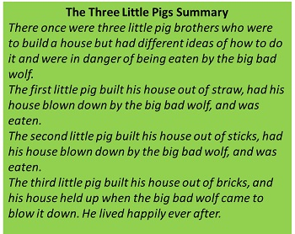
Key Fact = The brick house was strongest
And protected them from the wolf
Key Fact = Each house built of different material
Key Fact = Different ideas about how to build their house

To help us summarise, we sometimes need to think about what we know already so we can:
- Be clear and concise and summarise only the part we have been asked to
- Avoid writing too much (re-writing)
Here is an example of un-summarised text:
“500 years ago, the world was a very different place. European people had only just made contact with the Americans. England and Scotland were separate kingdoms, each with their own royal family. During this time, the Tudor family ruled England and Wales from 1485 to 1603. They encouraged new religious ideas, exploration and colonisation. There were six different monarchs during the 118 years of the Tudor reign.”
This is an example of the same text summarised:
The Tudors reigned England and Wales from 1485 to 1603.
England and Scotland were separate kingdoms.
There were six different monarchs during their reign.

Task (Green) Read the following text from, ‘Tom’s Midnight Garden’ and answer the questions to identify the main points.

- Who is the main character in this extract?
------------------------------------------------------------------------------------------------------------------------------------------------------------------------------------------------------------------------------------------------------------------------------------------------------------------------------------------------------------------------------------------------------------------------------------------------------------------------------------------------------------------------------------------------------------------------
- What is he doing?
------------------------------------------------------------------------------------------------------------------------------------------------------------------------------------------------------------------------------------------------------------------------------------------------------------------------------------------------------------------------------------------------------------------------------------------------------------------------------------------------------------------------------------------------------------------------------------------------------------------------------------------------------------------------------------------------------------------------------------------------------------------------------------------------------------------------------------------------------------------------------------------------------------------------------------------------------------------------------------------------------------------------------------------------------------------------------------------------------------------------------------------------
- In one sentence, write what the letter is about.
------------------------------------------------------------------------------------------------------------------------------------------------------------------------------------------------------------------------------------------------------------------------------------------------------------------------------------------------------------------------------------------------------------------------------------------------------------------------------------------------------------------------------------------------------------------------

Task 2 (Amber) In addition to completing the activity in task 1, summarise what happens in the extract. Write no more than a paragraph in the space below.
------------------------------------------------------------------------------------------------------------------------------------------------------------------------------------------------------------------------------------------------------------------------------------------------------------------------------------------------------------------------------------------------------------------------------------------------------------------------------------------------------------------------------------------------------------------------

Task 3 (Red) In addition to completing the activity in task 1, summarise the extract on the sheet below, then try paraphrasing on the following page. Paraphrasing can help us ensure we fully understand the words we read.
How to paraphrase
- Read the text.
- Cover the text.
- Explain what happens aloud using your own words.
- Write the main ideas in your own words.
- Re-read the original text to make sure you have kept the main ideas but used your own words.

---------------------------------------------------------------------------------------------------------------------------------------------------------------------------------------------------------------------------------------------------------------------------------------------------------------------------------------------------------------------------------------------------------------------------------------------------------------------------------------------------------------------------------------------------------------------------------------------------------------------------------------------------------------------------------------------------------------------------------------------------------------------------------------------------------------------------------------------------------------------------------------------------------------------------------------------------------------------------------------------------------------------------------------------------------------------------------------------------------------------------------------------------------------------------------------------------------------------------------------------------------------------------------------------------------------------------------------------------------------------------------------------------------------------------------------------------------------------------------------------------------------------------------------------------------------------------------------------------------------------------------------------------------------------------------------------------------------------------------------------------------------------------------------------------------------------------------------------------------------------------------------------------------------------------------------------

Task (All) Can you remember the four techniques to help us understand what we read? Check back in this booklet and define each term below:

Predict  ------------------------------------------------------------------------------------------------------------------------------------------------------------------------------------------------------------------  ------------------------------------------------------------------------------------------------------------------------------------------------------------------------------------------------------------------  ------------------------------------------------------------------------------------------------------------------------------------------------------------------------ | Clarify  ---------------------------------------------------------------------------------------------------------------------------------------------------------------------------------------------------------------------------------  ---------------------------------------------------------------------------------------------------------------------------------------------------------------------------------------------------------------------------------  ------------------------------------------------------------------------------------------------------------------------------------------------------------------------------------
Question  ------------------------------------------------------------------------------------------------------------------------------------------------------------------------------------------------------------------  ------------------------------------------------------------------------------------------------------------------------------------------------------------------------------------------------------------------  ------------------------------------------------------------------------------------------------------------------------------------------------------------------------ | Summarise  ---------------------------------------------------------------------------------------------------------------------------------------------------------------------------------------------------------------------------------  ---------------------------------------------------------------------------------------------------------------------------------------------------------------------------------------------------------------------------------  ------------------------------------------------------------------------------------------------------------------------------------------------------------------------------------

