Year 7
English Work Pack 4

Parents/Carers – only complete as much, or as little, of these booklets as your circumstances allow at this difficult time.

Welcome to this week’s English topic!

Reciprocal Reading Techniques
We will have fun learning to read by:

- Predicting
- Clarifying
- Questioning
- Summarising

Choose your own task level (green = easy, amber = slightly harder, red = challenge)

LO: To be able to use techniques to understand what we read – Predict
In this booklet, we will learn to have a better understanding of what we read by using the following techniques:

Predict | Clarify | Question | Summarise

What do these words really mean? Let’s look at the first one:

Predict A prediction is what someone thinks will happen.

Pre means ‘before’, so if we predict what a text will be about, it means that we should try to decide what it could be about before we read it.
How do we predict before we read?

We could use the following things as clues:

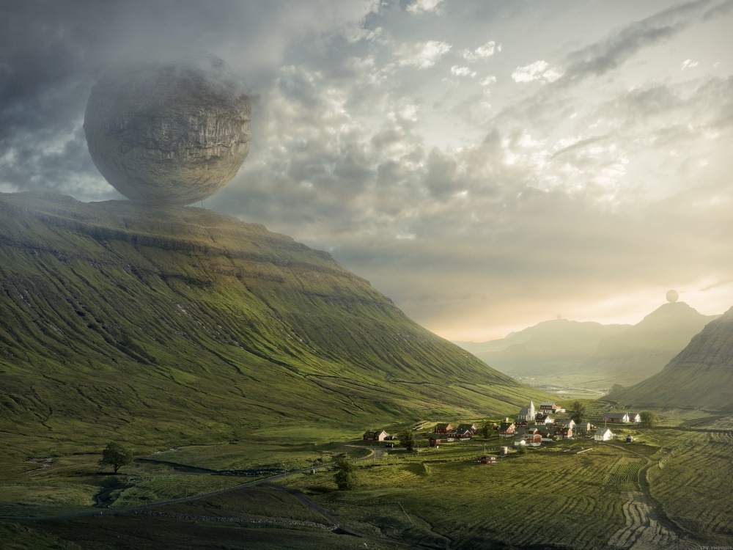
Pictures
Title
Imminent Peril
To predict what this book could be about using the picture, you could ask yourself questions such as:

- Where did the huge rock sphere come from?
- Have the people in the village seen it?
- What might they be thinking?
- What might they be doing?
- What might they be saying?
- How might they react (policeman, farmer, child, journalist/reporter, priest…)?
- What do you think is going to happen next?

Task 1a (Green) Look at the picture carefully and answer questions 1, 2, 4 and 7 using the space below.

1.-------------------------------------------------------------------------------------------------------------------------------------------------------------------------------------------------------------------------------------------------------------------------------------------------------------------------------------------------------------------------------------------------------------------------------------------------------------------------

2. ------------------------------------------------------------------------------------------------------------------------------------------------------------------------------------------------------------------------------------------------------------------------------------------------------------------------------------------------------------------------------------------------------------------------------------------------------------------------

4. ------------------------------------------------------------------------------------------------------------------------------------------------------------------------------------------------------------------------------------------------------------------------------------------------------------------------------------------------------------------------------------------------------------------------------------------------------------------------

7. ------------------------------------------------------------------------------------------------------------------------------------------------------------------------------------------------------------------------------------------------------------------------------------------------------------------------------------------------------------------------------------------------------------------------------------------------------------------------

Task 2a (Amber) Look at the picture carefully and answer questions 1 - 7 using the space below.
For extra challenge, try predicting by including modal verbs in your answers (may, might, could) e.g. I predict that… might… because…, I think… may…because …, I imagine that … could… because

1.-------------------------------------------------------------------------------------------------------------------------------------------------------------------------------------------------------------------------------------------------------------------------------------------------------------------------------------------------------------------------------------------------------------------------------------------------------------------------

2. ------------------------------------------------------------------------------------------------------------------------------------------------------------------------------------------------------------------------------------------------------------------------------------------------------------------------------------------------------------------------------------------------------------------------------------------------------------------------

3. ------------------------------------------------------------------------------------------------------------------------------------------------------------------------------------------------------------------------------------------------------------------------------------------------------------------------------------------------------------------------------------------------------------------------------------------------------------------------

4. ------------------------------------------------------------------------------------------------------------------------------------------------------------------------------------------------------------------------------------------------------------------------------------------------------------------------------------------------------------------------------------------------------------------------------------------------------------------------

5. -------------------------------------------------------------------------------------------------------------------------------------------------------------------------------------------------------------------------------------------------------------------------------------------------------------------------------------------------------------------------------------------------------------------------------------------------------------------------

6. ------------------------------------------------------------------------------------------------------------------------------------------------------------------------------------------------------------------------------------------------------------------------------------------------------------------------------------------------------------------------------------------------------------------------------------------------------------------------

7. ------------------------------------------------------------------------------------------------------------------------------------------------------------------------------------------------------------------------------------------------------------------------------------------------------------------------------------------------------------------------------------------------------------------------------------------------------------------------

Task 3a (Red) In addition to completing task 2, try using adverbs and modal verbs to show how likely something is to happen since there could be several possibilities. Complete your work using the writing lines for task 2. Remember:

Adverbs – show how the action is performed  e.g. I think the villagers would run quickly because they would be afraid.  definitely  certainly  clearly  obviously  surely  quite  likely  probably  possibly  maybe  hardly  undoubtedly | Modal Verbs – a verb added to another one to show how likely, possible, permissible, or obligatory it is for the action to occur  e.g. I predict that the villagers might try to stop the rock sphere from rolling down the hillside.  will  must  shall  ought to  should  can  would  may  might  could

A further way in which we could predict what a text may be about is by using the title to help us.

Task 1b (Green) Look at the titles and pictures of the following book covers, then answer the questions below, next to each picture.

- What do you think the text will be about, and why do you think that?
- What clues are there?
- What might happen in this story?

UFO

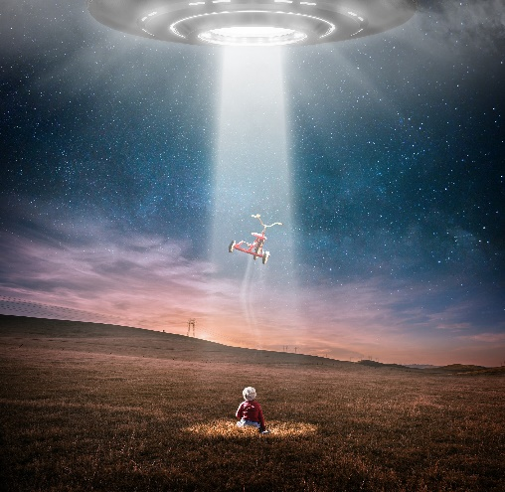

TUNNEL IN THE HEDGE

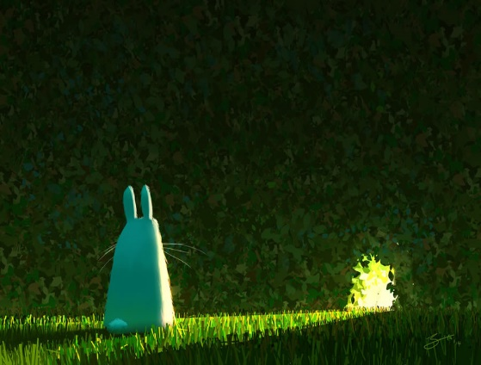

Crocodile

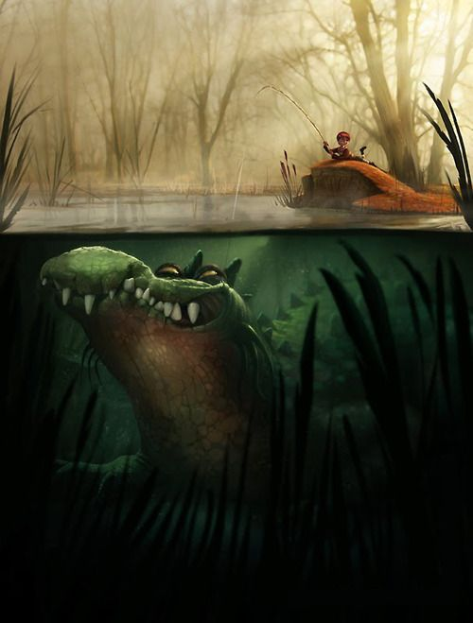

Forest

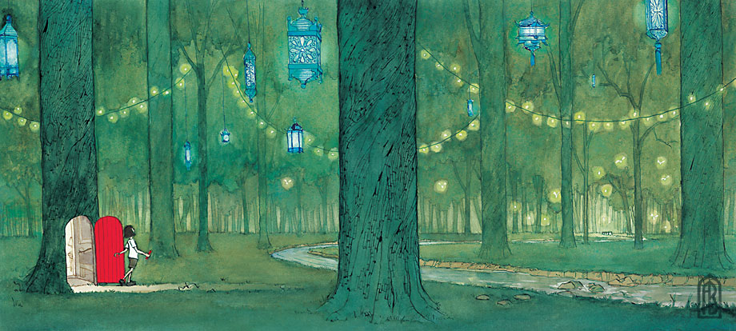

Task 2b (Amber) Look at the titles and pictures of the following book covers, then answer the questions below, next to each picture.

Invisible Girl

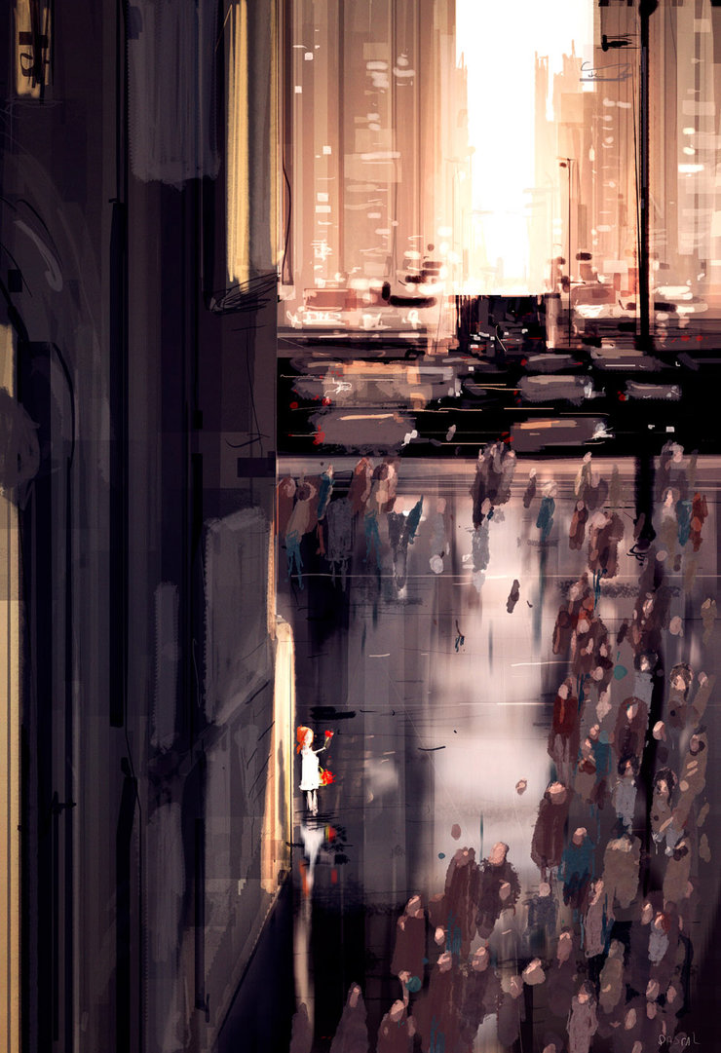

- What do you think the text will be about, and why do you think that?
- Is the girl really invisible?
- Why isn’t anyone looking at her or speaking to her?
- What is she doing?
- What might she be saying?
- Where do you think this is?
- Why is she alone?
- Where does she live?
- What is going to happen to her?
---------------------------------------------------------------------------------------------------------------------------------------------------------------------------------------------------------------------------------------------------------------------------------------------------------------------------------------------------------------------------------------------------------------------------------------------------------------------------------------------------------------------------------------------------------------------------------------------------------------------------------------------------------------------------------------------------------------------------------------------------------------
---------------------------------------------------------------------------------------------------------------------------------------------------------------------------------------------------------------------------------------------------------------------------------------------------------------------------------------------------------------------------------------------------------------------------------------------------------------------------------------------------------------------------------------------------------------------------------------------------------------------------------------------------------------------------------------------------------------------------------------------------------------

Let’s Leave
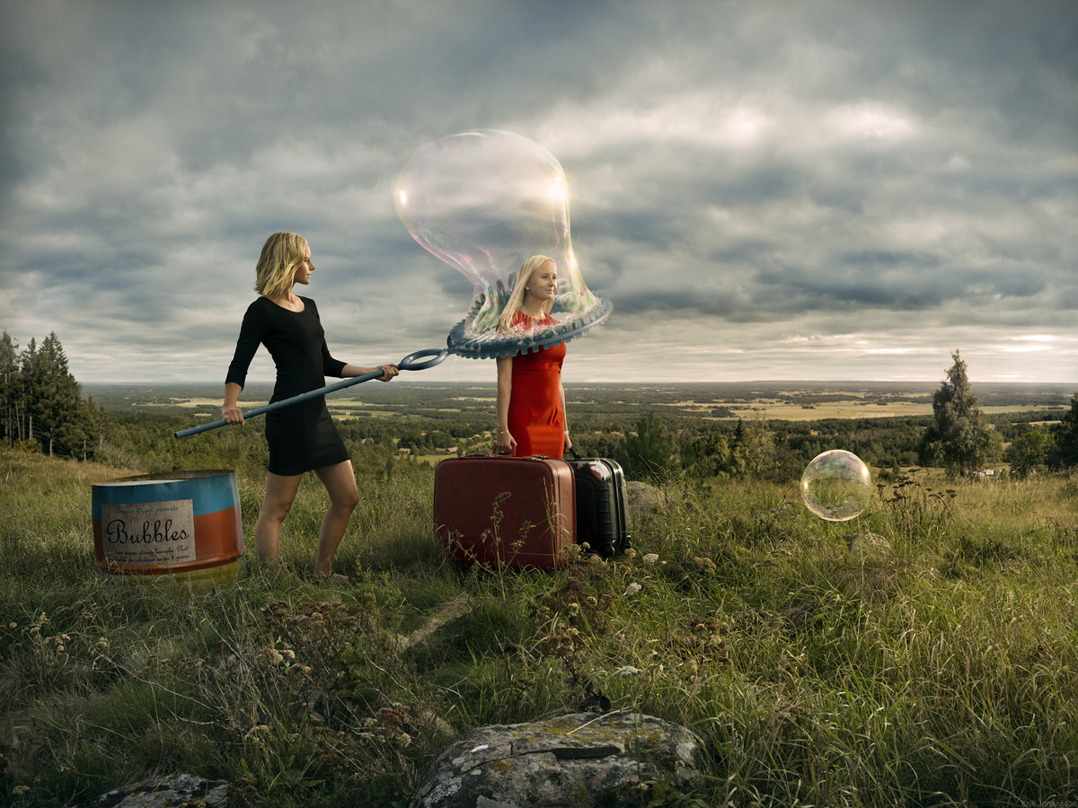

- What do you think the text will be about, and why do you think that?
- What is happening here?
- Why is the woman in red holding two suitcases?
- Why is the woman in black making a bubble over her?
- What will happen when the bubble is completely formed?
- Is there someone inside the smaller bubble?

---------------------------------------------------------------------------------------------------------------------------------------------------------------------------------------------------------------------------------------------------------------------------------------------------------------------------------------------------------------------------------------------------------------------------------------------------------------------------------------------------------------------------------------------------------------------------------------------------------------------------------------------------------------------------------------------------------------------------------------------------------------
------------------------------------------------------------------------------------------------------------------------------------------------------------------------------------------------------------------------------------------------------------------------------------------------------------------------------------------------------------------------------------------------------------------------------------
Task 3b (Red) Look at the titles and pictures of the following book covers, then answer the questions below, next to each picture.

Cracked Matador
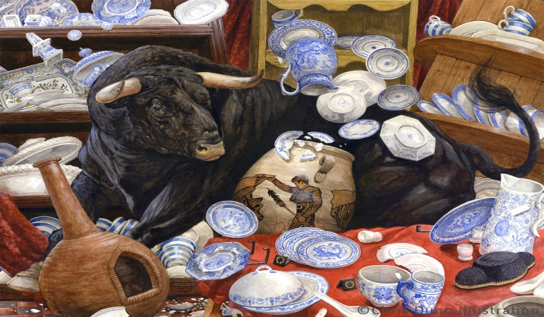

- What do you think the text will be about, and why do you think that?
- Describe the scene.
- Why is the bull in the shop? How did it get there?
- How is it feeling?
- How will the owner of the shop react? Why?
- Tell the ‘before and after’ of this picture.

---------------------------------------------------------------------------------------------------------------------------------------------------------------------------------------------------------------------------------------------------------------------------------------------------------------------------------------------------------------------------------------------------------------------------------------------------------------------------------------------------------------------------------------------------------------------------------------------------------------------------------------------------------------------------------------------------------------------------------------------------------------
------------------------------------------------------------------------------------------------------------------------------------------------------------------------------------------------------------------------------------------------------------------------------------------------------------------------------------------------------------------------------------------------------------------------------------
Old Man of the Woods
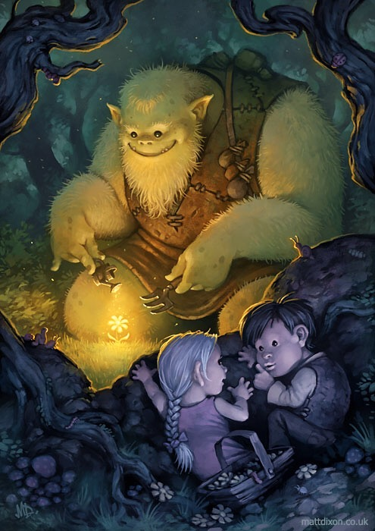
- What do you think the text will be about, and why do you think that?
- What is the ogre doing? Why?
- Why is there a glowing light over the flower? Where is it coming from?
- What do you think is in the pouches on the ogre’s bag strap?
- Why were the children in the woods?
- Does he know that they are watching him?
- Do the children want him to know that they are there?
- Does this remind you of any other stories you know? Why? What’s similar and what’s different?

---------------------------------------------------------------------------------------------------------------------------------------------------------------------------------------------------------------------------------------------------------------------------------------------------------------------------------------------------------------------------------------------------------------------------------------------------------------------------------------------------------------------------------------------------------------------------------------------------------------------------------------------------------------------------------------------------------------------------------------------------------------
------------------------------------------------------------------------------------------------------------------------------------------------------------------------------------------------------------------------------------------------------------------------------------------------------------------------------------------------------------------------------------------------------------------------------------
---------------------------------------------------------------------------------------------------------
------------------------------------------------------------------------------------------------------------------------------------------------------------------------------------------------------------------------------------------------------------------------------------------------------------------------------------------------------------------------------------------------------------------------------------
---------------------------------------------------------------------------------------------------------------------------------------------------------------------------------------------------------------------------------------------------------------------------------------------------------------------------------------------------------------------------------------------------------------------------------------------------------------------------------------------------------------------------------------------

Extension – (All)

- Do any of the stories, from any level, remind you of other stories you’ve read? Which ones and why?
- How did you predict what each story may be about?
- Look at books, magazines and newspaper articles in your house (that you haven’t read), and using the cover only, predict what they could be about. If you don’t have any, use the covers below:

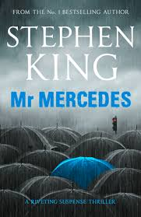 | 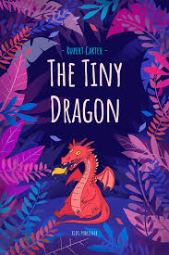 | 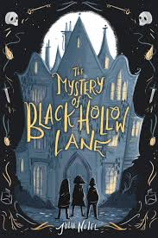
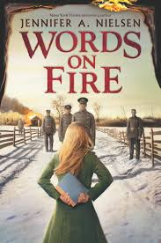 | 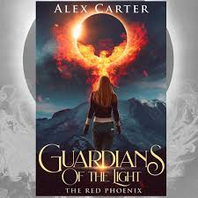 | 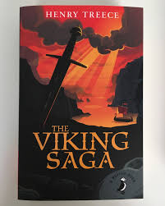

------------------------------------------------------------------------------------------------------------------------------------------------------------------------------------------------------------------------------------------------------------------------------------------------------------------------------------------------------------------------------------------------------------------------------------
------------------------------------------------------------------------------------------------------------------------------------------------------------------------------------------------------------------------------------------------------------------------------------------------------------------------------------------------------------------------------------------------------------------------------------
------------------------------------------------------------------------------------------------------------------------------------------------------------------------------------------------------------------------------------------------------------------------------------------------------------------------------------------------------------------------------------------------------------------------------------
------------------------------------------------------------------------------------------------------------------------------------------------------------------------------------------------------------------------------------------------------------------------------------------------------------------------------------------------------------------------------------------------------------------------------------
------------------------------------------------------------------------------------
------------------------------------------------------------------------------------------------------------------------------------------------------------------------------------------------------------------------------------------------------------------------------------------------------------------------------------------------------------------------------------------------------------------------------------

LO: To be able to use techniques to understand what we read – Clarify

We have considered our first technique in helping us to understand what we are reading – predicting what the text may be about before we read it.
In this lesson, we will learn to clarify our understanding of what we read before, or during, our reading. What does this mean?

Clarify – To make clear or easier to understand

Therefore, to predict what a text may be about using the picture and the title, we may need to check we understand the words in the title first. We may need to clarify our understanding.
For example, look at the following book cover and title:

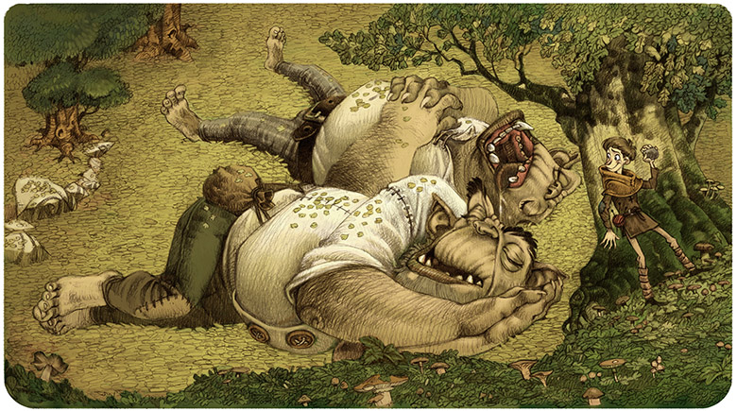
Valiant Knave
You may have an idea what this book will be about by examining the picture, but if you clarify your understanding of the word ‘valiant’ and ‘knave’, by checking the definition in the dictionary, your prediction may be much more accurate.

Task 1a (Green) Using the picture only, predict what you think this story could be about by answering the questions below:

- Who do you think the boy is?
---------------------------------------------------------------------------------------------------------------------------------------------------------------------------------------------------------------------------------------------------------------------------------------------------------------------------------------------------------------------------------------------------------------------------------------------------------------------------
- Who are the characters lying down?
----------------------------------------------------------------------------------------------------------------------------------------------------------------------------------------------------------------------------------------------------------------------------------------------------------------------------------------------------------------------------------------------------------------------------------------------------------------------------
- Why are the characters lying down laughing?
----------------------------------------------------------------------------------------------------------------------------------------------------------------------------------------------------------------------------------------------------------------------------------------------------------------------------------------------------------------------------------------------------------------------------------------------------------------------------
- What do you think the boy is going to do? Why?
--------------------------------------------------------------------------------------------------------------------------------------------------------------------------------------------------------------------------------------------------------------------------------------------------------------------------------------------------------------------------------
Task 1b (Green) Use a dictionary to look up the words in the title, then answer the following questions below the table:
Words in Title | Definition (Meaning)
Valiant

Knave

- What do you think is going to happen next?
- How did clarifying the meaning of the words in the title help you to answer?
- Has your answer changed from your response in question 4 on page 16?
-------------------------------------------------------------------------------------------------------------------------------------------------------------------------------------------------------------------------------------------------------------------------------------------------------------------------------------------------------------------------------------------------------------------------------------------------------------------------------------------------------------------------------------------------------------------------------------------------------------------------------------------------------------------
----------------------------------------------------------------------------------------------------------------------------------------------------------------------------------------------------------------------------------------------------------------------------------------------------------------------------------------------------------------------------------------------------------------------------------------------------------------------------
Task 2a (Amber) Complete task 1a in the space provided in green, then answer the additional questions below:
- What do you think happened before the situation in the picture?
---------------------------------------------------------------------------------------------------------------------------------------------------------------------------------------------------------------------------------------------------------------------------------------------------------------------------------------------------------------------------------------------------------------------------------------------------------------------------
- What do you think the boy is thinking?
---------------------------------------------------------------------------------------------------------------------------------------------------------------------------------------------------------------------------------------------------------------------------------------------------------------------------------------------------------------------------------------------------------------------------------------------------------------------------
--------------------------------------------------------------------------------------------------------
Task 2b (Amber) Use a dictionary to look up the words in the title, then answer the following questions:
- What do you think is going to happen next?
- How did clarifying the meaning of the words in the title help you to answer?
- Has your answer changed from your response in question 4 on page 16?
Words in Title | Definition (Meaning)
Valiant
Knave
----------------------------------------------------------------------------------------------------------------------------------------------------------------------------------------------------------------------------------------------------------------------------------------------------------------------------------------------------------------------------------------------------------------------------------------------------------------------------------------------------------------------------------------------------------------------------------------------------------------------------------------------------------------------------------------------------------------------------------------------------------------

Task 3a (Red) Complete task 2a and 2b (in the spaces provided above), but ensure answers are written:

- in full sentences
- using modal verbs e.g. may, might, could, will
- using adverbs e.g. quickly, silently, eerily

Extension – (All) Using the titles only, clarify your understanding of what the following books may be about by checking the meanings of the words in the titles. Use a dictionary to help you.

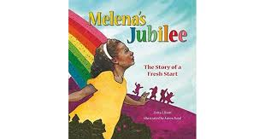 | 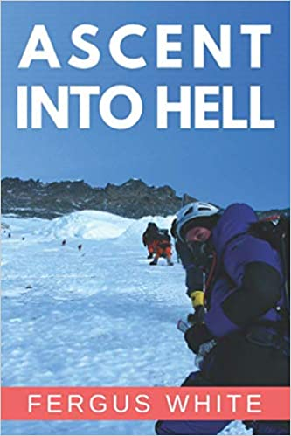 | 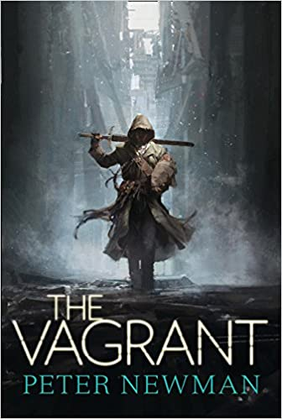
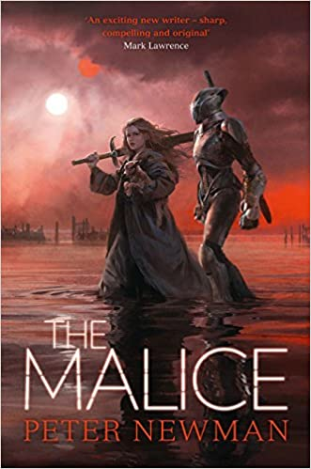 | 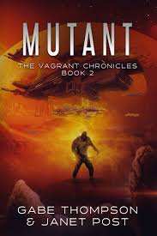 | 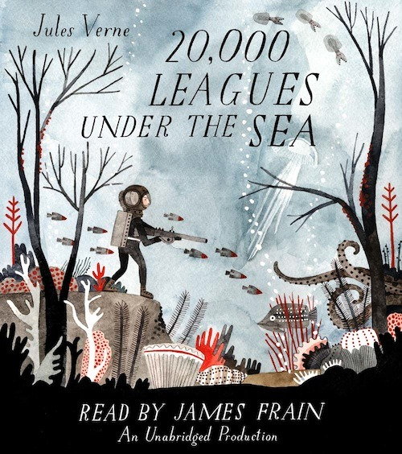

- Melena’s Jubilee

Difficult Words in Title | Definition of Word
Jubilee

What the book may be about:
--------------------------------------------------------------------------------------------------------------------------------------------------------------------------------------------------------------------------------------------------------------------------------------------------------------------------------------------------------------------------------------------------------------------------------------------------------------------------------------------------------------------------------------------------------------------------------------------------------------------------------------------------------------------

- Ascent into Hell
Difficult Words in Title | Definition of Word
Ascent

What the book may be about:
--------------------------------------------------------------------------------------------------------------------------------------------------------------------------------------------------------------------------------------------------------------------------------------------------------------------------------------------------------------------------------------------------------------------------------------------------------------------------------------------------------------------------------------------------------------------------------------------------------------------------------------------------------------------
- The Vagrant
Difficult Words in Title | Definition of Word
Vagrant

What the book may be about:
--------------------------------------------------------------------------------------------------------------------------------------------------------------------------------------------------------------------------------------------------------------------------------------------------------------------------------------------------------------------------------------------------------------------------------------------------------------------------------------------------------------------------------------------------------------------------------------------------------------------------------------------------------------------

- The Malice
Difficult Words in Title | Definition of Word
Malice

What the book may be about:
--------------------------------------------------------------------------------------------------------------------------------------------------------------------------------------------------------------------------------------------------------------------------------------------------------------------------------------------------------------------------------------------------------------------------------------------------------------------------------------------------------------------------------------------------------------------------------------------------------------------------------------------------------------------
- Mutant
Difficult Words in Title | Definition of Word
Mutant

What the book may be about:
--------------------------------------------------------------------------------------------------------------------------------------------------------------------------------------------------------------------------------------------------------------------------------------------------------------------------------------------------------------------------------------------------------------------------------------------------------------------------------------------------------------------------------------------------------------------------------------------------------------------------------------------------------------------

- 20,000 Leagues Under the Sea
Difficult Words in Title | Definition of Word
Leagues

What the book may be about:
--------------------------------------------------------------------------------------------------------------------------------------------------------------------------------------------------------------------------------------------------------------------------------------------------------------------------------------------------------------------------------------------------------------------------------------------------------------------------------------------------------------------------------------------------------------------------------------------------------------------------------------------------------------------
LO: To be able to use techniques to understand what we read – Question

After we read a text, we need to make sure that we really understand what we have read. How can we do this?

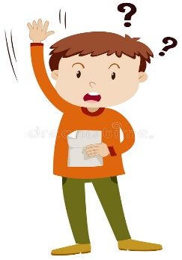
Ask Questions

There are different types of questions we could ask. Some are about what is obvious; what is happening in the text. These are called:

Literal Questions

Other types of questions are about what is less obvious. The text doesn’t tell us the answers to these directly, but we can work out the answer from clues in the text. These are called:

Inferential Questions

Let’s practise answering both types of questions after reading the following text. (Green level text first)

Task 1 (Green) After reading the text above, answer the following questions. They are labelled ‘L’ for literal questions (the answer will be in the text and you can simply find and copy it) and ‘I’ for inferential questions. Inferential questions require you to say what you think may be the answer based on your own knowledge and clues in the text.

I
L
L
L
L
L
L

Task 2 (Amber) Read the text below, then answer the questions on the following page.

Task 2 (Amber) Answer the questions below. They are labelled ‘L’ for literal questions (the answer will be in the text and you can simply find and copy it) and ‘I’ for inferential questions. Inferential questions require you to say what you think may be the answer based on your own knowledge and clues in the text.

I
L
L
L
L
L
I
I

Task 3 (Red) Read the text below, then answer the questions on the following page.
Task 3 (Red) Answer the questions below. They are labelled ‘L’ for literal questions (the answer will be in the text and you can simply find and copy it) and ‘I’ for inferential questions. Inferential questions require you to say what you think may be the answer based on your own knowledge and clues in the text.

I
L
L
L
L
L
I
I
I
L

Task (All) Extension – Practise answering inference questions on the following cards. These require you to use the clues in the picture and connect this to your own knowledge.
The literal information is on the top of each card.
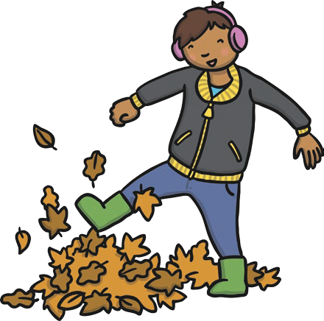

The boy is kicking leaves.
What time of year could it be? How is the boy feeling?
Where might the boy be?
What could happen next?

--------------------------------------------------------------------------------------------------------------------------------------------------------------------------------------------------------------------------------------------------------------------------------------------------------------------------------------------------------------------------------------------------------------------------------------------------------------------------------------------------------------------------------------------------------------------------------------------------------------------------------------------------------------------

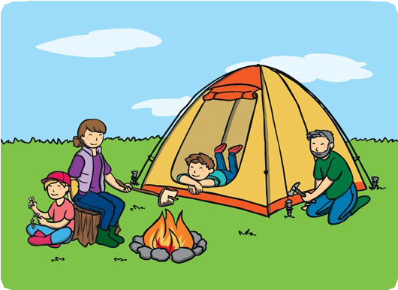
The family is camping.
Where could they be? Where will they sleep? How might they cook their food?
What will they do while they’re camping?

--------------------------------------------------------------------------------------------------------------------------------------------------------------------------------------------------------------------------------------------------------------------------------------------------------------------------------------------------------------------------------------------------------------------------------------------------------------------------------------------------------------------------------------------------------------------------------------------------------------------------------------------------------------------
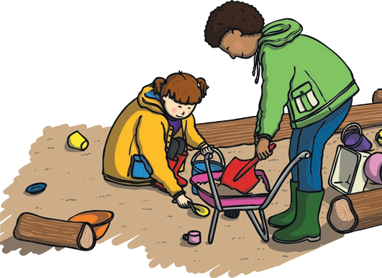

Some friends are playing outside.
What else might they play with?
Where might they be?
What could they be saying?
What could the weather be like?

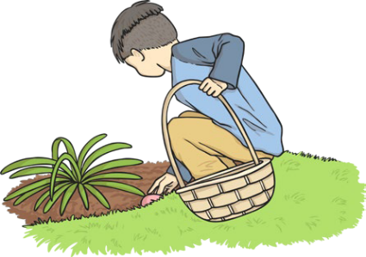
--------------------------------------------------------------------------------------------------------------------------------------------------------------------------------------------------------------------------------------------------------------------------------------------------------------------------------------------------------------------------------------------------------------------------------------------------------------------------------------------------------------------------------------------------------------------------------------------------------------------------------------------------------------------
A brother and sister are looking for chocolate eggs.
Where could they be?
What time of year is it?
Why are they looking for chocolate eggs?
Who might have hidden the eggs?

------------------------------------------------------------------------------------------------------------------------------------------------------------------------------------------------------------------------------------------------------------------------------------------------------------------------------------------------------------------------------------------------------------------------------------------------------------------------------------------------------------------------------------------------------------------------------------------------------------
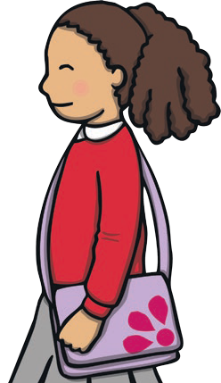
The girl is starting at a new school.
Why might the girl be at a new school? How might she be feeling?
Who might be holding her hand?
What might the adult say?

------------------------------------------------------------------------------------------------------------------------------------------------------------------------------------------------------------------------------------------------------------------------------------------------------------------------------------------------------------------------------------------------------------------------------------------------------------------------------------------------------------------------------------------------------------------------------------------------------------

LO: To be able to use techniques to understand what we read – Summarise
To demonstrate that we really understand a text, we need to be able to summarise it.
What does this mean?
Summarise - to express the most important facts or ideas about something in a short and clear form
Therefore, after reading a text, you need to be able to explain the key facts.
For example, look at this summary of the well-known ‘Three Little Pigs’ story.
Key Fact = Three pigs that were brothers
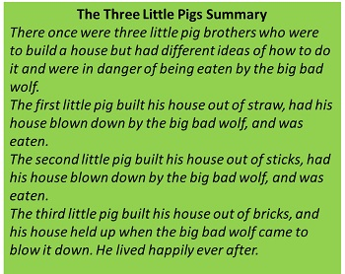
Key Fact = The brick house was strongest
And protected them from the wolf
Key Fact = Each house built of different material
Key Fact = Different ideas about how to build their house

To help us summarise, we sometimes need to think about what we know already so we can:
- Be clear and concise and summarise only the part we have been asked to
- Avoid writing too much (re-writing)
Task (Green) Complete the following activity on the book you read last term. Put the main ideas into your own words.

Task 2 (Amber) and Task 3 (Red) Read the text below from ‘How to Train Your Dragon’ and highlight the key facts (no more than around 25 words). Next, put them into a summary of what happens (about the size of a paragraph).

-----------------------------------------------------------------------------------------------------------------------------------------------------------------------------------------------------------------------------------------------------------------------------------------------------------------------------------------------------------------------------------------------------------------------------------------------------------------------------------------------------------------------------------------------------------------------------------------------------------------------------------------------------------------------------------------------------------------------------------------------------------------------------------------------------------------------------------------------------------------------------------------------------------------------------------------------------------------------------------------------
------------------------------------------------------------------------------------------------------------------------------------------------------------------------------------------------------------------------------------------------------------------------------------------------------------------------------------------------------------------------------------------------------------------------------------------------------------------------------------------------------------------------------------------------------------------------------------------------------------------------------------------------------------------------------------------------------------------------------------------------------------------------------------------------------------------------------------------------------------------------------------------------------------------------------------------------------------------------------------------------------------------------------------------------------------------------------------------------------------------------------------------------------------------------------------------------------------------------------------------------------------------------------------------------

Task (All) Can you remember the four techniques to help us understand what we read? Check back in this booklet and define each term below:

Predict  ------------------------------------------------------------------------------------------------------------------------------------------------------------------------------------------------------------------  ------------------------------------------------------------------------------------------------------------------------------------------------------------------------------------------------------------------  ------------------------------------------------------------------------------------------------------------------------------------------------------------------------ | Clarify  ---------------------------------------------------------------------------------------------------------------------------------------------------------------------------------------------------------------------------------  ---------------------------------------------------------------------------------------------------------------------------------------------------------------------------------------------------------------------------------  ------------------------------------------------------------------------------------------------------------------------------------------------------------------------------------
Question  ------------------------------------------------------------------------------------------------------------------------------------------------------------------------------------------------------------------  ------------------------------------------------------------------------------------------------------------------------------------------------------------------------------------------------------------------  ------------------------------------------------------------------------------------------------------------------------------------------------------------------------ | Summarise  ---------------------------------------------------------------------------------------------------------------------------------------------------------------------------------------------------------------------------------  ---------------------------------------------------------------------------------------------------------------------------------------------------------------------------------------------------------------------------------  ------------------------------------------------------------------------------------------------------------------------------------------------------------------------------------

