Physics lesson 3 (Year 7)

Floating and sinking.
https://www.bbc.co.uk/bitesize/articles/zbkkvwx

Learn
When something is in water, there are two forces acting on it. Its weight and the force of the water pushing up, the upthrust.

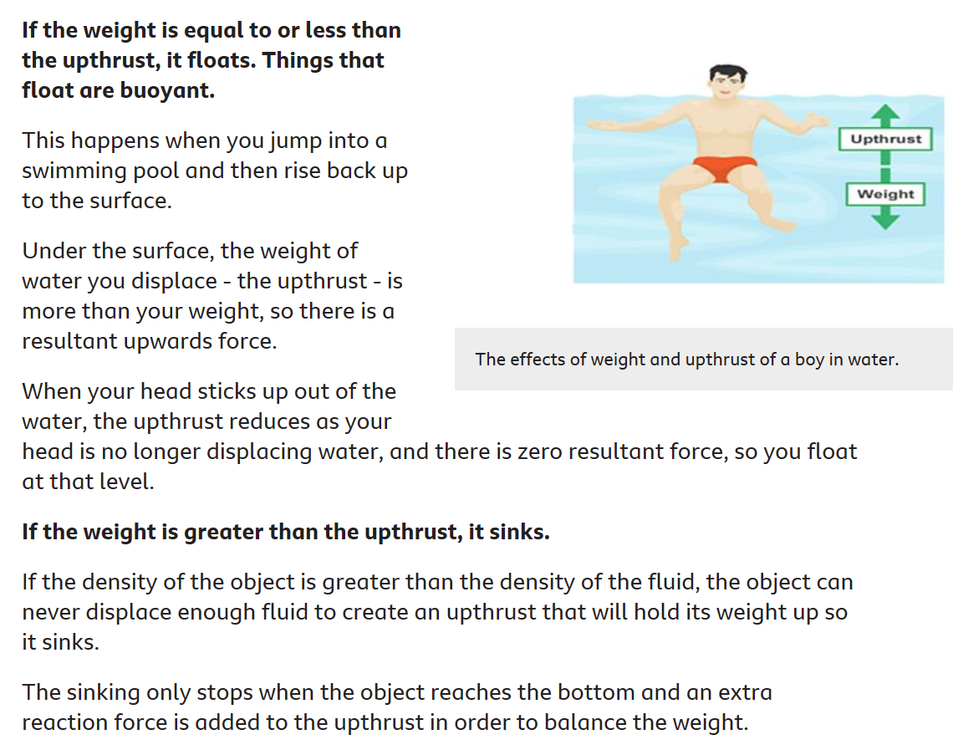Activity 1- Quick Quiz
Q1

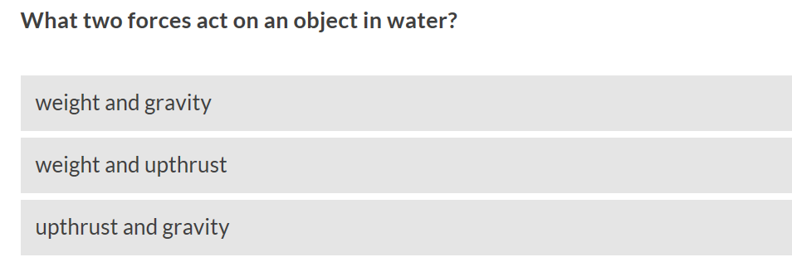

Q2

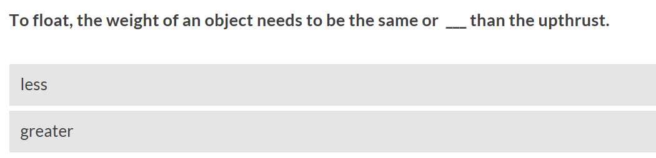

Q3

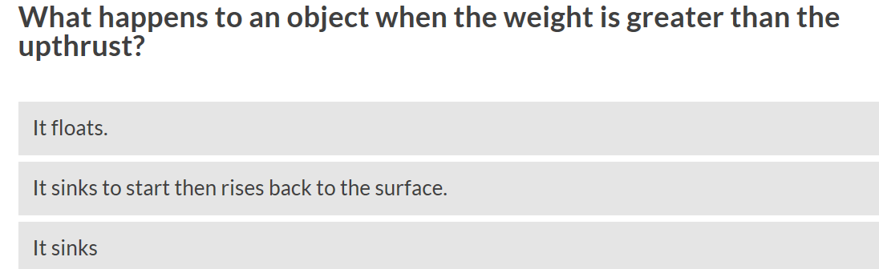

Q4

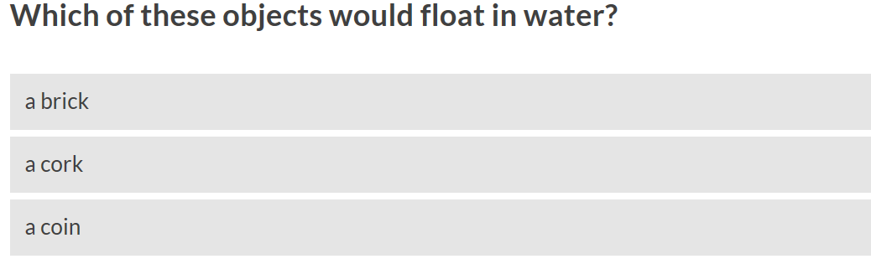

Q5

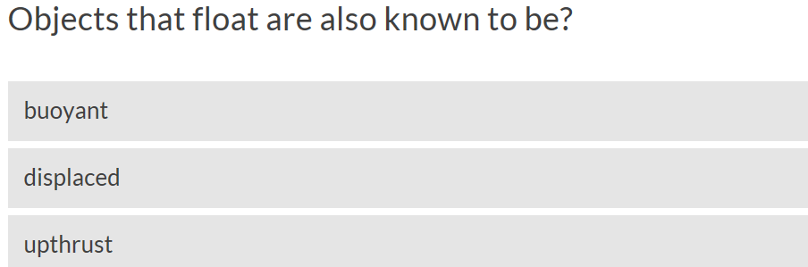

Activity 2
Carry out your own investigation to see which household objects float or sink.
You could use a bath, a sink, a bowl or a paddling pool to see whether the object floats or sinks!
(Remember: don't put anything electrical in water!)

Make a prediction whether you think the object will float or sink before testing it.
You could record your findings in a table. You may wish to use these headings object, prediction, result

CHALLENGE: Can you explain to another member of your family, why an object floats or sinks? These key words might help: upthrust, weight, buoyancy, greater, less

Activity 3- Read the information on the sheet titled “The Plimsoll line”, then answer all of the questions.

