Key Stage 4 Science. Lesson 5

Exothermic and endothermic reactions

Look online at-https://www.bbc.co.uk/bitesize/articles/zr6mkty

Learn- Learn about the reactions of metals with acids, water and oxygen.

Energy during a chemical reaction
Energy is conserved in chemical reactions, so the total amount of energy in the universe at the end of a reaction is the same as it was before the reaction.
When a chemical reaction happens, energy is transferred to or from the surroundings.

Exothermic reactions
When energy is transferred to the surroundings, this is called an exothermic reaction. The temperature of the surroundings increases.
Examples of exothermic reactions include:-
- combustion reactions
- most neutralisation reactions
- respiration
Everyday uses of exothermic reactions include self-heating cans and hand warmers.
I find it easier to remember that the prefix ex- means out. For example exhale and exit.

Endothermic reactions
When energy is taken in from the surroundings, this is called an endothermic reaction. The temperature of the surroundings decreases.
Examples of endothermic reactions include:
- thermal decomposition reactions
- photosynthesis.

Everyday uses of endothermic reactions include instant ice packs which can be used to treat sports injuries. I find it helps to remember endothermic reactions take in energy, same as an endoscope is camera that enters into the body.

Activity 1-
Complete the worksheet on exothermic and endothermic reactions.
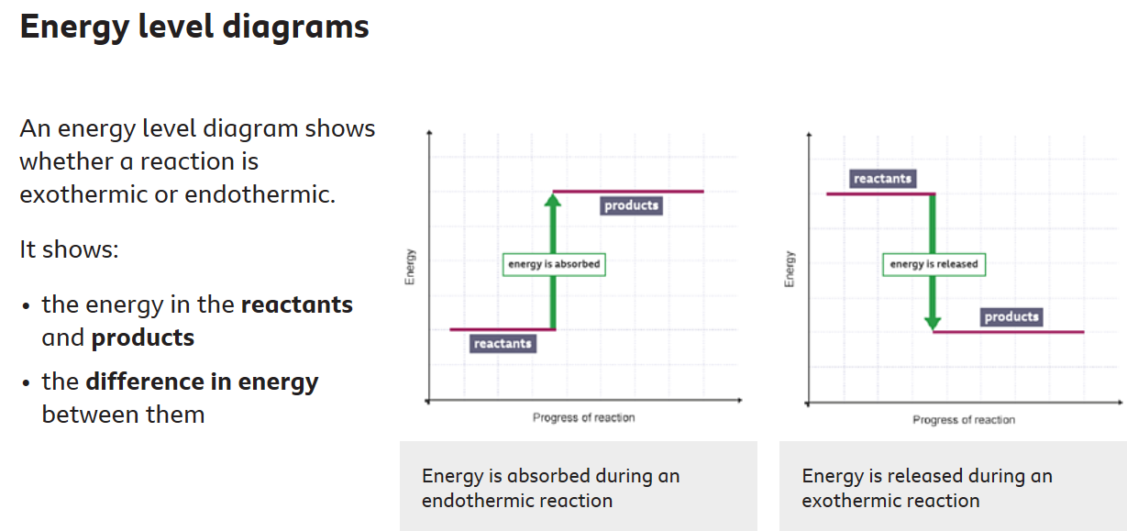

Explaining energy changes

Energy is transferred when bonds are broken or are formed.
During a chemical reaction:
- bonds in the reactants are broken
- new bonds are made in the products
The difference between the energy needed to break bonds and the energy released when new bonds are made determines the type of reaction.
A reaction is:
- exothermic if more heat energy is released in making bonds in the products than is taken in when breaking bonds in the reactants
- endothermic if less heat energy is released in making bonds in the products than is taken in when breaking bonds in the reactants

Activity 2- Quick Quiz. Circle the correct answers

1. What happens to energy during a chemical reaction?

a. INCREASES b. DECREASES c. STAYS THE SAME

2. Which type of reaction absorbs ebnergy from the surroundings?

a. EXOTHERMIC b. ENDOTHERMIC

3. What happens to the temperature during an exothermic reaction? a INCREASES b. DECREASES c. STAYS THE SAME

4. Which of the below is an ENDOTHERMIC reaction

a. NEUTRALISATION b. PHOTOSYNTHESIS c. COMBUSTION

5. In an ENDOTHERMIC reaction is the energy of the PRODUCTS higher or lower than the energy of the REACTANTS

a. HIGHER b. LOWER

Activity 3- Complete the Activity 3 worksheet with the GCSE exam style question

