Directed number helpsheet:

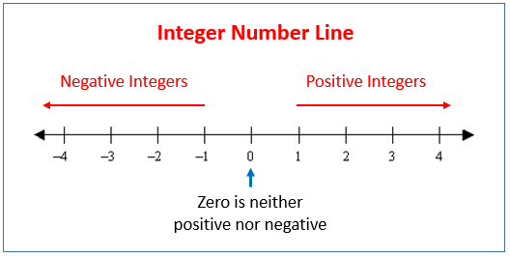

So, using number line:

-4 is smaller (lower, colder) than -2
-100 is lower than -3
0 is larger than -10

Adding and subtracting: Always use a number line. Eg: -5 – 6 we think of as starting on -5, then moving back 6. So the answer is -11.

9 - -3 means start on 9 then add (two minus makes a positive) 3. So answer is 12.

Multiplying and dividing:

We just do the sum as usual, then decide if answer is positive or negative
++ = +

+- = -

-+ = _

- - = +

Eg:

-8 x 3 = -24

But -8 x -3 = 24

