Year 9
English Work Pack 3
Parents/Carers – only complete as much, or as little, of these booklets as your circumstances allow at this difficult time.

Welcome to this week’s English topic!

The Travel Agent

We will have fun learning to:

- Identify a range of writing required in this industry
- Plan and write a formal letter
- Plan and write an email
- Plan and write an advert for a travel brochure

Choose your own task level (green = easy, amber = slightly harder, red = challenge)

LO: To be able to identify a range of writing required in the travel industry

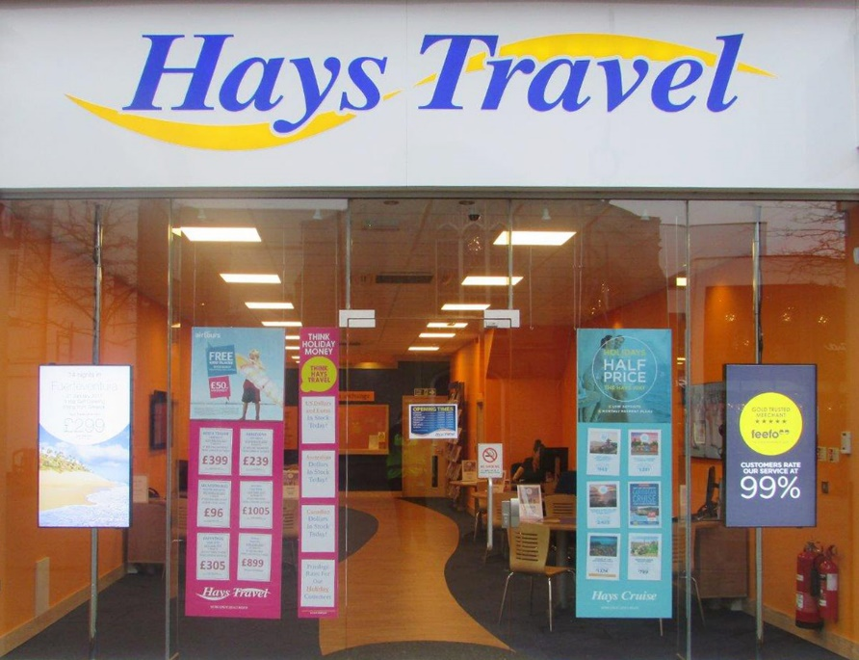

If you live near school, you may have noticed ‘Hays Travel’ agency in Crossgates shopping centre. If not, you may have noticed travel agents like ‘Thomas Cook’ or ‘STA’ in the city centre. Have you ever wondered what the goes on inside? What sort of writing is required of a travel agent?
Look at the following text examples commonly found in a travel agency:
Travel Brochures Formal Letters to customers
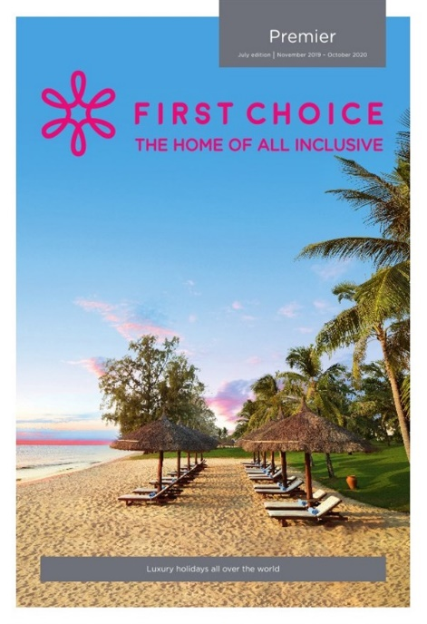 | 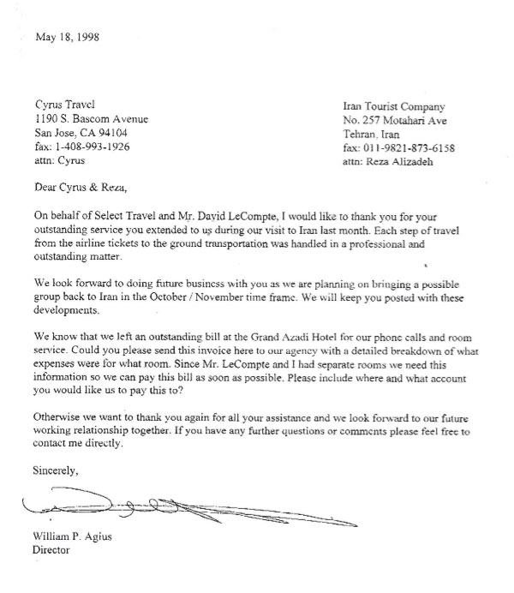
Emails to and from customers  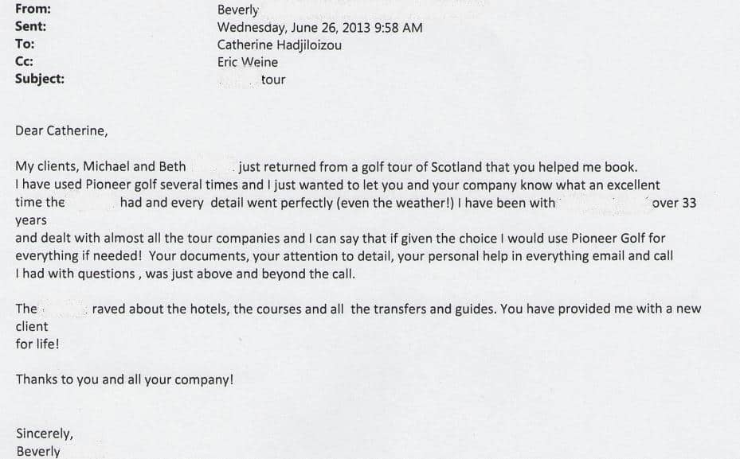 | Booking Forms  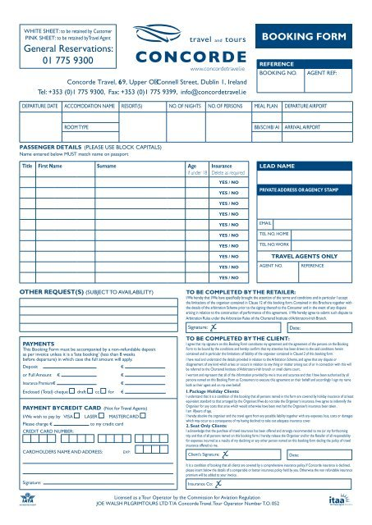
In work pack number two, we learned to identify the purpose of a variety of texts by looking at their layout. We also learned that texts often have a target audience and that the language and tone should suit this to make them more accessible.

Task 1 (Green) To recap last week’s work, identify the purpose and target audience of the texts above.

Text | Purpose – Explain | Target Audience – Explain
Travel Brochure

Formal Letter

Email

Booking Form

Task 2 (Amber)In addition to completing task one, annotate the texts to identify their various layout features and explain how these make the text easier to read.

Text | Layout Features  e.g. bold font, boxes, images | How the features help the reader  e.g. subheadings divide the text into shorter sections to make a long text easier to read
Travel Brochure

Formal Letter

Email

Booking Form

Task 3 (Red) In addition to completing text one and two, examine the language and tone of two of the texts. Is the tone formal/informal and why? Select words to support your answer. Are there any subject specific words used?

Text | Language | Tone
Travel Brochure

Formal Letter

Email

Booking Form

LO: To be able to be able to recognise the features and language used in a formal letter
Key Terms
Cover Letter – A letter to introduce the travel agent to the client and explain the accompanying contents of the envelope e.g. tickets, hotel information

Itinerary – A timetable of the arrangements for a tour-type holiday or holiday which may include several stops before reaching the destination

Travel agents often write letters to clients to inform them of arrangements for their holiday. The letters are sometimes short and simply outline the contents of the envelope which could contain tickets. This is called a cover letter. At other times, a longer letter may be required outlining details of an itinerary if the customer is going on a tour.
Look at the typical layout of a formal letter.

Sender’s Address
-----------------------
-----------------------
-----------------------
-----------------------
Date
-----------------------
Recipient’s Address
-----------------------
-----------------------
-----------------------
-----------------------

Dear………………….
---------------------------------------------------------------------------------------------------------------------------------------------------------------------------------------------------------------------------------------------------------------------------------------------------------------------------------------

----------------------------------------------------------------------------------------------------------------------------------------------------------------------------------------------------------------------------------------------------------------------------------------------------------------------------------------------------------------------------------------------------------------------------------------------------

Yours sincerely, (if you know the recipient’s name)
Yours faithfully, (if you do not know the recipient’s name)
Sender’s Name
Task 1 (Green) Cut out the various parts of the formal letter below. Arrange them into the correct order and stick them on to a blank A4 sheet of paper. Use the guide on p8 to help you. In addition, practise writing the correct opening and matching closing phrases with correct spelling and punctuation.

The Manager
Sunshine Hotel
Barcelona
Spain

Yours faithfully,

I am looking forward to staying with you and if you have any questions, please do not hesitate to contact me.

I expect to arrive between 5pm – 8pm and I would like to reserve a table in your restaurant as I wish to enjoy a meal cooked by your award-winning chef and his team. I will be driving to your hotel, so I would be grateful if you could arrange a car parking space for me so that I may leave my car and enjoy one of the many rail excursions your hotel has arranged for me. If you could arrange a non-smoking room with a view over your beautiful gardens, I would be delighted.

I am writing to outline the arrangements for my stay at your hotel during the week commencing April 28th 2020.

Sam Brown
12 Compton Road
Leeds
LS12 9HT
UK

Sam Brown

Dear Sir/Madam

Salutation - the opening phrase Valediction – the closing phrase

Practise writing the matching phrases. Check p8 to help you.

Salutation (Notice the punctuation in red) | Matching Valediction  (Yours sincerely, or Yours faithfully,)  + sender’s name + sender’s name
Dear Mr Brown,

Dear Sir/Madam,

Write your own salutation and valediction

Practise spelling the valediction phrases correctly below (remember to use a capital ‘Y’ for ‘Yours’ and a lower case ‘s’ or ‘f’ for sincerely and ‘faithfully’:

Yours sincerely | Yours faithfully

Task 2 (Amber) In addition to completing the exercises in task one, can you select words or phrases from the formal letter layout exercise on p9 that show that it is a formal letter?

Remember:
Formal language – serious, official, businesslike, subject specific words, avoids contractions e.g. ‘I will’ instead of ‘I’ll’
Informal Language – chatty, more relaxed, used more in social situations

Examples of formal words or phrases in the letter on p9

1.

2.

3.

4.

5.

6.

7.

Task 3 (red) In addition to completing the exercises in task one and two:
a) Can you spot any subject specific words or phrases in the letter on p9?
b) Use a dictionary to define the subject specific words below (some of them have been defined already, so revise by checking back through the booklet).
c) Use them in a sentence of your own.

Subject specific words (used by travel agents and other businesses in formal situations) | Example of word used in a sentence
Client

Recipient

Invoice

Commence/ Commencing

Excursion

Reserve

Outstanding (e.g. payment)

Transportation

Salutation

Valediction

Destination

Accommodation

LO: To be able to be able to write a formal letter

Scenario
Imagine that you are a travel agent. A client has asked you to book a holiday to one of the beautiful destinations below:

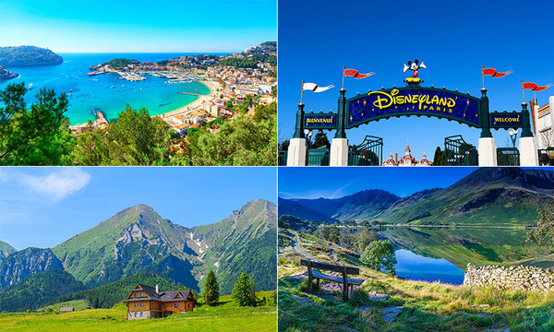
France
Ireland
Austria
Malta

You have:
- booked airline tickets for the customer
- arranged hotel accommodation
- booked daily excursions (trips) to exciting places
- arranged a taxi transfer from the client’s house to the airport, and from the airport to the hotel in your chosen country.

You need to inform the client of these arrangements in a formal letter.
Task 1 (Green) Choose a destination then using the template and sentence starters below, write a formal letter to your client informing them of the arrangements you have made (remember, details don’t have to be true, so names of hotels and places to visit etc… can be imaginary).

Dear………………………………………

I am writing to inform you that I have booked -----------------------------------------------------------------------------------------------------------------------------------------------------------------------------------------------------------------------

I have booked your airline tickets to----------------------------------------------------------------------------------------------------------------------------------------

You will be leaving on-------------------------------------------------------------------------------------------- and returning on------------------------------------------------------------------------------------------------------------------------------------

Your hotel accommodation will be at-----------------------------------------------------------------------------------------------------------------------------------------------------------------------------------------------------------------------------------

I have booked daily excursions to--------------------------------------------------------------------------------------------------------------------------------------------------------------------------------------------------------------------------------------------------------------------------------------------------------------------------------------------------------------------------------------------------------------------------------------------------------------------------------------------------------------------------------------------------------------------------------------------------------------------------------------------------------------------------------------------------------------------
For your convenience, I have arranged taxi transport from-----------------------------------------------------------------------------------------------------------------------------------------------------------------------------------------------------------------------------------------------------------------------------------------------------------------------------------------------------------------------------------------------
I hope these arrangements meet your requirements. Please feel free to contact me with any questions you may have.

Yours----------------------------------------
------------------------------------------------

Task 2 (Amber) Choose a destination then using the template, write a formal letter to your client informing them of the arrangements you have made (remember, details don’t have to be true, so names of hotels and places to visit etc… can be imaginary).

------------------------------------------

---------------------------------------------------------------------------------------------------------------------------------------------------------------------------------------------------------------------------------------------------------------------------------------------------------------------------------------------------------------------------------------------------------------------------------------------------------------------------
----------------------------------------------------------------------------------------------------------------------------------------------------------------------------------------
--------------------------------------------------------------------------------------------
-------------------------------------------------------------------------------------------- ---------------------------------------------------------------------------------------------------------------------------------------------------------------------------------------------------------------------------------------------------------------------------------------------------------------------------------------------------------------------------------------------------------------------------------------------------------------------------

-------------------------------------------------------------------------------------------------------------------------------------------------------------------------------------------------------------------------------------------------------------------------------------------------------------------------------------------------------------------------------
----------------------------------------------------------------------------------------------------------------------------------------------------------------------------------------------------------------------------------------------------------------------------------------------------------------------------------------------------------------------------------------------------------------------------------------------------------------------------------------------------------------------------------------------------------------------------------------------------------------------------------------------------------------------------------------------------------------------------------------------------------------
----------------------------------------------------------------------------------------------------------------------------------------------------------------------------------------------------------------------------------------------------------------------------------------------------------------------------------------------------------------------------------------------------------------------------------------------------------------------------

-----------------------------------------------
-----------------------------------------------

Task 3 (Red) Choose a destination and write a formal letter to your client informing them of the arrangements you have made (remember, details don’t have to be true, so names of hotels and places to visit etc… can be imaginary). Use the correct formal letter layout. In addition, try to use the subject specific and formal language (that you defined in the previous task) within your letter.

-------------------------------------------------------------------------------------------------------------------------------------------------------------------------------------------------------------------------------------------------------------------------------------------------------------------------------------------------------------------------------
----------------------------------------------------------------------------------------------------------------------------------------------------------------------------------------------------------------------------------------------------------------------------------------------------------------------------------------------------------------------------------------------------------------------------------------------------------------------------------------------------------------------------------------------------------------------------------------------------------------------------------------------------------------------------------------------------------------------------------------------------------------
----------------------------------------------------------------------------------------------------------------------------------------------------------------------------------------------------------------------------------------------------------------------------------------------------------------------------------------------------------------------------------------------------------------------------------------------------------------------------
-------------------------------------------------------------------------------------------------------------------------------------------------------------------------------------------------------------------------------------------------------------------------------------------------------------------------------------------------------------------------------
----------------------------------------------------------------------------------------------------------------------------------------------------------------------------------------------------------------------------------------------------------------------------------------------------------------------------------------------------------------------------------------------------------------------------------------------------------------------------------------------------------------------------------------------------------------------------------------------------------------------------------------------------------------------------------------------------------------------------------------------------------------
----------------------------------------------------------------------------------------------------------------------------------------------------------------------------------------------------------------------------------------------------------------------------------------------------------------------------------------------------------------------------------------------------------------------------------------------------------------------------
--------------------------------------------------------------------------------------------
----------------------------------------------------------------------------------------------------------------------------------------------------------------------------------------------------------------------------------------------------------------------------------------------------------------------------------------------------------------------------------------------------------------------------------------------------------------------------
------------------------------------------------------------------------------------------------------------------------------------------------------------------------------------------------------------------------------------------------------------------------------------
LO: To be able to write an email
Travel Vocab for this lesson
Destination | Location of holiday
Double Room | A room with a double bed for two people to share
Twin Room | A room with two single beds for two people to sleep separately
Single Room | A room with one bed for one person
Amendment | Change/ alteration to arrangements
Excursion | Trip

Look at the layout features and language used in the email example below. There are some mistakes (because it is a real-life example), nevertheless, the main layout features are shown, and the sort of formal language used in business are attempted.

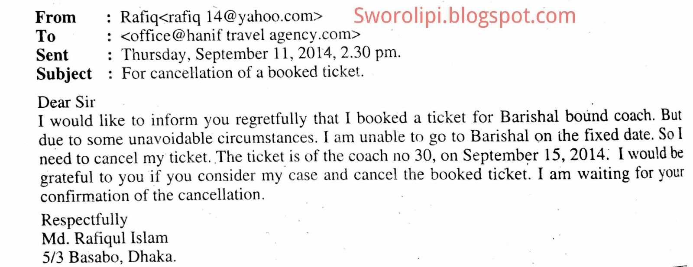
As you can see, sometimes the customer needs to make alterations to their holiday and sometimes the travel agent may forget to include certain requirements.
Task 1 (Green) Imagine you are the customer who received the formal letter in the last lesson. The travel agent has booked your holiday to your chosen destination but has forgotten to include:
- Details of the taxi transfers from your home to Leeds Bradford Airport e.g. the taxi company’s name and the time you will be picked up.
- The correct room request. They have booked a double room when you requested a twin.

Using the template and the sentence starters below, write an email to the travel agent asking for the missing information.
To:
Subject:
Date:

Dear Manager,
I am writing to let you know that you have missed some details regarding my holiday.
Please could you inform me about----------------------------------------------------------------------------------------------------------------------------------------------------------(Talk about taxi transfers)----------------------------------------------------------------------------------------------------------------------------------------------------------------------------------------------------------------------------------------------------------------------------------------------------------------------------------------------------------------------------------------------------------------------------------------------------------------------------------------------------------------------------------------------------------In addition, an error has been made regarding my hotel room-----------------------------------------------------------------------------------------------------------------------------------------------------------------------------------------------------------------------------------------------------------------------------------------------(Talk about the room mistake)----------------------------------------------------------------------------------------------------------------------------------------------------------------------------------------------------------------------------------------------------------------------------------------------------------------------------------------------------------------------------
Thank you for your attention to this matter and I look forward to hearing your reply.
Yours----------------------------------
(Use the same valediction as a formal letter, but make sure it matches the salutation)
------------------------------------------
(Your name)

Task 2 (Amber) Imagine you are the customer who received the formal letter in the last lesson. The travel agent has booked your holiday to your chosen destination but has forgotten to include:
- Details of the taxi transfers from your home to Leeds Bradford Airport e.g. the taxi company’s name and the time you will be picked up.
- The correct room request. They have booked a double room when you requested a twin.
- An excursion to a horse sanctuary, but you are allergic to horses and wish to swap it for a trip to the local zoo.

Using the template below, write an email to the travel agent asking for the amendments above (separate your request into three separate paragraphs).
To:
Subject:
Date:

Dear Manager,
----------------------------------------------------------------------------------------------------------------------------------------------------------------------------
--------------------------------------------------------------------------------------------------------------------------------------------------------------------------------------------------------------------------------------------------------------------------------------------------------------------------------------------------------------------------------------------------------------------------------------------------------------------------------------------------------------------------------------------------------------------------------------------------------------------------------------------------------------------------------------------------------------------------------------------------------------------------------------------------------------------------------------------------------------------------------------------------------------------------------------------------------------------------------------------------------------------------------------------------------------------------------------------------------------------------------------------------------------------------------------------------------------------------------------------------------------------------------------------------------------------------------------------------------------------------------------------------------------------------------------------------------------------------------------------------------------------------------------------------------------------------------------------------------------------------------------------------------------------------------------------------------------------------------------------------------------------------------------------------------------------------------------------------------------------------------------------------------------------------------------------------------------------------------------------------------------------------------------------------------------------------------------------------------------------------------------------------------------------------------------------------------------------------------------------------------------------------------------------------------------------------------------------------------------------------------------------------------------------------------------------------------------------------------------------------------
Thank you for your attention to this matter and I look forward to hearing your reply.
Yours----------------------------------
(Use the same valediction as a formal letter, but make sure it matches the salutation)
------------------------------------------
(Your name)

Task 3 (Red) In addition to completing task 2, include the subject specific vocabulary outlined in the yellow box at the beginning of this lesson. Write in detail and check your work for clarity. Ensure your email has a formal tone (check p11 for help with this).
To:
Subject:
Date:

--------------------------------------------------------------------------------------------------------------------------------------------------------------------------------
----------------------------------------------------------------------------------------------------------------------------------------------------------------------------------------------------------------------------------------------------------------------------------------------------------------------------------------------------------------------------------------------------------------------------------------------------------------------------------------------------------------------------------------------------------------------------------------------------------------------------------------------------------------------------------------------------------------------------------------------------------------------------------------------------------------------------------------------------------------------------------------------------------------------------------------------------------------------------------------------------------------------------------------------------------------------------------------------------------------------------------------------------------------------------------------------------------------------------------------------------------------------------------------------------------------------------------------------------------------------------------------------------------------------------------------------------------------------------------------------------------------------------------------------------------------------------------------------------------------------------------------------------------------------------------------------------------------------------------------------------------------------------------------------------------------------------------------------------------------------------------------------------------------------------------------------------------------------------------------------------------------------------------------------------------------------------------------------------------------------------------------------------------------------------------------------------------------------------------------------------------------------------------------------------------------------------------------------------------------------------------------------------------------------------------------------------------------------------------------------------------------------------------------------------------------------------------------------------------------------------------------------------------------------------------------------------------------------------------------------------------------------------------------------------------------------------------------------------------------------------------------------------------------------------------------------------------------------------------------------------------------------------------------------------------------------------------------------------------------------------------------------------------------------------------------------------------------------------------------------------------------------------------------------------------------------------------------------------------------------------------------------------------------------------------------------------------------------------------------------------------------------------------------------------------------------------------------------------------------------------------------------------------------------------------------------------------------------------------------------------------------------------------------------------------------------------------------------------------------------------------------------------------------------------------------------------------------------------------------------------------------------------------------------------------------------------------------------------------------------------------------------------------------------------------------------------------------------------------------------------------------------------------------------------------------------------------------------------------------------------------------------------------------------------------------------------------------------------------------
LO: To be able to write a persuasive article for a travel brochure

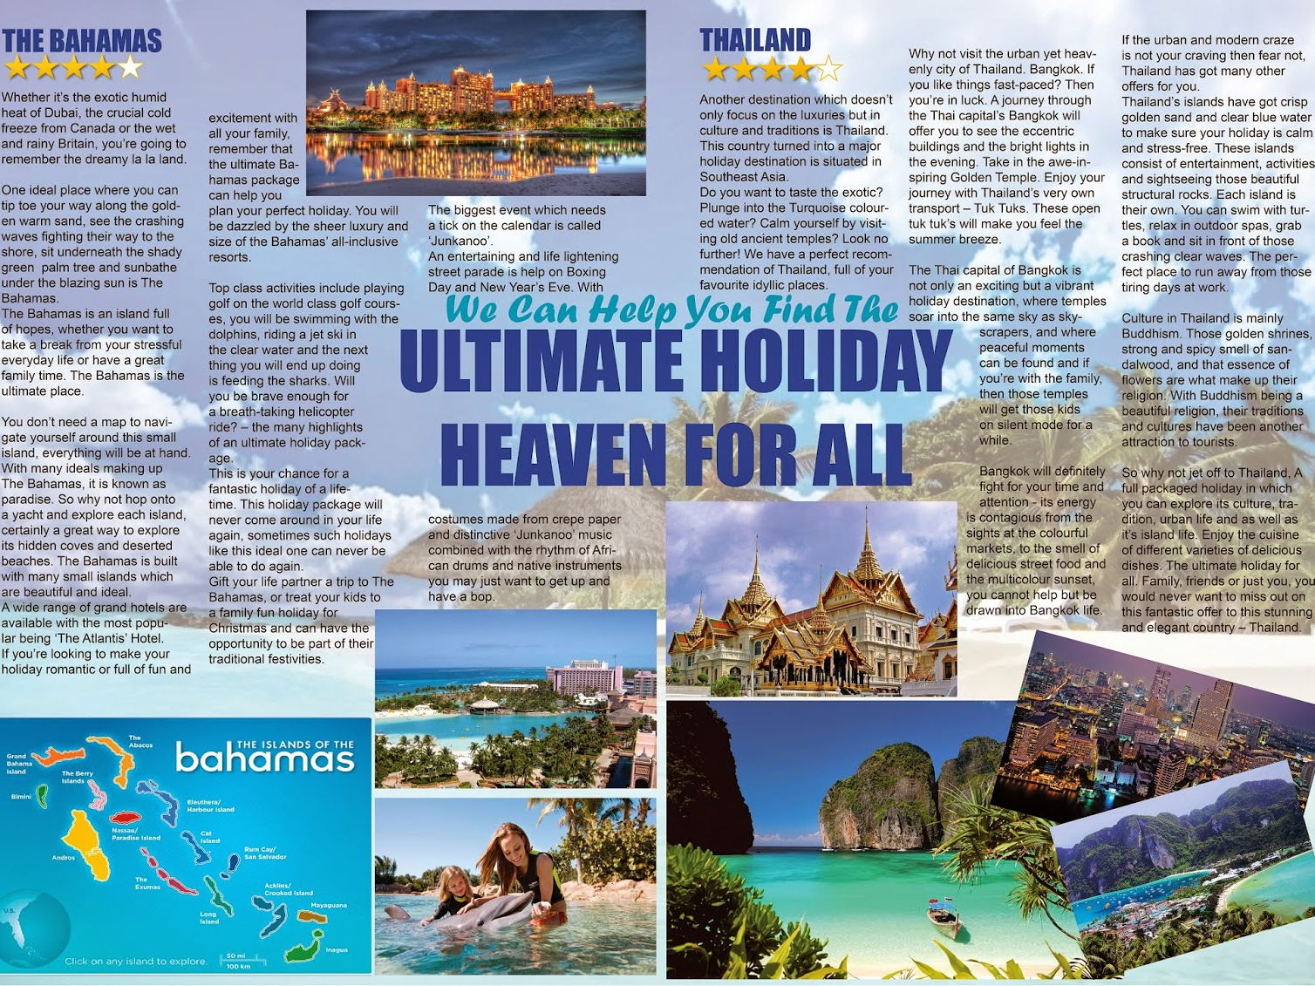

Look at the advert for various holiday destinations above. The travel agent has used lots of the persuasive features we explored in booklet 2. Persuasive features convince a reader to do something, in this case, buy a holiday to one of the destinations above.

Remember - Persuasive features include the following devices:

Feature | Persuasive Technique
Rhetorical Questions | A question asked in order to create a dramatic effect or to make a point rather than to get an answer.
Exclamations | An exclamatory sentence conveys a strong emotion and ends with an exclamation mark (!). It helps to persuade a reader by adding more force to the statement e.g. No one, absolutely no one should have to put up with unsanitary hotel rooms!
Ellipsis | Punctuation (…) - used to suggest that the reader thinks carefully.
Statistics | Figures (numerical facts) to support a point e.g. 100% of guests are satisfied with the hotel facilities.
Expert opinions/ Examples | The view of a qualified person on the topic.
Emotive words | Words intended to create certain feelings in the reader e.g. We urge you to try this precious gem of a location for yourself!
Personal pronouns | Words like ‘I’, ‘You’ or ‘We’ – used to involve the reader personally with the topic.

Task 1 (Green) Identify the following persuasive features in the article on page 28 and explain what they are persuading the reader to do:
Persuasive feature | What it is persuading the reader to do/ feel
Emotive words

Rhetorical Question (one example only)

Personal pronouns

Using any of the persuasive features in the box on p29, write a short paragraph for a travel brochure to advertise the holiday destination in the photo below. Include:
- The holiday destination
- Where to stay
- Exciting things to do
Remember, it doesn’t have to be true!

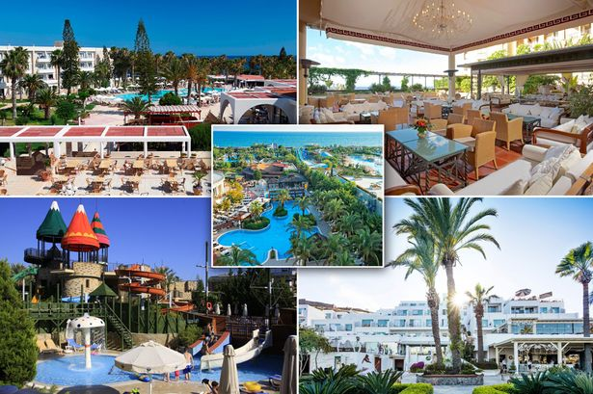

--------------------------------------------------------------------------------------------------------------------------------------------------------------------------------------------------------------------
----------------------------------------------------------------------------------------------------------
------------------------------------------------------------------------------------------------------------------------------------------------------------------------------------------------------------------------------------------------------------------------------------------------------------------------------------------------------------------------------------------------------------------------------------------------------------------------------------------------------------------------------------------------------------------------------------------------------------------------------------------------------------
Task 2 (Amber) Identify the following persuasive features in the article on page 28 and explain what they are persuading the reader to do:
Persuasive feature | What it is persuading the reader to do/ feel
Emotive words

Rhetorical Questions (three examples)

Exclamations

Personal pronouns

Using any of the persuasive features in the box on p29, write an advert for a travel brochure to advertise the holiday destination in the photo in task 1. Include:
- The holiday destination
- Where to stay
- Exciting things to do
- The above information in three separate paragraphs
- Subject specific vocabulary from the yellow box on p21

Remember, it doesn’t have to be true!

----------------------------------------------------------------------------------------------------------------------------------------------------------------------------------------------------------------------------------------------------------------------------------------------------------------------------------------------------------------------------------------------------------------------------------------------

----------------------------------------------------------------------------------------------------------------------------------------------------------------------------------------------------------------------------------------------------------------------------------------------------------------------------------------------------------------------------------------------------------------------------------------------------------------------------------------------------------------------------------------------------------------------------------------------------------------------------------------------------------------------------------------------------------------------------------------------------------------------------------------------------------------------------------------------------------------------------------------------------------------------------------------------------------------------------------------------------------------------------------------------------------------------------------------------------------------------------------------------------------------------------------------------------------------------------------------------------------------------------------------------------------------------------------------------------------------------------------------------------------------------------------------------------------------------------------------------------------------------
----------------------------------------------------------------------------------------------------------------------------------------------------------------------------
Task 3 (Red) In addition to completing all activities in task 2, when writing your advert also include:
- The layout features of an advert e.g. title, subheadings, bullet points (to make your advert easy to read and guide your reader through the information). Examples below.

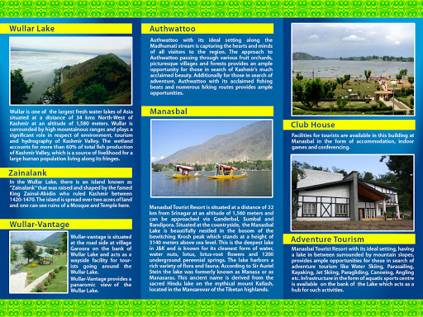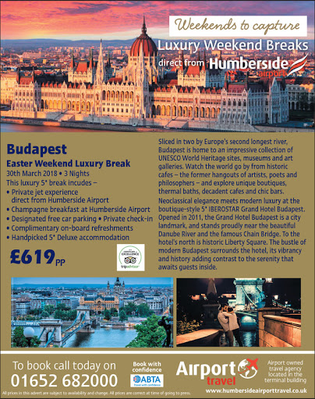

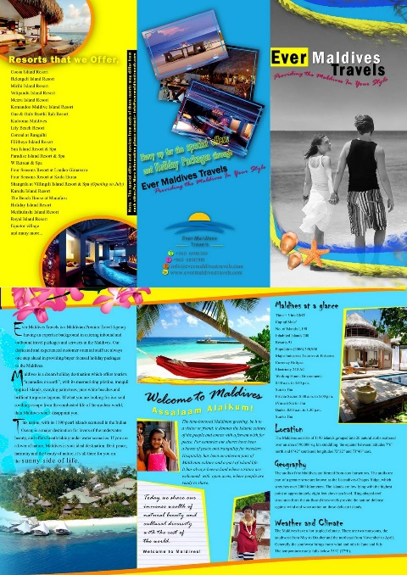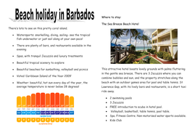

Use the following page to write your advert.

------------------------------------------------------------------------------------------------------------------------------------------------------------------------------------------------------------------------------------------------------------------------------------------------------------------------------------------------------------------------------------------------------------------------------------------------------------------------------------------------------------------------------------------------------------------------------------------------------------------------------------------------------------------------
-----------------------------------------------------------------------------------------------------------
------------------------------------------------------------------------------------------------------------------------------------------------------------------------------------------------------------------------------------------------------------------------------------------------------------------------------------------------------------------------------------------------------------------------------------------------------------------------------------------------------------------------------------------------------------------------------------------------------------------------------------------------------------------------
------------------------------------------------------------------------------------------------------------------------------------------------------------------------------------------------------------------------------------------------------------------------------------------------------------------------------------------------------------------------------------------------------------------------------------------------------------------------------------------------------------------------------------------------------------------------------------------------------------------------------------------------------------------------
------------------------------------------------------------------------------------------------------------------------------------------------------------------------------------------------------------------------------------------------------------------------------------------------------------------------------------------------------------------------------------------------------------------------------------------------------------------------------------------------------------------------------------------------------------------------------------------------------------------------------------------------------------------------
------------------------------------------------------------------------------------------------------------------------------------------------------------------------------------------------------------------------------------------------------------------------------------------------------------------------------------------------------------------------------------------------------------------------------------------------------------------------------------------------------------------------------------------------------------------------------------------------------------------------------------------------------------------------

