Year 8
English Work Pack 3
Parents/Carers – only complete as much, or as little, of these booklets as your circumstances allow at this difficult time.

Welcome to this week’s English topic!

Survival
Writing for Different Purposes

We will have fun learning to:

- Write a persuasive advert
- Write an informative and instructional leaflet
- Write an interesting diary entry

Choose your own task level (green = easy, amber = slightly harder, red = challenge)

Have you ever watched the survival expert, Bear Grylls, on television? This homework booklet will teach you that reading the right things, written clearly, can help you to survive in all sorts of dangerous terrain.
We will focus on knowledge required to survive in the jungle.
LO: To be able to write a persuasive advert

Imagine that you would like to have a real adventure. You would like to go somewhere very exciting and see new things. On the way home from school, you see an advert for an adventure holiday company called:

An adventure travel company you can trust

There's a reason why 96% of customers say they would book an adventure holiday with us again.

Unforgettable experiences
From big wows to hidden gems, our tours leave you feeling that you've really explored.

Expert local guides
Chosen for great knowledge of their country, and a passion to make your trip extraordinary.

Small groups
Average groups of 12; solos, couples, families and friends, united by a desire for authentic experiences.

What draws your attention to this advert? What persuasive features are used? Look at the list of examples below:

Persuasive Features

Rhetorical Questions
Questions designed to make the reader think about the topic (they are not explicitly answered in the text)

Statistics
Numbers given as a percentage to prove a point e.g. Doctors say 78% of people never wash their feet

Personal Pronouns
Using the words ‘I’ and ‘You’ to personally involve the reader with the topic

Emotive Words
Strong words to make a reader feel something deeply

Bold Font, Images and Logos
These features help to make information stand out and become more memorable

Task 1 a (Green) Read the advert on page 2 and identify three persuasive features in it from the list in the table above. Explain how they caught your attention and made you want to read on.

Persuasive Feature Used | How it caught your attention. What did it make you think? How did it help you trust the company?
1.

2.

3.

You now go inside the travel agent and see another advert to a specific destination – the African jungle!

Task 1 b (Green) Using the template below, write the advert you see.
Think about the persuasive features used to attract you to read it.
Include:
- a minimum of three persuasive features from the table on page 3
- a title (that states the destination)
- subheadings (to separate your information about the different things you’ll see and do)

----------------------------------------------------------------------------------------------------------------------------------------------------------------------------------------------------------------------------------------------------------------------------------------------------------------------------------------------------------------------------------------------------
--------------------------------------------------------------------------------------------------------------------------------------------------------------------------------------------------------------------------------------------------------------------------------------------------------------------------------------------------------------------------------------------------------------------------------------------------------------------------------------------------------------------------------------------------------------------------------------------------------------------------------------------------------------------------------------------------------------------------------------------------------------------------------------------------------
----------------------------------------------------------------------------------------------------------------------------------------------------------------------------------------------------------------------------------------------------------------------------------------------------------------------------------------------------------------------------------------------------
--------------------------------------------------------------------------------------------------------------------------------------------------------------------------------------------------------------------------------------------------------------------------------------------------------------------------------------------------------------------------------------------------------------------------------------------------------------------------------------------------------------------------------------------------------------------------------------------------------------------------------------------------------------------------------------------------------------------------------------------------------------------------------------------------------
----------------------------------------------------------------------------------------------------------------------------------------------------------------------------------------------------------------------------------------------------------------------------------------------------------------------------------------------------------------------------------------------------
--------------------------------------------------------------------------------------------------------------------------------------------------------------------------------------------------------------------------------------------------------------------------------------------------

Task 2a (Amber) In addition to completing task 1a, find two more persuasive features and explain the effect they had on you.

Persuasive Feature Used | How it caught your attention. What did it make you think? How did it help you trust the company?

You now go inside the travel agent and see another advert to a specific destination – the African jungle!

Task 2 b (Amber) Using the template on page 5and 6 for green level, write the advert you see.
Think about the persuasive features used to attract you to read it.
Include:
- a minimum of five persuasive features from the table on page 3
- a title (that states the destination)
- subheadings (to separate your information about the different things you’ll see and do)
- write in paragraphs
- use bullet points (if you include a short list anywhere in your advert) e.g. to outline the highlights of the trip; list animals you may see

Task 3 (Red) In addition to completing the activities in task 2 (a and b), in your advert include:

- a minimum of five persuasive features from the table on page 3
- a title (that states the destination)
- subheadings (to separate your information about the different things you’ll see and do)
- write in paragraphs
- use bullet points (if you include a short list anywhere in your advert) e.g. to outline the highlights of the trip; list animals you may see
- write in detail
- try to use strong verbs and adjectives to attract customers to the holiday e.g. urge, excite, unforgettable, extraordinary

LO: To be able to write an informative and instructive leaflet
Imagine that you have booked an adventure holiday to the African jungle. Your advert was so persuasive, you couldn’t ignore it!

The travel agent has sent some information about your trip and you find a leaflet about elephants within it. It includes:

- general information about elephants
- how to survive an elephant attack
- how to ride an elephant

You are excited about seeing and riding an elephant, but also determined to remember the information on how to survive an attack. However, the leaflet is very badly designed and difficult to follow. How could the leaflet have been written more clearly?

Let’s look at the special features of informative and instructive texts:

Informative Texts  e.g. newspaper reports, magazine articles, scientific articles | Instructive Texts  e.g. recipes, flat pack assembly, leaflets about how to do something
Give information about a topic | Give instructions about how to do something
State Facts | Uses a clear format which may include diagrams or pictures
Use clear language | Uses bullet points or numbered steps
May include a glossary to explain difficult words | Uses imperative verbs e.g. slice, grate, wash
Consider the examples of each text type on the following page:
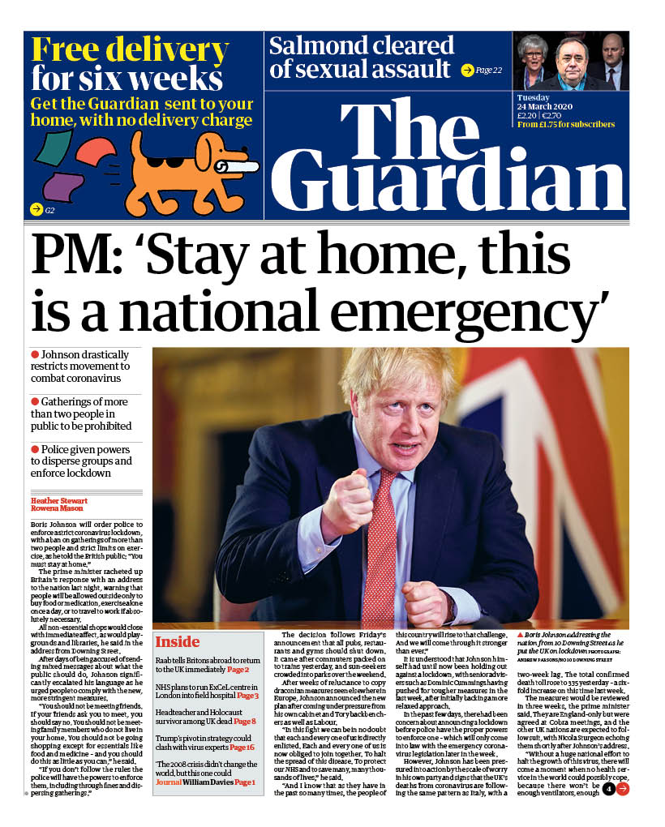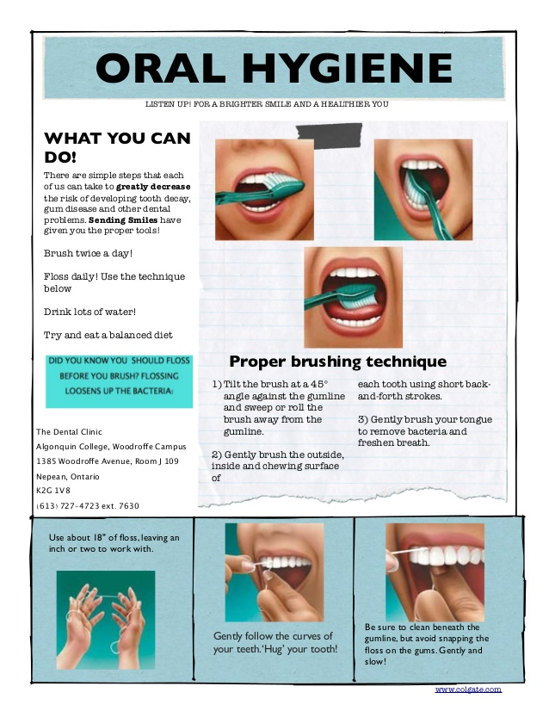
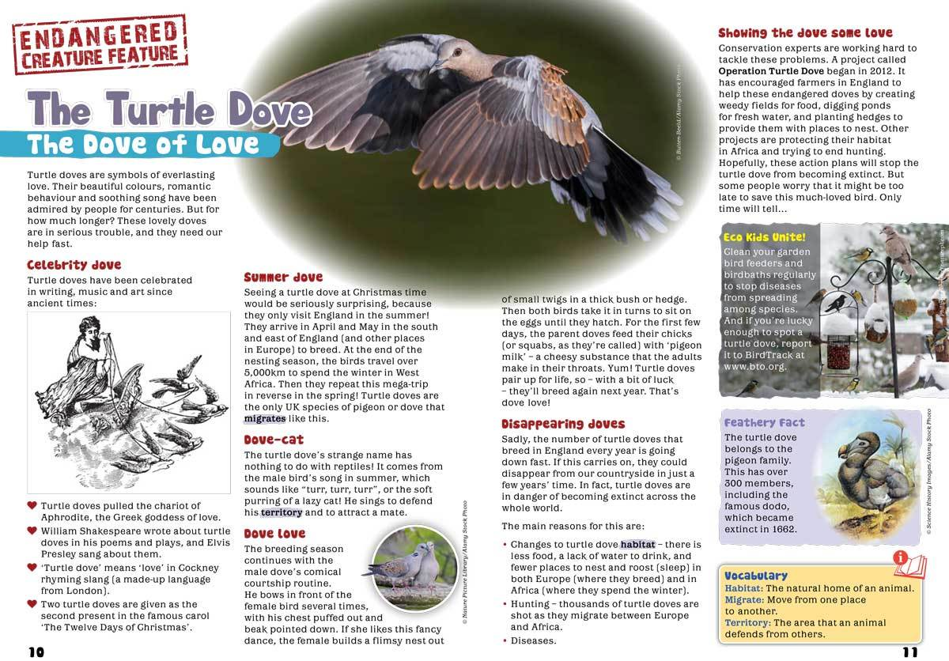
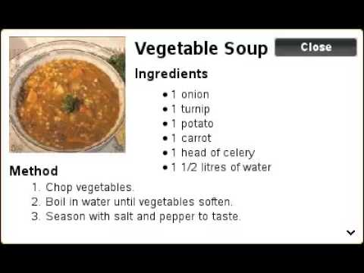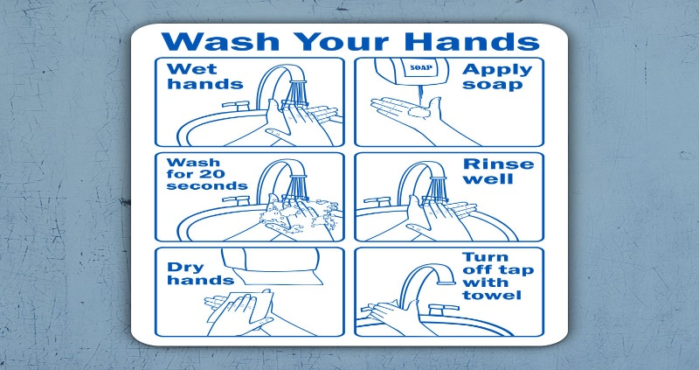
Task 1a (Green) Identify each text type above using the clues in the yellow table on page 9 to help you (they will be informative or instructive). Annotate (label in the margin) one feature that proves you are correct e.g. the vegetable soup recipe is an instructive text because it has bullet points to make each step easier to follow.
Task 2a (Amber) In addition to completing the activities in task 1a, find a further two features within each text to support your decision on text type.
Task 3a (Red) In addition to completing the activities in task 1a, find a further three features to support your decision on text type. Next, make a list of three additional text examples of instructional and informative texts.
Text | Instructive or Informative? | Features that prove it is instructive or informative | Red only – Additional example of instructive or informative texts
1
2
3
4
5

You now need to rewrite the badly written leaflet, by organising the information more clearly and making it easier to read, so that it looks more like the examples on page 10.
This is how the leaflet looks when you receive it and open it out. As you can see, the information, instructions and pictures are mixed up.
Jungle Jumbos  How to survive an elephant attack.  Keep downwind of elephants and give them lots of space to start with. If one starts charging, stand still – running may encourage it. If the elephant has its ears out, it’s probably a mock charge. Wait until it’s stopped and then move away slowly. If the elephant’s ears are back, it’s probably not kidding. Find a large tree and climb it as quickly as possible. If there are no trees, throw a decoy, like a hat or rucksack. The elephant may start attacking it giving you time to escape. If all else fails, squeeze into a hiding place or curl into as small a ball as possible.  Elephants are found in jungles and savannah grasslands of Africa and Asia. They can be fierce and dangerous, but their intelligence and great strength also mean they can be a great help to an explorer. | Additional elephant facts from Bear Grylls  If you are lost in the wild with no water, you can squeeze life-saving fluid from fresh elephant dung, but do NOT touch any other animal waste because it will make you very sick.  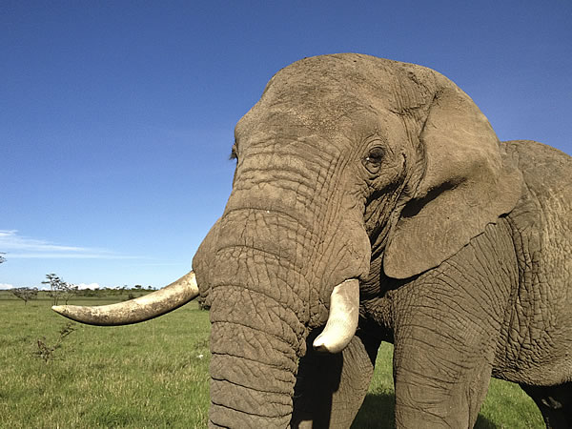 | 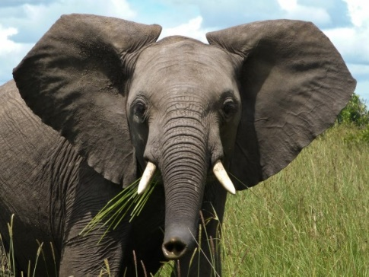  To get off, tap the elephant’s back. This is the signal to sit down so you can get off easily. To get on, give the command for ‘lift’ – it should raise its foot to form a natural ladder. Grab hold of an ear and put your foot on the leg, then grab a rope or part of the saddle and pull yourself on.  To move around, practise giving the commands for ‘forward’, ‘left’ or ‘right’. Use your knees to give nudges behind the ears.
Task 1b (Green) Cut out and separate the information and instructions in the leaflet above and put them in the correct place on the template below. Put the pictures next to the relevant text and begin with the introduction. Rewrite the instructions on riding an elephant, separating the three steps using bullet points or numbers to make them easier to follow.
How to ride an elephant
1.------------------------------------------------------------------------------------------------------------------------------------------------------------------------------------------------------------------------------------------------------------------------------------------------------------------------------------------------------------------------------------------------------------------2.--------------------------------------------- -----------------------------------------------------------------------------------------------------------------------------------------------------------------------------------------------------------------------------------------------------------------------------------------------------------------------
3.---------------------------------------------------------------------------------------------------------------------------------------------------------------------------------------------------------------------------------------------------------------------------------------------------------------------------------------------------------------------
Task 2b (Amber) In addition to the activities in task 1b, copy out the instructions for surviving an elephant attack and separate it using bullet points or numbers to make the different steps easier to follow.

Task 3b (Red) In addition to the activities in task 1b and 2b, use a dictionary to write a glossary to explain the special terms in the leaflet.

Term | Definition
Mock

Savannah Grassland

Dung

Decoy

Extension (All) Write an informative and instructive leaflet about an animal of your choice e.g. your pet dog. Include:

- General facts about the animal
- Instructions on how to care for the animal

Use the features of each text type e.g. bullet points, subheadings, clear language.

LO: To be able to write a creative diary entry

Your name is Juliane Koepcke and you are 17 years old.You are on your way to your adventure holiday when something terrible and unexpected happens.
This account of the experience appears in the ‘Leeds Daily News’.

The Woman Who Fell Out of a Plane
What Happened?  Seventeen-year-old Juliane Koepcke was flying over the jungle in 2020 when her plane was hit by lightening and broke into pieces in midair.  Amazingly, she survived falling form 3km (2 miles) up, crashing through the trees and landing with little more than a black eye.  Everyone else on the plane, including her mother, was killed.  *Lumberjack  A person who fells trees, cuts them into logs, or transports them to a sawmill. | How Did She Survive?  Lost in the middle of thick jungle and with nothing to eat except a few sweets, Koepcke remembered some advice from her father: find a stream and follow it downhill.  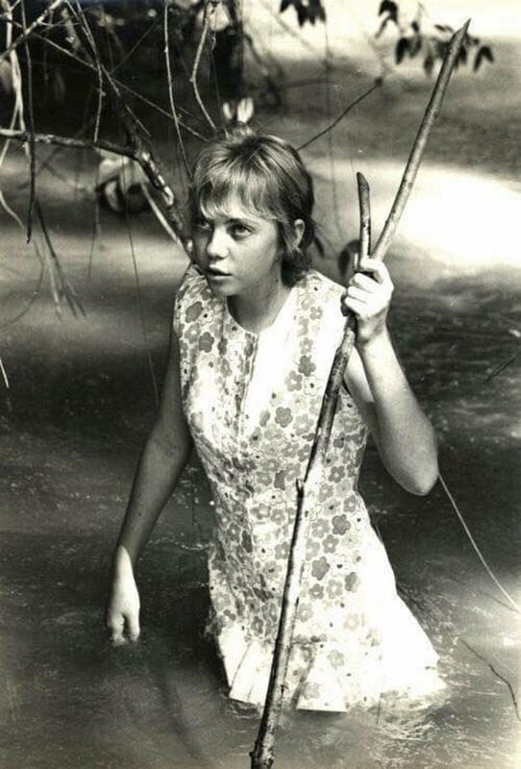  Juliane Koepcke  Streams lead to rivers and rivers will eventually lead  *Botflies  A stout hairy-bodied fly with larvae that are internal parasites of mammals. | to people. Koepcke walked for days along a stream until she found a *lumberjack’s cabin. By now her skin was infested with baby *botflies, so to get rid of them she poured petrol over her wounds and pulled out 50 *larvae.  How Did She Escape?  Soon after the botfly incident, some lumberjacks turned up and she was rescued.  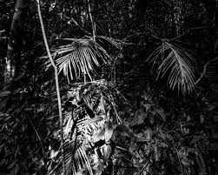  The Jungle  *Larvae  The immature form of an insect. Differs from the adult and forms the stage between egg and pupa, e.g. a caterpillar.
The account above is a true story; only the date has been changed. The real incident took place in 1971.

Your task will be to write Juliane Koepcke’s diary entry.
What are the features of a diary?
- Written in the first person e.g.‘I followed the path.’
- Written in the past tense e.g. ‘It was dark,’ rather than ‘It is dark’.
- Includes an introduction to set the scene
- Expresses opinions, thoughts and feelings e.g. I felt scared and alone.
- Uses time conjunctions to show when things happened e.g. Later, Next, Meanwhile, After that, Lastly
- Is about events that are important or significant to the writer
Task 1a (Green) On the example below, identify, at least, three features of diary writing from the yellow table above (draw arrows and write in the margin). An example has been done for you.
Task 2a (Amber) On the example below, identify, at least, five features of diary writing from the yellow table above.
Task 3a (Red) On the example below, identify all the features of diary writing from the yellow table above. Additionally, identify specific adjectives that convey the writer’s feelings.
Diary Example
Use of past tense
Well that was one of the best days ever! Today I went to an amazing waterpark on a school trip and we stayed in the swimming pools for almost the entire day! I was very excited about the trip yesterday, and when we arrived, I wasn’t disappointed – the park was massive with slides and flumes everywhere you looked. The best bit was a kind of structure that you could climb up and walk around – there were buckets and water guns you could use to try and soak people who were underneath you.
After we had got changed and when we first got into the pool, my friend and I headed straight for the biggest flume ride called the ‘Master Blaster’. I was a little nervous about going on it because I hadn’t been on anything like that before, but I felt glad to be on the same rubber ring as my friend. The ride was amazingly fast and at one point, there was no light so that as you went round and round, you felt like you were travelling to the centre of the Earth. We loved it so much we kept going back to the top until we had ridden on it five times in a row.
Next, we wanted to try another flume ride – one that you had to ride on your own by sitting in a yellow ring. By the time we did this I was feeling confident about the flumes but as I sat at the top I didn’t feel properly balanced in the ring. Before I knew it I was shooting down the slide and slipping off the ring at the same time. Then, as the slide turned a sharp corner, the ring slipped out from under me and I bashed my head on the side of the tube! I managed to grab the ring, but I couldn’t get on it again and after a couple of dodgy corners I was just glad to see the daylight of the plunge pool at the bottom. The lifeguard had seen the incident on his monitor, so he got me some ice for my head, and I sat there for a while watching the others come down. It put me off going on the flumes for a while, but after about 5 minutes I was ready to go again!
I can’t wait to go back, but I must remember two key things that happen if you DO stay in a swimming pool all day – 1. Your hands will be wrinkled like a very old person’s 2. You will be very tired. I am!

Task 1b (Green), 2b (Amber) and 3b (Red) Using the planning sheet below, identify the three main parts of the incident (use the subheadings to help you). Next, pick out the main points from each part. After that, answer the questions on the planning sheet to help you write creatively about details we are not told.

Planning for Diary Entry

Part 1? | Part 2? | Part 3?
Main Points | Main Points | Main Points
Planning Continued - Questions to help you write creatively (remember, the answers you give are imaginary)

- Where do you think Juliane and her mother were travelling to when her plane was hit by lightening e.g. to visit relatives, to interview for a job in another city, to attend a party?
----------------------------------------------------------------------------------------------------------------------------------------------------------------------------------------------------------------------------------------------------------------------------------------------------------------------------------------------------------------------------------------------------------------------------------------------------------------------------------------------------------------------------------------
- How do you think she felt before the lightening struck e.g. excited, relaxed?
----------------------------------------------------------------------------------------------------------------------------------------------------------------------------------------------------------------------------------------------------------------------------------------------------------------------------------------------------------------------------------------------------------------------------------------------------------------------------------------------------------------------------------------
- How do you think she felt:

- At the moment the lightening struck? Why? What was she thinking?
----------------------------------------------------------------------------------------------------------------------------------------------------------------------------------------------------------------------------------------------------------------------------------------------------------------------------------------------------------------------------------------------------------------------------------------------------------------------------------------------------------------------------------------
- While she was falling two miles through the air? Why? What was she thinking?
----------------------------------------------------------------------------------------------------------------------------------------------------------------------------------------------------------------------------------------------------------------------------------------------------------------------------------------------------------------------------------------------------------------------------------------------------------------------------------------------------------------------------------------

- As she landed in the trees that broke her fall? Why? What was she thinking?
----------------------------------------------------------------------------------------------------------------------------------------------------------------------------------------------------------------------------------------------------------------------------------------------------------------------------------------------------------------------------------------------------------------------------------------------------------------------------------------------------------------------------------------
- When she realised her mother wasn’t with her and she was all alone in the jungle? Why? What was she thinking?
----------------------------------------------------------------------------------------------------------------------------------------------------------------------------------------------------------------------------------------------------------------------------------------------------------------------------------------------------------------------------------------------------------------------------------------------------------------------------------------------------------------------------------------
- What did she do while she was walking for days along the river? Did she find anything to eat?
----------------------------------------------------------------------------------------------------------------------------------------------------------------------------------------------------------------------------------------------------------------------------------------------------------------------------------------------------------------------------------------------------------------------------------------------------------------------------------------------------------------------------------------
- What were her feelings when she eventually came across the lumberjack’s cottage? Did it show evidence of people being there recently e.g. scraps of food, discarded paper. Did she find a bed with bedding? Did she get into it and sleep? How did her sleep feel after all her days of walking? Did she dream? Describe the scene.
----------------------------------------------------------------------------------------------------------------------------------------------------------------------------------------------------------------------------------------------------------------------------------------------------------------------------------------------------------------------------------------------------------------------------------------------------------------------------------------------------------------------------------------
--------------------------------------------------------------------------------------------------------------------------------------------------------------------------------------------------------------------------------------------------------------------------------------------------------------------------------------------------------------------------------------------------------------------------------
Words to Help You Describe Feelings

Green Level Amber Level Red Level
Sad | Desperate | Abandoned | Numb | Bewildered | Shattered
Worried | Confused | Anxious | Hesitant | Demoralised | Defeated
Nervous | Helpless | Overwhelmed | Troubled | Distraught | Apathetic
Excited | Hopeless | Lost | Panicky | Despairing | Jittery

Task 1c (Green) Using your planning, write the diary entry of Juliane’s experience in the jungle below. Check the features of a diary again on page 18 and include:
- at least, three of the features
- words to covey feelings from the green or amber section of the table above
- capital letters at the beginning of each sentence
- a full stop, question mark or exclamation mark at the end of each sentence

My Diary – Juliane Koepcke May 2020

I was travelling to-------------------------------------------------------------------
and feeling----------------------------------------------------------------------------
when------------------------------------------------------------------------------------------------------------------------------------------------------------------------------------------------------------------------------------------------------------------------------------------------------------------------------------------------------------------------------------------------------------------------------------------------------------------------------------------------------------------------------------------------------------------------------------------------------------------------------------------------------------
----------------------------------------------------------------------------------------------------------------------------------------------------------------------------------------------------------------------------------------------------------------------------------------------------------------------------------------------------------------------------------------------------------------------------------------------------------------------------------------------------------------------------------------------------------------------------------------------------------------------------------------------------------------------------------------------------------------------------------------------------------------------------------------------------------------------------------------------------------------------------------------------------------------------------------------------------------------------------------------------------------------------------------------------------
----------------------------------------------------------------------------------------------------------------------------------------------------------------------------------------------------------------------------------------------------------------------------------------------------------------------------------------------------------------------------------------------------------------------------------------------------------------------------------------------------------------------------------------------------------------------------------------------------------------------------------------------------------------------------------------------------------------------------------------------------------------------------------------------------------------------------------------------------------------------------------------------------------------------------------------------------------------------------------------------------------------------------------------------------
----------------------------------------------------------------------------------------------------------------------------------------------------------------------------------------
Task 2c (Amber) Complete the bold part of task 1c but include:
- an additional two diary features from the yellow table on page 18
- words to covey feelings from the amber or red section of the table on page 23
- capital letters at the beginning of each sentence
- a full stop, question mark or exclamation mark at the end of each sentence
- correct SPaG (use a dictionary to help you)

Task 2c (Amber) Complete the bold part of task 1c but include:
- all the diary features from the yellow table
- words to covey feelings from the red section of the table on page 23
- writing set out in paragraphs
- capital letters at the beginning of each sentence
- a full stop, question mark or exclamation mark at the end of each sentence
- correct SPaG (use a dictionary to help you)

Extra writing space for amber and red level if needed
------------------------------------------------------------------------------------------------------------------------------------------------------------------------------------------------------------------------------------------------------------------------------------
----------------------------------------------------------------------------------------------------------------------------------------------------------------------------------------------------------------------------------------------------------------------------------------------------------------------------------------------------------------------------------------------------------------------------------------------------------------------------------------------------------------------------------------------------------------------------------------------------------------------------------------------------------------------------------------------------------------------------------------------------------------------------------------------------------------------------------------------------------------------------------------------------------------------------------------------------------------------------------------------------------------------------------------------------
------------------------------------------------------------------------------------------------------------------------------------------------------------------------------------------------------------------------------------------------------------------------------------
--------------------------------------------------------------------------------------------
----------------------------------------------------------------------------------------------------------------------------------------------------------------------------------------------------------------------------------------------------------------------------------------------------------------------------------------------------------------------------------------------------------------------------------------------------------------------------------------------------------------------------------------------------------------------------------------------------------------------------------------------------------------------------------------------------------------------------------------------------------------------------------------------------------------------------------------------------------------------------------------------------------------------------------------------------------------------------------------------------------------------------------------------------
------------------------------------------------------------------------------------------------------------------------------------------------------------------------------------------------------------------------------------------------------------------------------------
LO: To be able to evaluate and edit my writing to improve.
Do you remember the following definitions from booklet one?
Evaluate | Assess your work to decide how good it is
Edit | Correct or modify your work to make it better

Task 1 (Green) Read and check your diary entry to make sure you have included the following:
- at least, three diary features form the yellow table on page 18
- words to covey feelings from the green or amber section of the table on page 23
- capital letters at the beginning of each sentence
- a full stop, question mark or exclamation mark at the end of each sentence
Edit by correcting anything you’ve missed or use extra paper to re-write a section.

Task 2 (Amber) Read and check your diary to make sure you have included the following:
- an additional two diary features from the yellow table on page 18
- words to covey feelings from the amber or red section of the table on page 23
- capital letters at the beginning of each sentence
- a full stop, question mark or exclamation mark at the end of each sentence
- correct SPaG
Edit by correcting anything you’ve missed or use extra paper to re-write a section.

Task 3 (Red) Read and check your diary to make sure you have included the following:
- all the diary features from the yellow table
- words to covey feelings from the red section of the table on page 23
- writing set out in paragraphs
- capital letters at the beginning of each sentence
- a full stop, question mark or exclamation mark at the end of each sentence
- correct SPaG

Edit by correcting anything you’ve missed or use extra paper to re-write a section.

