Year 7
English Work Pack 3

Parents/Carers – only complete as much, or as little, of these booklets as your circumstances allow at this difficult time.

Welcome to this week’s English topic!

Instructional Writing

We will have fun learning to:

- Identify verbs
- Identify and use imperative verbs
- Use layout features such as bullet points, numbered lists and subheadings
- Evaluate and edit our work to make it BRILLIANT!

Choose your own task level (green = easy, amber = slightly harder, red = challenge)

LO: To be able to identify verbs in a sentence

Verb – a doing/ action word
e.g. enter, move, sneak

In work book 2, you learned to identify verbs as the action or ‘doing’ word in a sentence. To recap, try the following exercises;

Task 1 (Green) Highlight the verb in each sentence, then write ten sentences of your own containing an appropriate verb. The first one is done for you.

- Sally and Tom played football together.
- John washed his car.
- Peter walked quickly to school.
- Sarah worked at the computer for two hours.
- The gardener mowed the lawn.
- The cat snored loudly on the sofa.
- Birds fly very long distances in winter.
- ‘Will you write for me?’
- Suzy sang loudly as she baked cakes in the kitchen.
10.Springwell always writes the best anthologies.

1.

2.

3.

4.

5.

6.

7.

8.

9.

10.

Task 2 (Amber) Highlight the two verbs in each sentence, then write ten sentences of your own containing an appropriate and interesting verb e.g. don’t say ‘walk’ if you can describe the action more effectively by saying ‘sprinted’. The first one is done for you.

- The eagle glided slowly across the sky and then swooped down to catch its prey.
- The teacher shouted the instructions and the students sprinted as fast as they could.
- The bat hung upside down until the owner removed it from his loft.
- The small boy worried about his exam until he was comforted by his mother.
- Football is an exciting game to play and gives players lots of exercise.
- Television is very relaxing to watch and listen peacefully together.
- Mealtimes are a good opportunity to share ideas and enjoy good food.
- Shirley swept across the dance floor as she tried her best to win the contest.
- Jane tried to play the game but her brother constantly won it.
10.Yellow Pod always succeed in beating Green Pod in the ‘paint a door’ competition.

1.

2.

3.

4.

5.

6.

7.

8.

9.

10.

Task 3 (Red) In addition to completing the exercises in task 2, add appropriate verbs to the article below. These are indicated by a yellow box and some of them are ‘irregular’ verbs e.g. was, were, stood - they don’t follow the same rules as ‘regular’ verbs.

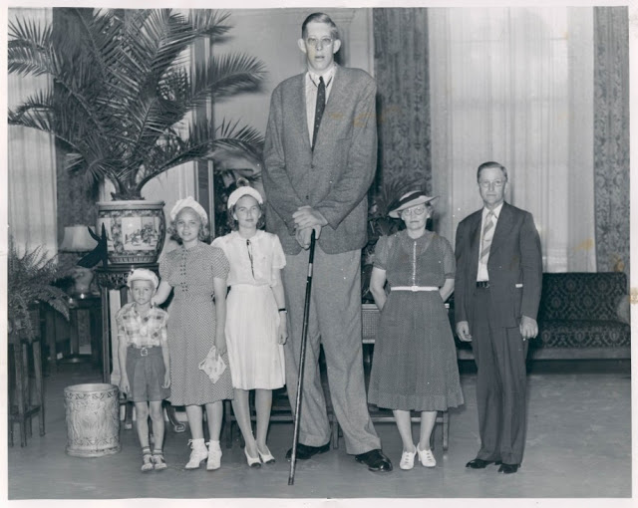

Robert Wadlow (1918-1940) ………………. the tallest man in medical history. He ……………..8 feet, 11.1 inches tall. He ………………from a disease called gigantism, a rare condition in which too much growth hormone makes a child unusually large. He was more than 50 percent taller than the average man.
At birth, Wadlow …………….. a normal eight pounds, six ounces, but he started ………………quickly and reached 30 pounds at just six months. He stood six-foot-two at age eight and kept ………………… even into his early 20’s. By the end of his short life, Wadlow weighed 490 pounds. Wadlow’s clothes were all custom-made, as ……………. his size 37 shoes, which he started ………………free of charge from the International Shoe Company at age 20. That year, he and his dad ……………. a long road trip to ……………… the shoe company. The car’s front passenger seat was ………………so he could …………………… comfortably in the back seat. They …………………more than 800 towns in 41 states, eventually covering more than 300,000 miles.
Despite those custom shoes, Wadlow’s feet were his eventual undoing. He could barely feel them, so when blisters ………………. he didn’t notice. One blister became infected during a visit to Manistee, Michigan, in 1940. Unable to fit into a bed at the local hospital, Wadlow was ordered to …………….. in bed at his hotel, but his fever rose and he ……………….. sicker, needing transfusions and surgery and eventually dying in his sleep.

LO: To be able to identify and use imperative verbs in recipes
Imperative verbs instruct people to do something.
They come at the beginning of sentences that are commands. Sometimes they are referred to as ‘bossy verbs’ because they do not leave room for questions or discussion, even if the sentence has a polite tone.

Tip Stir Bake Slice Stir Mix Knead Cut Make
Simmer Sift Toast Fry Leave Cover Tip Add Roll Heat Smooth

As you can see from the examples above, imperative verbs can be very useful when writing recipes. Look at the example below:

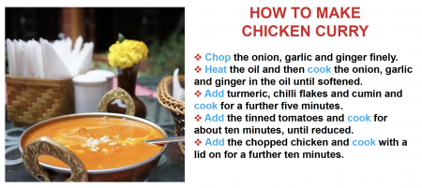
Task 1 (Green) Using the words in the yellow box above, look at the recipe below and write the missing imperative verbs in the spaces. You may need to use some of them more than once.

Ingredients

300g strong white bread flour, plus extra for dusting
1 tsp instant yeast
1 tbsp olive oil
For the tomato sauce
1 tbsp olive oil
2 garlic cloves, crushed
200ml passata

For the topping

8 mozzarella pearls, halved

small bunch fresh basil

Method
- ………………….. the flour into a bowl. ………………… in the yeast and 1 tsp salt. …………………a well in the centre and pour in 200ml warm water (make sure it’s not too hot) along with the oil. ………………… together with a wooden spoon until you have a soft, fairly wet dough.
- ………………… the dough out onto a lightly floured surface and ………………… for 5 mins until smooth. ………………… with a tea towel and set aside for an hour or so or until the dough has puffed up and doubled in size. You can also leave the rough, unkneaded dough in the bowl, ………………… with a tea towel and leave in the fridge overnight and the dough will continue to prove on its own.
- …………………make the tomato sauce. ………………… the oil in a small pan and ………………… the garlic briefly (don’t let it brown), then ………………… the passata and ………………… everything until the sauce thickens a little. ………………… to cool.
- Once the dough has risen, knead it quickly in the bowl to knock it back, then tip out onto a lightly floured surface and cut into two balls. ………………… out each ball into a large teardrop that is very thin and about 25cm across (teardrop shapes fit baking sheets more easily than rounds).
- ………………… oven to 240C/220C fan/ gas 9 with a large baking sheet inside. Lift one of the bases onto another floured baking sheet. ………………… the sauce over the base with the back of a spoon, scatter over half the mozzarella, drizzle with olive oil and season. ………………… the pizza, still on its baking sheet, on top of the hot sheet in the oven and bake for 8-10 mins until crisp.
Task 2 (Amber) Choose the correct imperative verb to go with each instruction in this recipe to make a cheese omelette.

Mix | Grill | Heat | Grate
Crack | Serve | Add

-----------------------------and enjoy – your omelette is ready!
------------------------------your pan until it is nice and hot.
------------------------------some eggs in a bowl and whisk.
------------------------------together thoroughly.
------------------------------some cheese and add to the egg mixture.
------------------------------for a final two minutes until completely cooked.
------------------------------your egg mixture and cook for three minutes.
In the exercise above, you have written the steps to make a cheese omelette. However, the steps are in the incorrect order. To make the steps clearer, you need to put them in order and number them (to make a list). Use the connectives below to put the steps in order.
Firstly,------------------------------------------------------------------------------------------------
Secondly, -------------------------------------------------------------------------------------------
Thirdly, ----------------------------------------------------------------------------------------------
After, ------------------------------------------------------------------------------------------------
Then, ------------------------------------------------------------------------------------------------
Next, -------------------------------------------------------------------------------------------------
Finally, ----------------------------------------------------------------------------------------------

Task 3 (Red) In addition to completing the exercise in task 2, write instructions for an alien to make a sandwich (remember, an alien has never seen a sandwich, tasted a sandwich or been in a kitchen, so your instructions should be clear, written in a list and contain appropriate imperative verbs).
Think of what connectives you should use. Use the examples below to help:

Firstly | Secondly | Thirdly | Next
After | Finally | Then | Meanwhile

You will also need to use imperative verbs. These may be useful:

Put | Mix | Spread | Open | Chop | Season
Add | Slice | Cut | Get | Serve | Place

Decide what type of sandwich you would like your alien to make and write the instructions, in order and numbered, below.
How to Make a Sandwich
-----------------------------------------------------------------------------------------------------------------------------------------------------------------------------------------------------------------------------------------------------------------------------------------------------------------------------------------------------------------------------------------------------------------------------------------------------------------------------------------------------------------------------------------------------------------------------------------------------------------------------------------------------------------------------------------------------------------------------------------------------------------------------------------------------------------------------------------------------------------------------------------------------------------------------------------------------------------------------------------------------------------------------------------------------------------------------------------------------------------------------------------------------------------------------------------------------------------------------------------------------------------------------------------------------------------------------------------------------------------------------------------------------------------------------------------------------------------------------------------------------------------------------------------------
-----------------------------------------------------------------------------------------------------------------------------------------------------------------------------------------------------------------------------------------------------------------------------------------------------------------------------------------------------------------------------------------------------------------------------------------

LO: To be able to use imperative verbs in instructions
We have looked at how useful imperative verbs can be in making the steps in recipes clearer and easier to follow. However, imperative verbs can also be used in instructions to do other things.
Task (All) There are 15 imperative verbs in the grid below. Some of the imperative verbs relate to cooking, some relate to other activities. See how many you can find.
l | l | f | s | m | e | a | s | u | r | e | w | f | k | n
q | v | o | w | d | y | t | o | w | m | k | s | a | c | p
e | g | n | s | v | v | v | l | l | l | b | s | a | i | b
r | e | v | o | m | z | i | z | s | l | e | e | p | t | g
i | r | n | r | o | x | k | q | p | x | i | g | m | s | v
m | u | l | t | i | a | w | j | r | x | q | g | g | w | m
s | i | g | j | v | d | y | n | e | l | p | k | u | a | u
m | r | b | h | y | r | v | o | a | v | p | r | h | s | s
e | n | f | e | d | i | v | i | d | b | p | m | m | h | c
h | e | c | j | l | c | l | p | e | d | j | e | w | o | n
g | v | x | n | o | v | t | s | c | i | c | n | a | c | x
i | g | c | h | e | p | t | n | a | d | e | x | t | r | e
e | t | u | c | g | w | f | u | l | a | c | l | e | a | n
w | t | t | z | y | r | n | q | p | n | w | u | l | c | k
f | h | a | i | u | i | b | k | r | u | o | p | b | k | w

Task 1 a (Green) Circle the imperative verbs in the mixed commands below:

Place the cup on the table.

Tear the sandwich into pieces.

Share the cake with your friends.

Listen to your teacher.

Hold my hand.

Cross the road safely.

Open the door for Mrs Riaz.

Type in your password.

Underline today’s date.

Read your book quietly.

Task 1 b (Green) Add an imperative verb to each of these commands so that they make sense.

- a line with a ruler.

- the ingredients together properly.

- to the instructions.

- your hand up to ask a question.

- your homework by Friday.
Task 2 (Amber) Add an imperative verb to each of these commands so that they make sense, then write a subsequent command beginning with a sequencing connective. The first one is done for you.

Draw a line with a ruler. Next, write the date.

--------------------------the ingredients together properly-----------------------------------------------------------------------------------------------------------------

--------------------------to the instructions-------------------------------------------------------------------------------------------------------------------------------------

--------------------------your hand up to ask a question----------------------------------------------------------------------------------------------------------------------

--------------------------your homework by Friday--------------------------------------------------------------------------------------------------------------------------------

---------------------------what you saw-------------------------------------------------------------------------------------------------------------------------------------------------

--------------------------the suspects about the crime------------------------------------------------------------------------------------------------------------------------

--------------------------the webpage---------------------------------------------------------------------------------------------------------------------------------------------

--------------------------your answers--------------------------------------------------------------------------------------------------------------------------------------------

-------------------------to bring your book bag---------------------------------------------------------------------------------------------------------------------------------

Write four imperative verbs that you might find when:

Using a computer

Write the commands in a numbered list below:

Task 3 (Red) Write four imperative verbs that might be used in each of these situations.

Brushing your teeth Washing a car

At school Read an email

Now, use an imperative verb to complete each sentence then think of three alternative imperative verbs you could use in its place.

- ------------------- the chocolate bar down.

--------------------- ------------------------ -----------------------

- -------------------- to the head teacher.

--------------------- ------------------------ -----------------------

- ------------------ your playtime.

--------------------- ------------------------ -----------------------

- ------------------your bedtime.

--------------------- ------------------------ -----------------------

- ------------------ the milk.

--------------------- ------------------------ -----------------------

LO: To identify how writers use imperative verbs to explain a series of steps used by a character

Look at the way Roald Dahl uses imperative verbs to explain the process George uses to make his ‘marvellous medicine’. George is trying to enlarge a chicken so it will lay extra-large eggs.

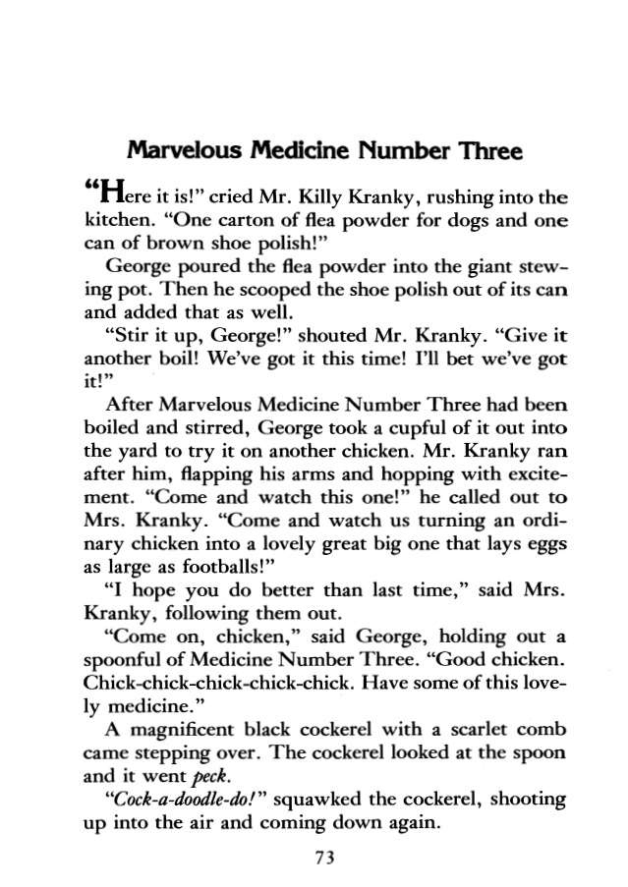

Task 1 (Green) Read the extract above. Identify the two ingredients added to ‘marvellous medicine number three’. Now, write the method used to make it using imperative verbs. Begin with a sequencing connective.

‘Marvellous Medicine Number Three’ - Recipe

Ingredients | Method

Task 2 (Amber) Read the extract below where George makes ‘marvellous medicine’ to use on his Grandma. There are five ingredients used and Roald Dahl simply says, ‘he emptied them one by one into the pot’. Could you write the recipe and method in more detail using imperative verbs and sequencing connectives?
Use the imperative verbs in the table below to help you.

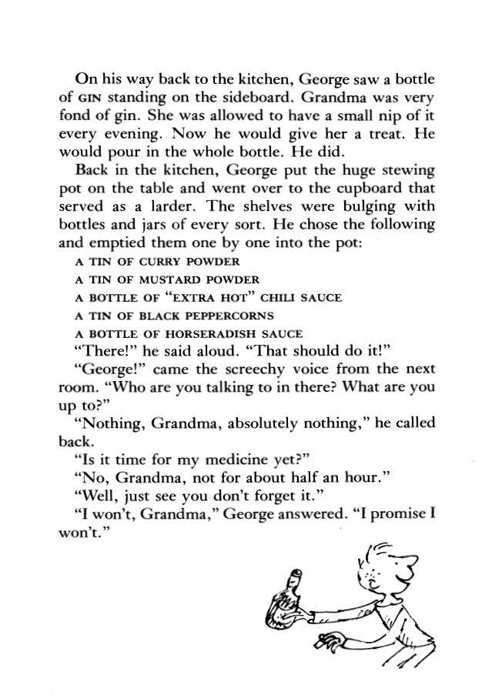
 | Scooped | Shook | Poured |  | Drizzled | Threw
‘George’s Marvellous Medicine’ - Recipe

Ingredients |  |  |  | Method  - First, --------------------------------------------------------------------------------------------------------------------------------------------------------------------------------------------------------------------  - ----------------------------------------------------------------------------------------------------------------------------------------------------------------------------------------------------------------------------  - --------------------------------------------------------------------------------------------------------------------------------------------------------------------------------  - --------------------------------------------------------------------------------------------------------------------------------------------------------------------------------  - ----------------------------------------------------------------------------------------------------------------------------------------------------------------------------------------------------------------------------
Task 3 (Red) Read the extract below in which George is about to give Grandma his ‘marvellous medicine. On this page, he relates the ingredients he has already added, and on page 23 he begins to add more. Could you write all the ingredients (from both pages) and the method (you can make this up to make it interesting), in the form of a recipe, using imperative verbs and sequencing connectives? Use the template below to help you.
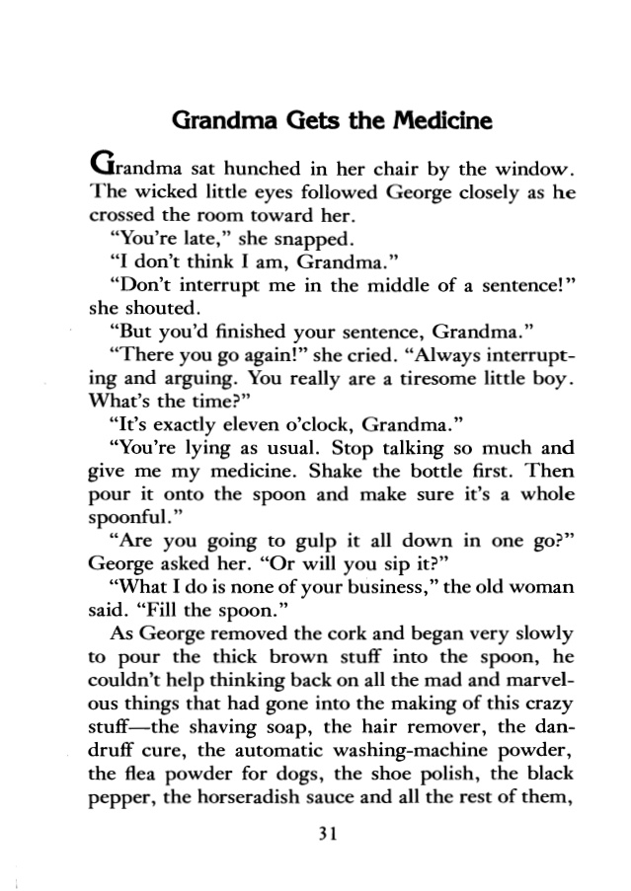

‘George’s Marvellous Medicine’ - Recipe

Ingredients | Method  - First, --------------------------------------------------------------------------------------------------------------------------------------------------------------------------------------------------------------------  - ----------------------------------------------------------------------------------------------------------------------------------------------------------------------------------------------------------------------------  - --------------------------------------------------------------------------------------------------------------------------------------------------------------------------------  - --------------------------------------------------------------------------------------------------------------------------------------------------------------------------------  - ----------------------------------------------------------------------------------------------------------------------------------------------------------------------------------------------------------------------------

Method Continued
- ------------------------------------------------------------------------------------------------------------------------------------------------------------------------------------------------------------------------------------------------------------------------

- ------------------------------------------------------------------------------------------------------------------------------------------------------------------------------------------------------------------------------------------------------------------------

- --------------------------------------------------------------------------------------------------------------------------------------------------------------------------------

- --------------------------------------------------------------------------------------------------------------------------------------------------------------------------------

- --------------------------------------------------------------------------------------------------------------------------------------------------------------------------------------------------------------------------------------------------------------------

LO: To be able to use imperative verbs to describe steps taken to shrink ‘the scary stranger in your garden’

In booklet 2, you introduced a scary stranger to your story ‘Through the Window’. You may have written something like this, using interesting verbs and adjectives:

Suddenly, a scary stranger entered my garden. He was tall, with long, greasy hair the colour of ravens. His back had a hump like a camel but he moved around as quietly as a mouse sneaking silently between the shed and the patio. He wore filthy, stained clothes…

Your task was to decide what the stranger was doing that caused a problem for you. You were working on the ‘problem’ part of your story’s structure. In this task, we will find an answer to the ‘problem.
(Look at the structure table on page 3 in booklet 2 to remind you).

Imagine that the answer to your problem (a scary stranger in your garden who is clearly up to no good) is to shrink him, so you can pick him up and take him to the police station. You decide to make a potion like George’s to do this so you can simply offer your stranger ‘a glass of water….’ Ha, ha, ha!

Task 1 (Green) Look at the ingredients George used on his grandma. What could you use on your stranger? Look around your house for things you could use and invent interesting and funny names for them - remember, it is dangerous to mix chemicals so this is an imaginary ‘medicine’. Write your list of ingredients below – remember to be specific.

Shrinking Ingredients Required:

Ingredients | Quantity | Equipment e.g. grater

Now, write the recipe. Use imperative verbs at the start of each step and try to make it funny and engaging like Roald Dahl’s version of Greorge’s medicine.

Shrinking Recipe Method
Step 1
--------------------------------------------------------------------------------------------------------------------------------------------------------------------------------------------------------------------------------------------------------------------------------------------------------------------------------------------------------------------
Step 2
--------------------------------------------------------------------------------------------------------------------------------------------------------------------------------------------------------------------------------------------------------------------------------------------------------------------------------------------------------------------
Step 3
--------------------------------------------------------------------------------------------------------------------------------------------------------------------------------------------------------------------------------------------------------------------------------------------------------------------------------------------------------------------
Step 4
--------------------------------------------------------------------------------------------------------------------------------------------------------------------------------------------------------------------------------------------------------------------------------------------------------------------------------------------------------------------
Step 5
--------------------------------------------------------------------------------------------------------------------------------------------------------------------------------------------------------------------------------------------------------------------------------------------------------------------------------------------------------------------
Step 6
--------------------------------------------------------------------------------------------------------------------------------------------------------------------------------------------------------------------------------------------------------------------------------------------------------------------------------------------------------------------

Task 2 (Amber) In addition to task 1, use sequencing connectives and specific imperative verbs to your recipe e.g. First, sprinkle… Second, dice…

Task 3 (Red) In addition to task 2, use adjectives to make your recipe clearer. Describe each ingredient in detail as you add it to your potion e.g. Firstly, mash slimy food bits from the bottom of used dishwater. Secondly, slice a rotten, brown cherry tomato, mix with a fiery chilli and…

LO: To be able to describe the effect of your shrinking potion on your scary stranger
Imagine that you have made your shrinking potion. You now have to get your stranger to drink it… What effect will it have on him? Remember, George’s potions didn’t always go to plan!
Read what happened to George’s grandma below:
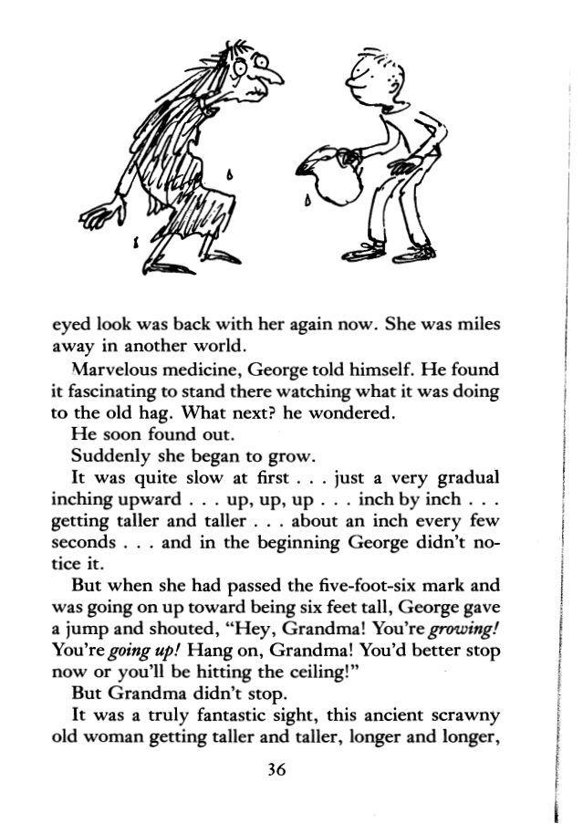
Task 1 (Green) Using the sentence starters below, describe what happens to your scary stranger when he drinks your potion. Remember, your intention was to shrink him so you could easily take him to the police station. Is this what happens or does something go wrong…? In the first box, begin by describing how you make your potion.
Through the Window – Shrinking the Scary Stranger
Suddenly, I had an idea! I could shrink the stranger, pick him up, drop him in my pocket and take him to Officer Brown at Leeds Police Station. Yes, he’d know what to do with this character who’d been poking around my garden! I began by making a potion to shrink him.
Firstly, I sprinkled --------------------------------- into a big, shiny pan. Secondly, I------------------------------------------------------------------------------------------------------------------------------------------------------------------------------------------------------------------------------------------------------------------------------------------------------------------------------------------------------------------------------------------------------------------------------------------------------------------------------------------------------------------------------------------------------------------------------------------------------------------
I couldn’t believe the effect my potion had on the stranger….
First, he began to------------------------------------------------------------------------------------------------------------------------------------------------------------------------------------------------------------------------------------------------
Next, he started to-----------------------------------------------------------------------------------------------------------------------------------------------------------------------------------------------------------------------------------------------
After that, he-----------------------------------------------------------------------------------------------------------------------------------------------------------------------------------------------------------------------------------------------------
Eventually, he---------------------------------------------------------------------------------------------------------------------------------------------------------------------------------------------------------------------------------------------------
Then suddenly, he-----------------------------------------------------------------------------------------------------------------------------------------------------------------------------------------------------------------------------------------------
Task 2 (Amber) In addition to completing task 1, include interesting verbs to describe the stranger’s reaction to the potion e.g. does it make him jump, or does it make him leap? Does it make him fall, or does it make him collapse? Use the table below to help you:

Groan | Sigh | Tremble | Hop | Bellow | Stare
Dribble | Stagger | Screech | Kneel | Focus | Belch

Suddenly, I had an idea! I could shrink the stranger, pick him up, drop him in my pocket and take him to Officer Brown at Leeds Police Station. Yes, he’d know what to do with this character who’d been poking around my garden! I began by making a potion to shrink him.
Firstly, -----------------------------------------------------------------------------
Secondly, --------------------------------------------------------------------------------------------------------------------------------------------------------------------------------------------------------------------------------------------------------------------------------------------------------------------------------------------------------------------------------------------------------------------------------------
I couldn’t believe the effect my potion had on the stranger….
------------------------------------------------------------------------------------------------------------------------------------------------------------------------------------------------------------------------------------------------------------------------------------------------------------------------------------------------------------------------------------------------------------------------------------------------------------------------------------------------------------------------------------------------------------------------------------------------------------------------------------------------------------------------------------------------------------------------------------------------------------------------------------------------------------------------------------------------------------------------------------------------------------------------------------------------------------------------------------------------------------------------------------------------------------------------------------
---------------------------------------------------------------------------------------------------------------------------------------------------------------------------------------------------------------------------------------------------------------------

Task 3 (Red) In addition to completing task 2, extend your story by describing how you eventually take your stranger to the police station…or did you? What happens in your story?
----------------------------------------------------------------------------------------------------------------------------------------------------------------------------------------------------------------------------------------------------------------------------------------------------------------------------------------------------------------------------------------------------------------------------------------------------------------------------------------------------------------------------------------------------------------------------------------------------------------------------------------------------------------------------------------------------------------------------------------------------------------------------------------------------------------------------------------------------------------------------------------------------------------------------------------------------------------------------------------------------------------------------------------------------------------------------------------------------------------------------------------------------------------------------------------------------------------------------------------------------------------------------------------------------------------------------------------------------------------------------------------------------------------------------------------------------------------------------------------------------------------------------------------------------------------------------------------------------------------------
----------------------------------------------------------------------------------------------------------------------------------------------------------------------------------------------------------------------------------------------------

Task (All) Evaluate and Edit – After you have completed your story, check that you have included the things in the box that matches your level below (green, amber or red). Go back to your work and add anything you’ve missed

Have you included:
- Steps to make your potion?
- Sequencing connectives at the beginning of each step?
- The effect of your potion on your stranger?
- Capital letters at the start of each sentence?
- A full stop, question mark or exclamation mark at the end of each sentence?

Have you included:
- Steps to make your potion?
- Sequencing connectives at the beginning of each step?
- The effect of your potion on your stranger?
- Capital letters at the start of each sentence?
- A full stop, question mark or exclamation mark at the end of each sentence?
- Interesting verbs to describe the stranger’s reaction?

Have you included:
- Steps to make your potion?
- Sequencing connectives at the beginning of each step?
- The effect of your potion on your stranger?
- Capital letters at the start of each sentence?
- A full stop, question mark or exclamation mark at the end of each sentence?
- Interesting verbs to describe the stranger’s reaction?
- An extension to your story describing how you eventually took your stranger to the police station?

