Science Experiments to do at home.
6. Gravity defying water
Safety First-
This experiment is best done outdoors
Eye protection is recommended but not essential, work carefully and try not to get soaked! Always try to keep the card flat when you remove it. If you do not have a laminated card thick cardboard or a cereal packet will work just as well 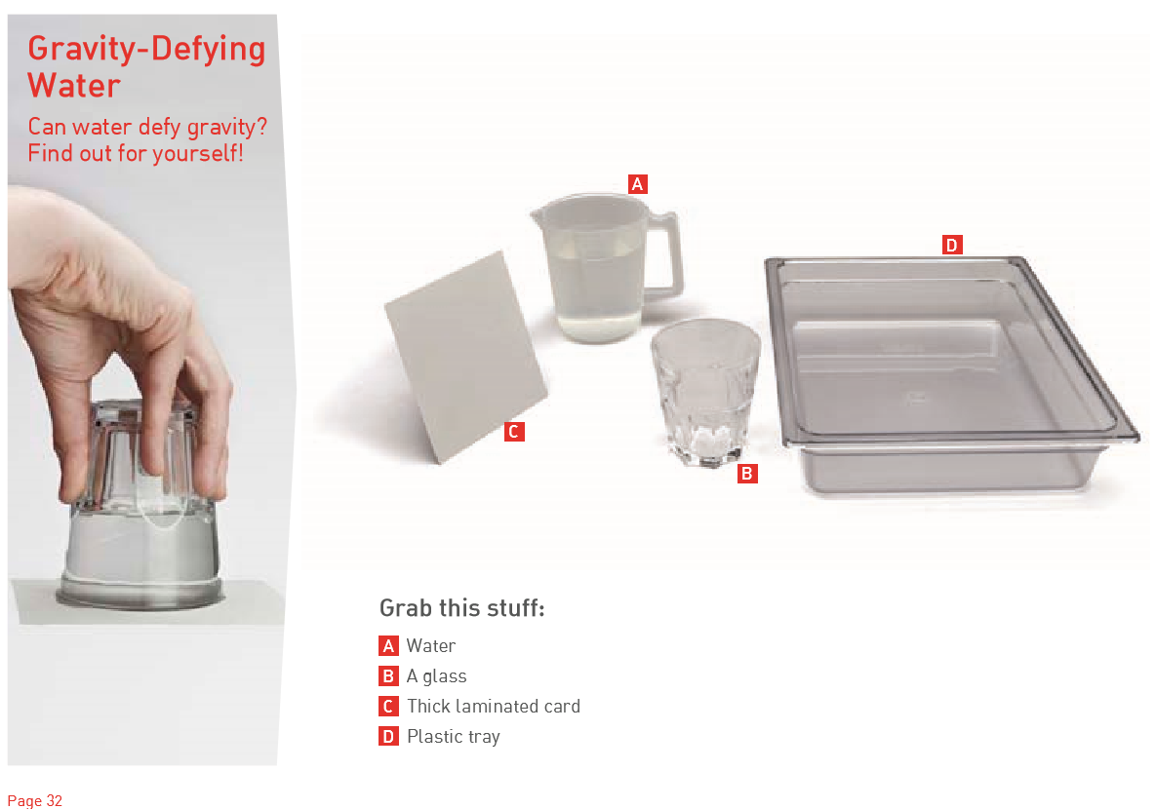

Method- follow the steps below.

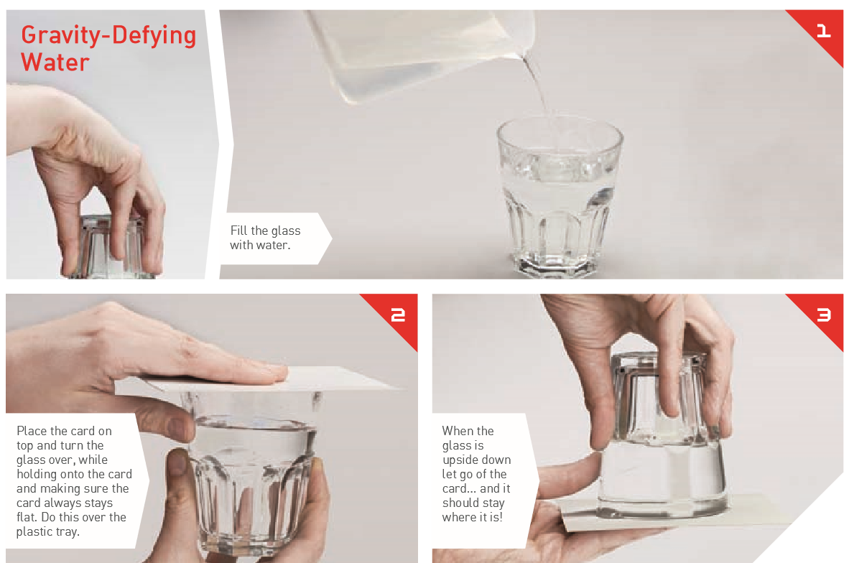
Explanation, points to discuss and extension and links to real life.
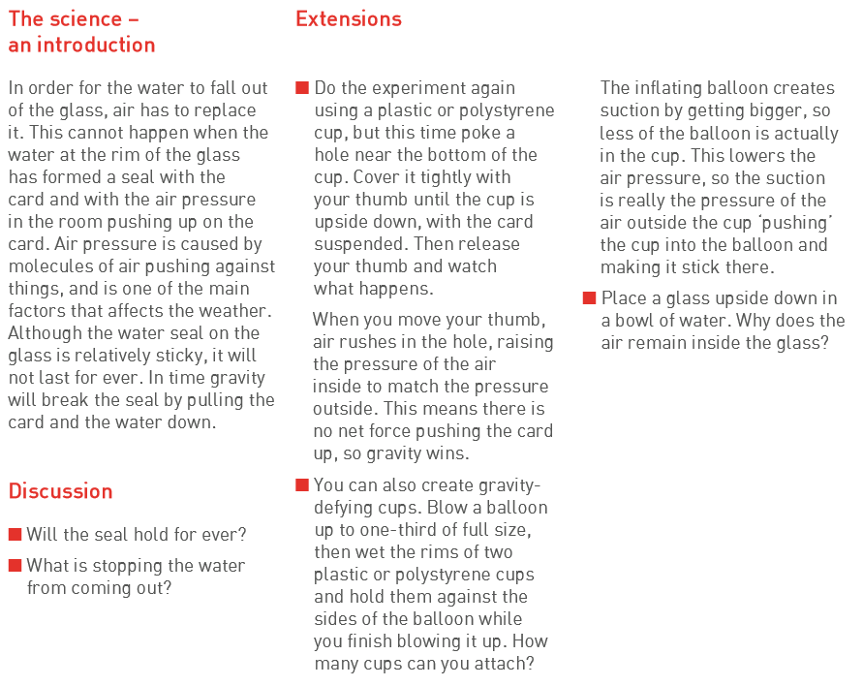
Links to real life-
