Science Experiments to do at home.
5. Milk Magic- Make your own beautiful rainbow patterns in milk
Safety First-
This experiment is best done outdoors
Eye protection is recommended but not essential, work carefully and try to minimise contact between skin and eyes with the food colouring and washing up liquid.
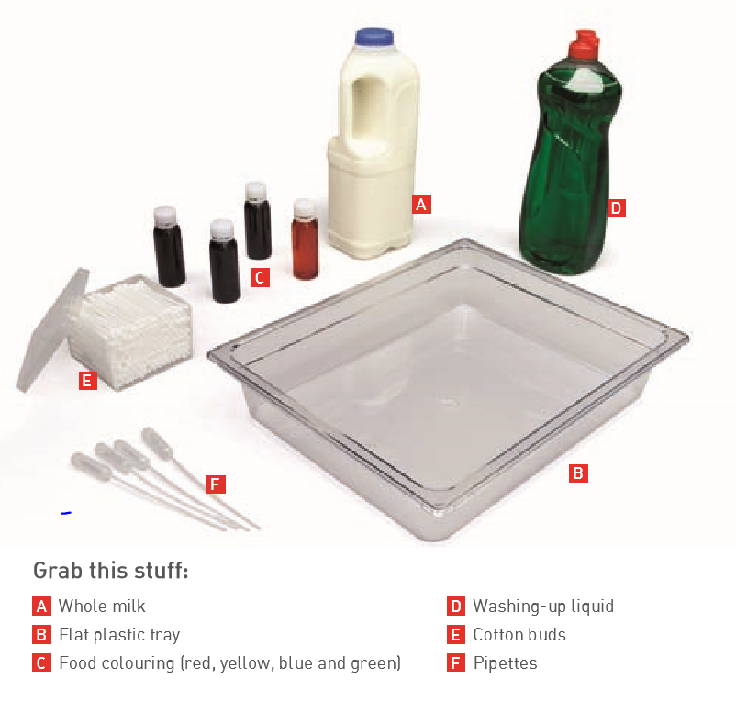
Method- follow the steps below.
Firstly check that any food colourings you use do not sink in the milk. Always wash container well if you choose to repeat, as traces of washing up liquid and food colouring can contaminate any experiments.

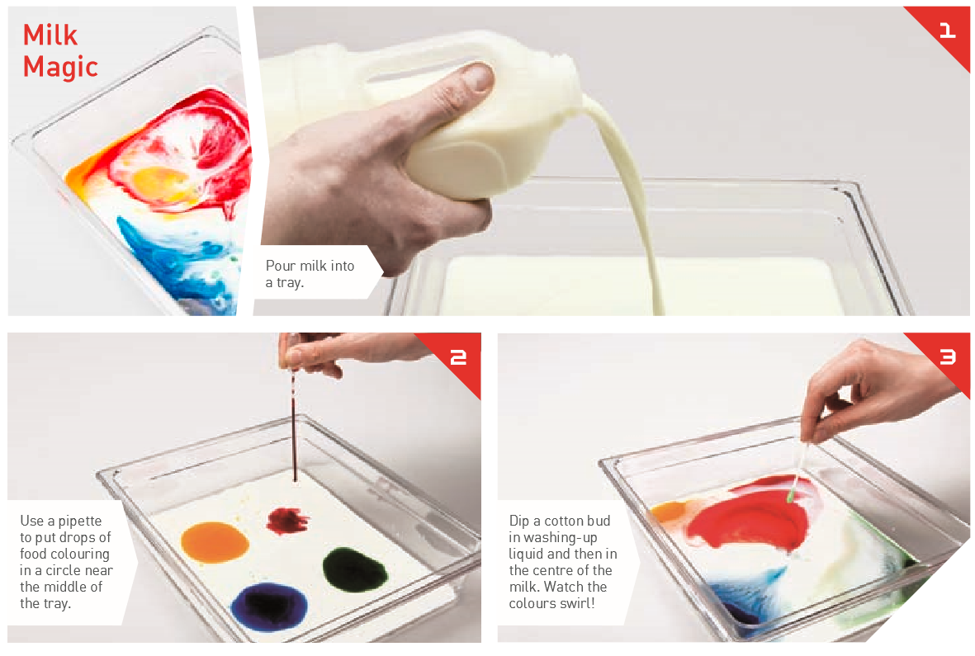
Explanation, points to discuss and extension and links to real life.
