Physics lesson 2 (Year 7)

Energy Stores.

https://www.bbc.co.uk/bitesize/articles/zh68wty
Home learning focus
Learn about energy stores, useful and wasted energy in energy transfers. How Sankey diagrams can be used to represent energy transfers.

Learn

Conservation of energy
Energy cannot be either created or destroyed.
This law of energy means that energy is eternal and is all around us. It also means that when it is not being used, then it must be stored somewhere, ready to be transferred somewhere else.
Energy that is stored or waiting to be transferred is called an energy store.
A waterfall is a great example of how potential energy is stored and then transferred to movement, sound and heat when the water falls.
There are different forms of energy store, including:
kinetic energy, internal energy, elastic potential energy, gravitational potential energy, electrical energy, magnetic energy, chemical energy

Kinetic energy
All moving things have kinetic energy , even very large things like planets, and very small ones like atoms.
The amount of kinetic energy an object has depends upon:
the mass of the object AND the speed of the object

Internal energy - All objects have internal energy . This includes:
Energy caused by the movement of particles, sometimes called thermal energy
Energy due to the bonds between particles, sometimes called chemical energy

Elastic potential energy- is stored in squashed or stretched objects
Some objects can change shape reversibly. Rubber balls, springs and elastic bands are like this.
When a rubber ball is stretched or squashed, it can regain its shape again.

Magnetic energy
Some objects can be magnetised and create magnetic fields.
They can exert forces on other magnetised objects, or on magnetic materials.

Gravitational potential energy
When an object is moved higher, it gains gravitational potential energy.
The amount of gravitational potential energy it gains depends upon:
The mass of an object, The extra height it gains AND The gravitational field strength

Electrical energy
Some objects carry electrical charges and create electric fields.
These charged objects can exert forces on each other.
You get an electric current when charged particles move through a wire.

Chemical energy
Energy stored in fuel or a battery is called chemical energy.
Energy is stored in the chemicals ready to be transferred to other energy types like electrical or heat.
Sankey Diagrams
We use Sankey diagrams to represent energy transfer.
The thicker the line or arrow, the greater the amount of energy involved. The length of the arrow doesn't matter.

Example: a light bulb

Energy in a light bulb will be stored as electrical energy

Energy will be transferred into heat and light when it is switched on
Energy is conserved: 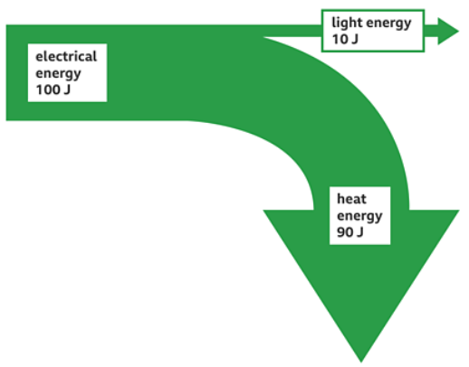
- = 90 J + 10 J
In this transfer: -light energy is considered useful because we need light to be able to see. Heat energy is wasted as it just heats up the surroundings and is lost
Practise

Activity 1
Complete the worksheet titled “What is energy KS3”

Activity 2
Complete the worksheet titled “Sankey Diagrams KS3”
Extension- Walk around your house and find 5 electrical appliances such as mobile phones, TV, hairdryer. Can you state the- 1. Type of input energy (battery is chemical, if it is plugged in it’s electrical. 2. The useful output energy (such as light and sound in a TV) 3. The wasted energy (this is often as Heat or Sound).

