Measures:

Common metric measures of length, volume and mass:
mm, cm, m , km millimetre centimetre metre kilometre
ml L millilitre Litre
g Kg gram kilogram

Imperial units could be miles, inches, gallons, pints, stone, pounds and ounces for example.

Converting:

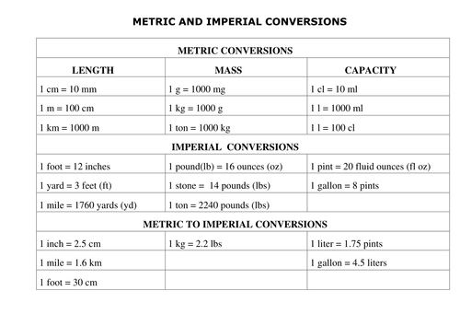
So, for example: 7.6kg = 7.6kg x 2.2 = 16.72lbs (Pounds)

