Key Stage 4 Science lesson

Topic- DNA, genes and chromosomes

https://www.bbc.co.uk/bitesize/articles/zbnhnrd

Learn
Heredity is the process where genetic information is passed from parents to offspring. DNA, found in the nuclei of cells and organised into chromosomes, is the substance that carries this information.
Watch this video about DNA from a forensic scientist. You may want to pause the video and use a notepad and pen to make notes - there'll be a quiz to test you later.

DNA, genes and chromosomes
What is DNA?
DNA stands for deoxyribonucleic acid. It is a chemical made up of two long molecules. The molecules are arranged in a spiral, like a twisted ladder. We call this the double helix structure.
There is DNA in the nucleus of every cell. DNA carries genetic information. It has all the instructions that a living organism needs to grow, reproduce and function.

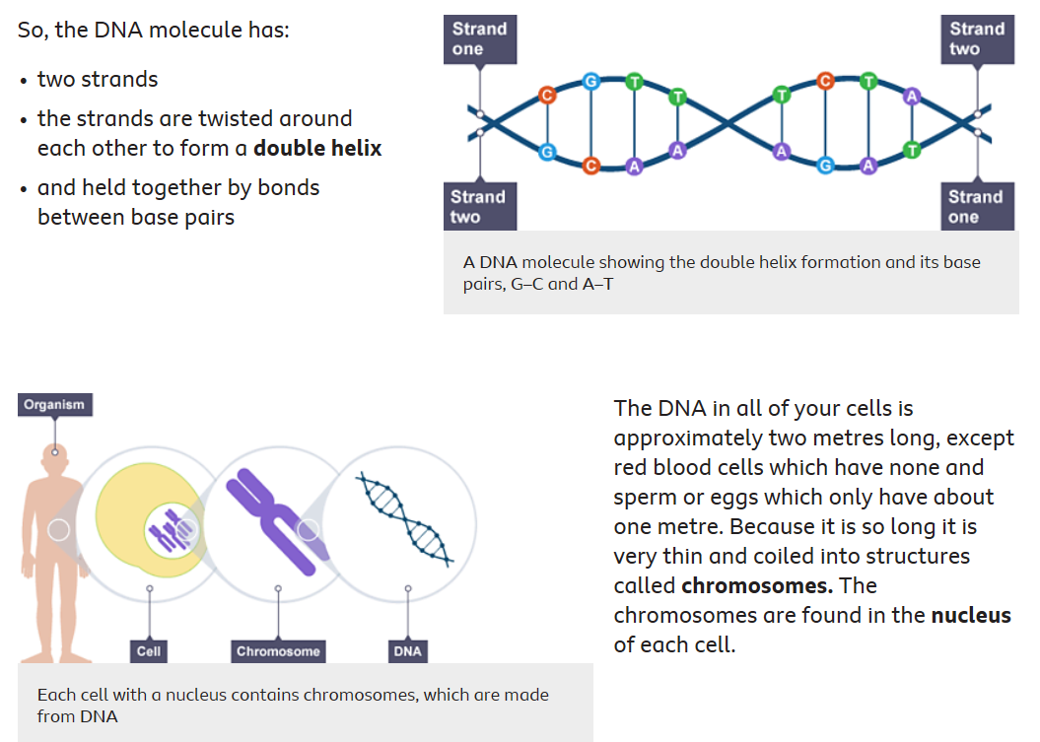

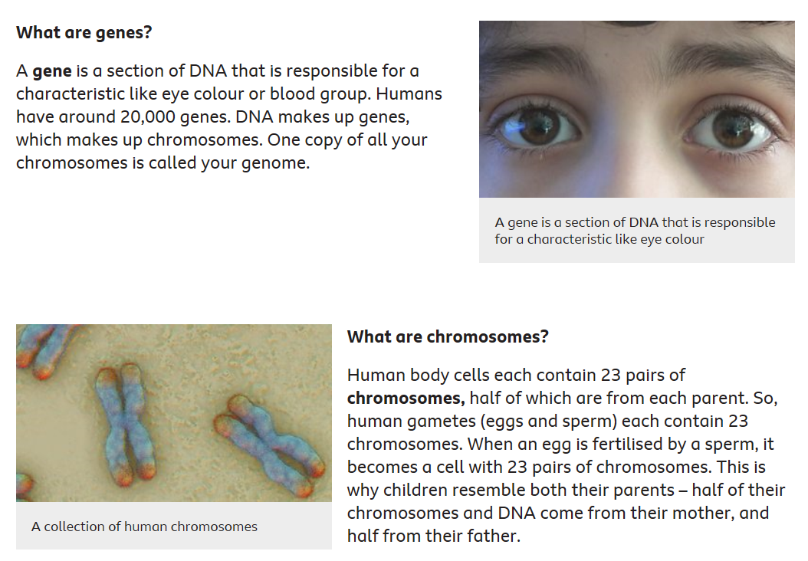

Activity 1

Colour in the sheet. Ensure all of the base pairs are represented by different colours. Can you think of a rhyme or mnemonic to remember that bases A (adenine) and T (thymine) always go together as do G (guanine) and C (cytosine).

Activity 2
Put the following in order of size from the largest to the smallest-
Chromosome
Nucleus
Cell
Base
Gene

Activity 3
Complete the worksheet titled “DNA, genes and chromosomes worksheet”.

