ANSWERS Metric & Imperial Conversion

- 19.2km
- £58
- 180

8 oz flour | 2 oz sugar | 3 oz butter | 5 oz oats
240g | 60g | 90g | 150g

- 1440km
- 6
- 660
- 187.5cm, 180cm, 195cm, 175cm
Metric & Imperial Conversion

- Mr Martin needs to run 12 miles in training for a half marathon. His phone app only measures in km. How far does he need to run in km?

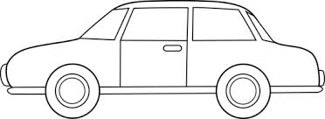
- The tank of Mr Martin’s car holds 45 litres. He fills it at a pump which charges £5.80 per gallon. How much does it cost him?

- A supermarket worker finds a crate of 50 2-litre milk cartons in the warehouse which are off. He records details on a stock write off sheet which asks for the amount in pints. How many pints are written off?

- A cooking recipe asks for the following measurements:

8 oz flour | 2 oz sugar | 3 oz butter | 5 oz oats
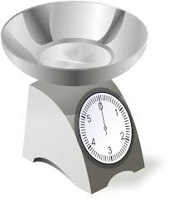
The weighing scales only measure in grams, work out the conversions in the table above.

- The Land’s End to John O’Groats bike ride is 900 miles long. What is this in km?

- A 130 litre diesel spill needs to be cleared from the motorway. The highways authority use special boom kits which each absorb 5 Gallons. How many boom kits do they require?

- A weightlifter is lifting 300kg, how much is this in pounds?

- The heights of 4 rugby players are recorded as follows:
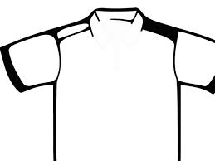
H – 6 Foot 3
H – 5 Foot 10
H – 6 Foot
H – 6 Foot 3
W – 17 stone

H – 6 Foot 6

Convert their heights into cm.

