Conversion between fraction, decimal and percentage, complete and amazing practice
Change into percentages: The first one is done for you.  - 0.2= 100 x 0.2 = 20%  - 0.5  - 0.6  - 0.9  - 0.25  - 0. 35  - 0.75  - 0.65  - 0.95  - 0.03  - 0.03  - 0.06  - 0.005 | Change into decimals: The first one is done for you.  - 11% = 11/100 = 0.11  - 17%  - 23%  - 88%  - 63%  - 9%  - 8%  - 1%  - 12.5%  - 15.8%  - 11.2%  - 0.2%  - 0.21%

Extension:
Fractions | Decimals | Percentages
 | 0.8
 |  | 24%
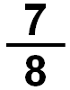
 |  | 45%
 | 0.14
 |  | 5%
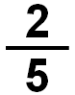
 | 0.02
 |  | 60%
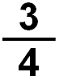
 | 0.94

