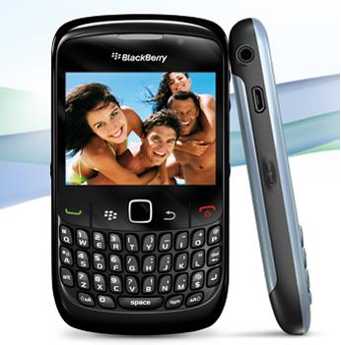

**Sketch and annotate your own mobile phone, xbox or sony playstation**

screen

On/off button

Space bar

Call/answer button

It allows the user to see what they are doing

**Annotating my phone**

scroll