Year 9
English Work Pack
30/3/20 – 3/4/20

Welcome to this week’s English topic!

Games

We will have fun learning to:

- Identify persuasive features in others’ writing
- Use persuasive features in our own writing
- Plan and write a persuasive speech
- Evaluate and edit our speeches to make them BRILLIANT!

Choose your own task level (green = easy, amber = slightly harder, red = challenge)

30 - 31/3/20 LO: To be able to identify persuasive features in others’ writing.

Persuasive features convince a reader to agree with the topic. Below are a list of features used to persuade:

Feature | Persuasive Technique
Rhetorical Questions | A question asked in order to create a dramatic effect or to make a point rather than to get an answer.
Exclamations
Ellipsis | Punctuation (…) - used to suggest that the reader thinks carefully.
Statistics
Expert opinions/ Examples | The view of a qualified person on the topic.
Emotive words
Personal pronouns | Words like ‘I’, ‘You’ or ‘We’ – used to involve the reader personally with the topic.

Task 1 (Green) Use a dictionary, or your mobile phone if you don’t have one, to look up the missing definitions of the devices above.
Task 2 (Amber) Complete task one and give an example for three of the features. Explain how they are used to persuade the reader.

Task 3 (Red) Complete task one and give examples for each of the features. Can you think of any other persuasive features? Explain how they are used to persuade the reader.

Feature | Example
Rhetorical Questions

Exclamations
Ellipsis
Statistics
Expert opinions/ Examples
Emotive words
Personal pronouns

Task 1 (Green) Read the following persuasive text written by a student. With a coloured pen, highlight the persuasive features they have tried to use. How are they used to persuade the reader? Answer using the table below.

Are Mobile Phones Necessary?
I strongly believe that mobile phones are vital! My reason for this belief is that mobile phones are extremely convenient for businesspeople who travel a lot, and they are essential to have in case of an emergency.
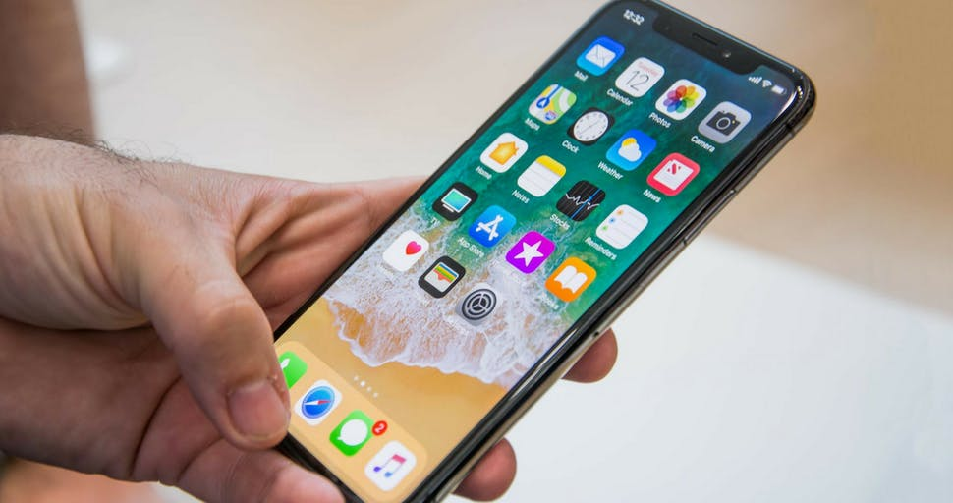
Mobile phones are essential because they are convenient for businesspeople. For example, if you are working away from home or even working overseas and you have to contact a client to do some important work, it is useful to have one to use. By using a mobile phone, important information can be received. People can’t stay in an office all day waiting for their phone to ring, can they?
Some people have to go and do jobs, or they will go out of business. What’s even better is that you can even send messages and use the internet with your mobile.
My other main reason is that mobile phones are vital to have in case of an emergency. 68% of paramedics say that lives have been saved simply due to a quick response due to mobile phones. For instance, if you tragically fall down a flight of stairs in a building and you are badly injured, imagine how relieved you’d be to have a mobile phone on hand to use. Or, if your car breaks down in the middle of the night in a dangerous neighbourhood, it would be foolish to leave it in search of a public phone booth. Not only will you worry about your car being neglected, but you could also put yourself in a desperately vulnerable situation.
In conclusion, I believe that mobile phones have now become an indispensable part of our everyday life. Instant communication will ensure that crucial information can be passed on with a simple press of a button. Whether this is to do with business or personal information or emergencies, mobile phones are crucial to live our lives.
Persuasive feature example  (copy the sentence) | How it is used to persuade the reader

Task 2 (Amber) Read the following persuasive text. With a coloured pen, highlight the persuasive features used. How are they used to persuade the reader? Answer using the table below.

The Exclusive Five Palms Hotel
Rated:
*****
By Trip Advisor
Experts
Our Guests said:
Thomas (aged 14)
"This has to be the best kids club
I've ever been to.
I absolutely loved the football
tournament and obstacle course."

Are you ready for some family fun in the sun? If the answer is yes, choose the exclusive Five Palms Hotel for your all-inclusive family holiday.

The award-winning Five Palms Hotel is one of the most modern hotels in the area with something to suit all ages. We are proud to offer three outdoor swimming pools, one indoor pool, a fully equipped gym, a tennis court and luxury spa.
The Five Palms Hotel has a large, air-conditioned restaurant and snack bar which offers a wide selection of food to suit even the fussiest of eaters. Expert reviews confirm that 98% of guests were delighted with our menu.
Kids will definitely enjoy the huge, indoor play gym or spending time at one of our fantastic clubs: High Fivers (ages 4-7) and Five Alivers (ages 8-12), both of which run from 9am until 5pm every day, giving adults time to switch off! High Fivers activities include stories, arts and crafts, team games and drama whilst Five Alivers offers a wide range of sports, music, dancing, obstacle courses and more!
Situated on the beach, sea views and balconies come as a standard with every room, as does air-conditioning, satellite TV and an en-suite bathroom. What’s not to love?
Our hotel is in a prime location and only 15 minutes away from Palms Airport, so why would you want to go anywhere else?

Persuasive feature example  (copy the sentence) | How it is used to persuade the reader
Task 3 (Red) Read the following persuasive text. With a coloured pen, highlight the persuasive features used and show how they persuade the reader? Answer using the table below.
Tribute to Dogs (adapted)
George Graham Vest - c. 1855
The one, absolutely unselfish, friend that man can have in this selfish world, the one that never deserts him, the one that never proves ungrateful or treacherous. Who is it? It is his dog.
A man's dog stands by him in prosperity and in poverty, in health and in sickness. He will sleep on the cold ground, where the wintry winds blow and the snow drives fiercely, if only he may be near his master's side. He will kiss the hand that has no food to offer. He will lick the wounds and sores that come in encounters with the roughness of the world. He guards the sleep of his pauper master as if he were a prince. When all other friends desert, he remains! When riches take wings, and reputation falls to pieces, he is as constant in his love as the sun in its journey through the heavens.
If fortune drives the master forth, an outcast in the world, friendless and homeless, the faithful dog asks no higher privilege than that of accompanying him, to guard him against danger, to fight against his enemies. And when the last scene of all comes, and death takes his master in its embrace and his body is laid away in the cold ground, no matter if all other friends pursue their way, there by the graveside will the noble dog be found, his head between his paws, his eyes sad, but open in alert watchfulness, faithful and true even in death.

Persuasive feature example  (copy the sentence)  You may use the same feature more than once with different examples. | How it is used to persuade the reader

1/4/20 LO: To be able to plan a persuasive speech.

You are going to write a persuasive speech for your class.
The title of this speech will be:

Video Games Negatively affect Young People Today

Task – All (Green, Amber and Red) Planning:
Decide who the audience (listeners) of this speech will be. Write Below:
------------------------------------------------------------------------------------------------------------------------------------------------------------------
Decide what the purpose of the speech is (the reason for the speech).
Write Below:
------------------------------------------------------------------------------------------------------------------------------------------------------------------

Now plan points you would like to talk about.

Think about the negative effects of playing video games e.g.

- Wasting time better spent on other things
- Lack of exercise
- Exposure to screen violence
- Isolation through playing alone
- Grooming through online gamers posing as young people.
Planning:
Write each separate point you would like to discuss next to the arrows below. Try to think of examples to support your points.
Each point will become a separate paragraph in your speech.

Video Games Negatively Effect Young People Today

2/4/20 LO: To be able to write a persuasive speech.

Task – All (Green, Amber and Red) Look at the persuasive examples considered earlier. How did they start?
You will notice that each one began with an introduction outlining the key topic and including a persuasive technique to immediately engage the audience.

- Introduction e.g. (Green) ‘I strongly believe that mobile phones are vital!’ (Emotive words)
(Amber) ‘Are you ready for some family fun in the sun?’ (Rhetorical question)
(Red) ‘The one, absolutely unselfish, friend that man can have in this selfish world, the one that never deserts him, the one that never proves ungrateful or treacherous. Who is it? It is his dog.’(Emotive language and examples)

What came next?

- A series of separate points supported by examples.

How did each one end?

- A powerful concluding sentence or paragraph.

(Green) ‘…mobile phones are crucial to live our lives.’
(Amber) ‘why would you want to go anywhere else?’
(Red) ‘…the noble dog be found, his head between his paws, his eyes sad, but open in alert watchfulness, faithful and true even in death.’

Task 1 (Green) Use the following template to help you write up your planned points into a speech for your class.

Tips for success:
- Try to discuss only one clear point at a time
- Support each point with evidence e.g. expert opinion/ examples of your own
- Include at least one rhetorical question
- An emotive, powerful concluding sentence
Video Games Negatively affect Young People Today

Introduction e.g. Video games are extremely dangerous for young people for several reasons. These are………and I would urgently like to discuss each of these reasons with you today.

Discuss one point with examples e.g. Firstly, I would like to talk about….

Discuss second point with examples.

Discuss third point with examples.

Conclude with a powerful sentence or question.

Task 2 (Amber) Use the following template to help you write up your planned points into a speech for your class.

Tips for success:
- Discuss only one clear point at a time
- Support each point with evidence e.g. expert opinion/ examples of your own
- Include several rhetorical questions
- Include a powerful exclamation
- Include some ellipsis appropriately
- Include some statistics
- Include an emotive, powerful conclusion
Video Games Negatively affect Young People Today

Introduction

Discuss one point with examples

Discuss second point with examples.

Discuss third point with examples.

Discuss fourth point with examples

Conclude with a powerful paragraph.

Task 3 (Red) Write up your planned points into a speech for your class.

Tips for success:
- Begin with a thought-provoking introduction
- Discuss only one clear point at a time
- Support each point with evidence e.g. expert opinion/ examples of your own
- Include several rhetorical questions
- Include a powerful exclamation
- Include some ellipsis appropriately
- Include some statistics
- Include an emotive, powerful conclusion

Video Games Negatively affect Young People Today

------------------------------------------------------------------------------------------------------------------------------------------------------------------------------------------------------------------------------------------------------------------------------------------------------------------------------------------------------------------------------------------------------------------------------------------------------------------------------------------------------------------------------------------------------------------------------------------------------------------------------------------------------------------------------------------------------------------------------------------------------------------------------------------------------------------------------------------------------------------------------------------------------------------------------------------------------------------------------------------------------------------------------------------------------------------------------------------------------------------------------------------------------------------------------------------------------------------------------------------------------------------------------------------------------------------------------------------------------------------------------------------------------------------------------------------------------------------------------------------------------------------------------------------------------------------------------------------------------------------------------------------------------------------------------------------------------------------------------------------------------------------------------------------------------------------------------------------------------------------------------------------------------------------------------------------------------------------------------------------------------------------------------------------------------------------------------------------------------------------------------------------------------------------------------------------------------------------------------------------------------------------------------------------------------------------------------------------------------------------------------------------------------------------------------------------------------------------------------------------------------------------------------------------------------------------------------------------------------------------------------------------------------------------------------------------------------------------------------------------------------------------------------------------------------------------------------------------------------------------------------------------------------------------------------------------------------------------------------------------------------------------------------------------------------------------------------------------------------------------------------------------------------------------------------------------------------------------------------------------------------------------------------------------------------------------------------------------------------------------------------------------------------------------------------------------------------------------------------------------------------------------------------------------
3/4/20 LO: To be able to evaluate and edit my writing to improve.

Look at the following definitions:
Evaluate | Assess your work to decide how good it is
Edit | Correct or modify your work to make it better

Task 1 (Green) Read and check your speech for missing words and the following:
- Only one clear point discussed in each paragraph
- Each point supported with evidence e.g. expert opinion/ examples of your own
- At least one rhetorical question included
- An emotive, powerful concluding sentence included
Edit by correcting anything you’ve missed.

Task 2 (Amber) Read and check your speech for missing words and the following:
- Only one clear point discussed in each paragraph
- Each point supported with evidence e.g. expert opinion/ examples of your own
- Included several rhetorical questions
- Included a powerful exclamation
- Included some ellipsis appropriately
- Included some statistics
- Included an emotive, powerful conclusion
Edit by correcting anything you’ve missed.
Task 3 (Red) Read and check your speech for missing words and the following:
- Began with a thought-provoking introduction
- Discussed only one clear point at a time
- Supported each point with evidence e.g. expert opinion/ examples of your own
- Included several rhetorical questions
- Included a powerful exclamation
- Included some ellipsis appropriately
- Included some statistics
- Included an emotive, powerful conclusion
Edit by writing a second draft correcting anything you’ve missed.

All (Green), (Amber) and (Red)
Remember - To make your speech BRILLIANT, you also need to check your spelling, punctuation and grammar.

