Year 9
English Work Pack 2
Parents/Carers – only complete as much, or as little, of these booklets as your circumstances allow at this difficult time.

Welcome to this week’s English topic!

Report Writing

We will have fun learning to:

- Identify a range of writing forms
- Use the correct form features of a report
- Plan and write a report
- Evaluate and edit our report to make it BRILLIANT!

Choose your own task level (green = easy, amber = slightly harder, red = challenge)

LO: To be able to identify a range of writing forms

Look at the different types of writing below. Can you see the differences between the way they are presented? Each type has its own unique layout and features. These features make them easier for the reader to access.

Task 1 (Green) Label the features of the texts below:

Formal Letter

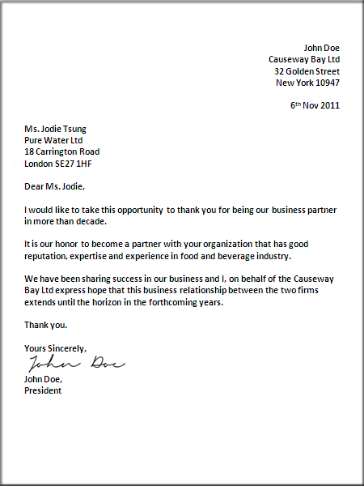

Email
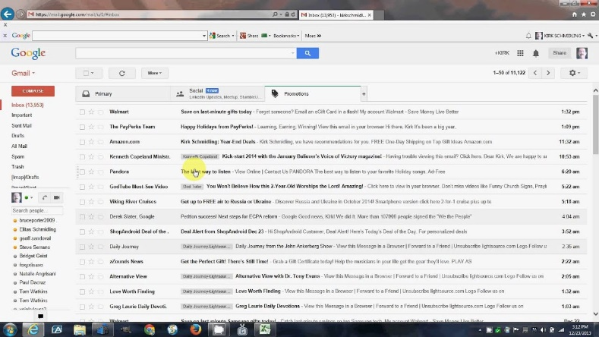
Task 2 (Amber) Label the features of the texts in task 1 and the ones below:

Review

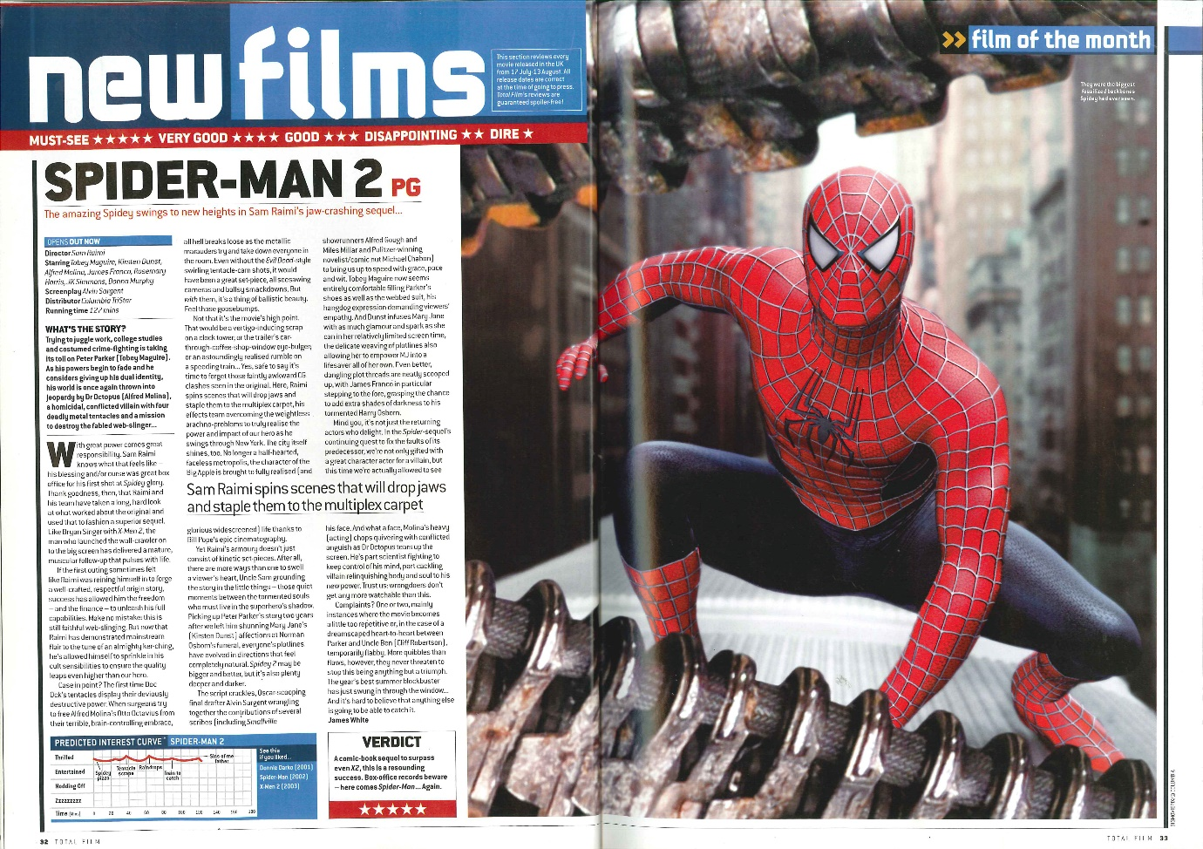

Article

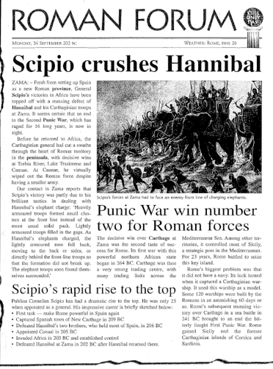

Task 3 (Red) Label the features of the texts in task 1 and 2 and note any similar features.

Text | Similar Features
LO: To be able to explain how specific layout and form features help the reader

The purpose of a text determines which layout features are most useful to the reader.

The purpose and audience of a text determines other form features such as the sort of language and tone that should be used.

Look at the four main purposes of texts that you could come across:

Informative | Gives the reader information  Full of facts
Descriptive | Tells the reader what something is like  Uses lots of adjectives
Instructive | Gives the reader instructions to follow  Tells the reader how to do something  Uses clear language that is easy to understand  Uses imperative verbs
Persuasive | Tries to convince the reader to do something  Uses language that could make the reader feel as certain way (emotive)  Sometimes uses facts and examples to support points made

Task 1 (Green) Can you identify the various types of texts and their purposes below?

- Text Type  ----------------------------------------------------------  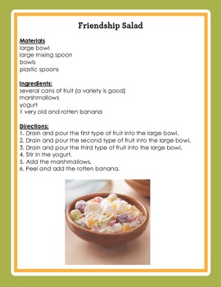 | Text Purpose  --------------------------------------------------------------------------------------------------------------------------------------------------------------------------------------------------------------------------------------------------------------------------------------------------
- Text Type  ----------------------------------------------------------Berlin is one of the most interesting cities in Europe, and certainly the one that has changed the most in the last 20 years. Once the symbol of the Cold War, it has become Europe’s capital of cool – a vibrant mix of fashion, design, music and art.  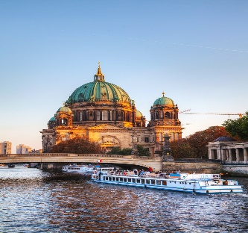  A cultural city always on the move and a budget traveller’s paradise, the German capital has something for everyone, from pulsating nightlife to more than 170 world-class museums, galleries, and philharmonics, and from stately relics that still tell the story of its turbulent past to all the promises of a glittering future. | Text Purpose  ----------------------------------------------------------  --------------------------------------------------------------------------------------------------------------------------------------------------------------------------------------------------------------------------------------------------------------------------------------------------

- Text Type  ----------------------------------------------------------  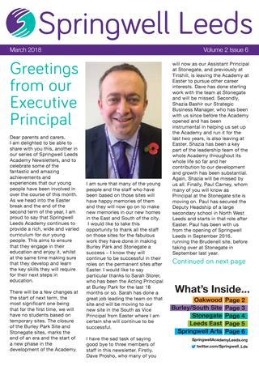 | Text Purpose  -----------------------------------------------------------------------------------------------------  ------------------------------------------------------------------------------------------------------------------------------------------------------------------------------------------------------------------------------------------------------------------------------------------------------------------
- Text Type  -------------------------------------------------------------- | Text Purpose  -----------------------------------------------------------------------------------------------------  ------------------------------------------------------------------------------------------------------------------------------------------------------------------------------------------------------------------------------------------------------------------------------------------------------------------
Task 2 (Amber) Can you identify the various types of texts and their purposes in Task 1? In addition, can you identify the target audience (reader) of each text and explain your answer?

- Target Audience
------------------------------------------------------------------------------------------------------------------------------------------------------------------------------------------------------------------------------------------------------------------------------------------------------------------------------------------------------------------------------------------------------------------------------------------------------------------------------------------------------------------------------------------------------------------------

- Target Audience
------------------------------------------------------------------------------------------------------------------------------------------------------------------------------------------------------------------------------------------------------------------------------------------------------------------------------------------------------------------------------------------------------------------------------------------------------------------------------------------------------------------------------------------------------------------------

- Target Audience
------------------------------------------------------------------------------------------------------------------------------------------------------------------------------------------------------------------------------------------------------------------------------------------------------------------------------------------------------------------------------------------------------------------------------------------------------------------------------------------------------------------------------------------------------------------------

d) Target Audience
------------------------------------------------------------------------------------------------------------------------------------------------------------------------------------------------------------------------------------------------------------------------------------------------------------------------------------------------------------------------------------------------------------------------------------------------------------------------------------------------------------------------------------------------------------------------
Task 3 (Red)
Identify the various types of texts and their purposes in Task 1? Identify the target audience of each text and explain your answer? Annotate (label) each text to show examples of specific presentational features used to make the text more effective e.g. numbered lists to make instructions easier to follow.

- Target Audience
------------------------------------------------------------------------------------------------------------------------------------------------------------------------------------------------------------------------------------------------------------------------------------------------------------------------------------------------------------------------------------------------------------------------------------------------------------------------------------------------------------------------------------------------------------------------

- Target Audience
------------------------------------------------------------------------------------------------------------------------------------------------------------------------------------------------------------------------------------------------------------------------------------------------------------------------------------------------------------------------------------------------------------------------------------------------------------------------------------------------------------------------------------------------------------------------

- Target Audience
------------------------------------------------------------------------------------------------------------------------------------------------------------------------------------------------------------------------------------------------------------------------------------------------------------------------------------------------------------------------------------------------------------------------------------------------------------------------------------------------------------------------------------------------------------------------

d) Target Audience
------------------------------------------------------------------------------------------------------------------------------------------------------------------------------------------------------------------------------------------------------------------------------------------------------------------------------------------------------------------------------------------------------------------------------------------------------------------------------------------------------------------------------------------------------------------------

Extension (All) – Look around your house to find examples of texts with different purposes and intended audiences.

Record your findings in the table below:

Text type  e.g. Instructive, descriptive | Main Purpose | Intended Audience
LO: To be able to identify the features of a report

A report is a document that presents information in an organised

format for a specific audience and purpose

Task 1 (Green) Look at the various types of report below. What do you notice about the layout features? Label the features e.g. subheadings, bullet points.

School Progress Report | Features
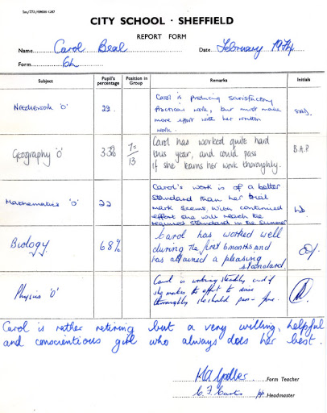

School Behaviour Report  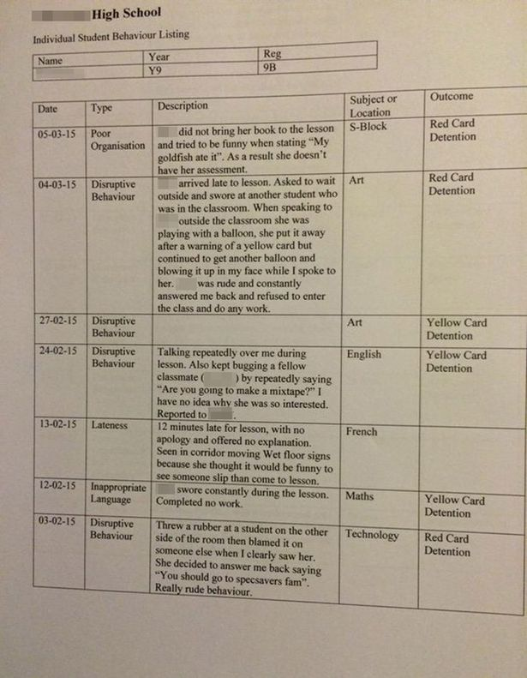 | Features
Police Report | Features
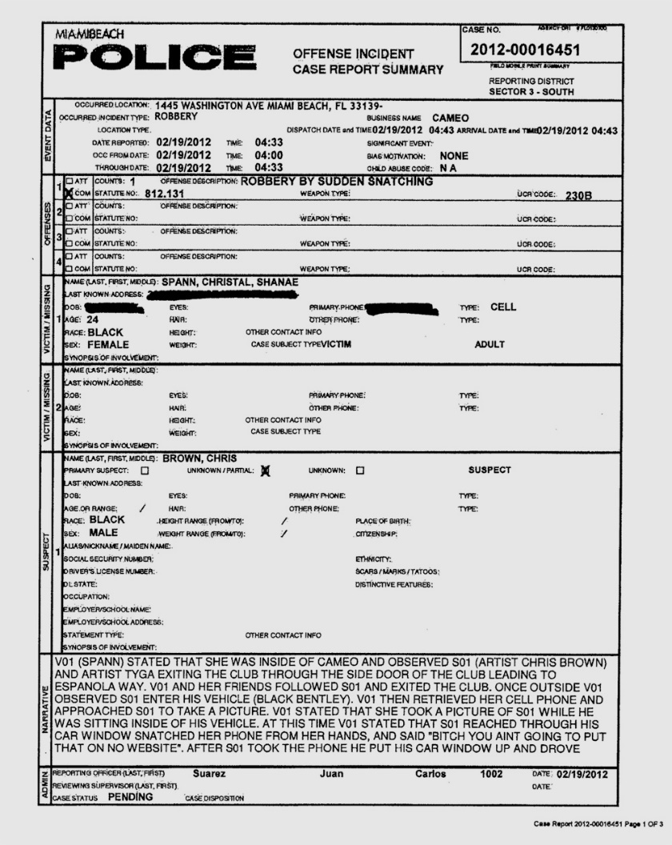
Surveyor’s Building Report | Features
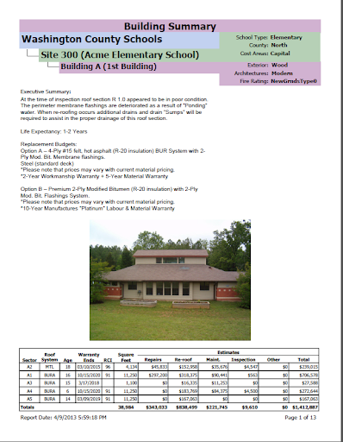

Task 2 (Amber) In addition to completing task 1, what do you notice about the language and tone used in each report? Write a sentence about each report and give some examples to support your answer e.g. In the police report, the language is clear and straightforward. It is business-like and uses subject specific words used by the police such as ‘suspect’ and ‘victim’.

School Progress Report

---------------------------------------------------------------------------------------------------------------------------------------------------------------------------------------------------------------------------------------------------------------------------------------------------------------------------------------------------------------------------------------------------------------------------------------------------------------------------------------------------------------------------------------------------------------------------------------------------------------------------------
------------------------------------------------------------------------------------------------------------------------------------------------------------------------------------------------------------------------------------------------------------------------------------------------------------------------------------------------------------

School Behaviour Report
---------------------------------------------------------------------------------------------------------------------------------------------------------------------------------------------------------------------------------------------------------------------------------------------------------------------------------------------------------------------------------------------------------------------------------------------------------------------------------------------------------------------------------------------------------------------------------------------------------------------------------
------------------------------------------------------------------------------------------------------------------------------------------------------------------------------------------------------------------------------------------------------------------------------------------------------------------------------------------------------------

Police Report

---------------------------------------------------------------------------------------------------------------------------------------------------------------------------------------------------------------------------------------------------------------------------------------------------------------------------------------------------------------------------------------------------------------------------------------------------------------------------------------------------------------------------------------------------------------------------------------------------------------------------------
------------------------------------------------------------------------------------------------------------------------------------------------------------------------------------------------------------------------------------------------------------------------------------------------------------------------------------------------------------
Surveyor’s Building Report
---------------------------------------------------------------------------------------------------------------------------------------------------------------------------------------------------------------------------------------------------------------------------------------------------------------------------------------------------------------------------------------------------------------------------------------------------------------------------------------------------------------------------------------------------------------------------------------------------------------------------------
---------------------------------------------------------------------------------------------------------------------------------------------------------------------------------------------------------------------------------------------------------------------
Task 3 (Red) In addition to completing task 1 and 2, are there any differences between the style of each report e.g. think of the audience and purpose of each report – does the number of people reading the report require additional or omitted information? Write a sentence about each one e.g. A police report may involve an unsolved case, therefore, it would be important to state this with the words ‘pending’ so that officers reading the report understand that further action is required.
School Progress

School Behaviour

Police

Surveyor

LO: To be able to identify and use formal language to write a report

Standard Features of a Report – Checklist

- A clear title (should immediately inform the reader of the topic of the report)

- An introductory paragraph outlining the main issues

- Subheadings to separate each issue to make it clearer and easier to read

- Bullet points or numbered lists

- A conclusion or summary to outline further actions, recommendations or pending investigations

- Clear, straightforward, formal language

Look at the last bullet point in the checklist above. The purpose of a report is to inform people about something, therefore the language should be clear and formal.

Remember:
Formal language – serious, official, businesslike, subject specific words, avoids contractions, impersonal (avoids using ‘I’, ‘you’, ‘we’)
Informal Language – chatty, more relaxed, used more in social situations, more personal (‘I’, ‘you’, ‘we’)

Task 1 (Green) Can you match the following formal words to their informal synonyms? Use a dictionary to help you.
Write some sentences with the words you’ve matched. Keep them either formal or informal.

Formal Words Informal Words

now
profession

chance
injustice

not fair

sufficient
give up
job
enough
immediately
sacrifice
opportunity

Write your own sentences here:
----------------------------------------------------------------------------------------------------------------------------------------------------------------------------------------------------------------------------------------------------------------------------------------------------------------------------------------------------------------------------------------------------------------------------------------------------------------------------------------------------------------------------------------------------------------------------------------------------------------------------------------------------------------------------------------------------------------------------------------------------------------
----------------------------------------------------------------------------------------------------------------------------------------------------------------------------------------------------------------------------------------------------------------------------------------------------------------------------------------------------------------------------------------------------------------------------------------------------------------------------------------------------------------------------------------------------------------------------------------------------------------------------------------------------------------------------------------------------------------------------------------------------------------

Task 2 (Amber) Complete task 1, then decide whether the sentences below are formal or informal. Underline the words that help you decide (blue – formal words, red – informal words). Write six sentences of your own maintaining a formal or informal tone.
Is the sentence formal or informal? | F/I
School is generally regarded as an excellent place to learn new facts.

Tomorrow morning the kids in Blue 1 are off to the Leeds City Museum to see the new stuff they’ve got in.

Mr Khan loves a bit of fishing at Roundhay lake.

Assuming the report is satisfactory, work on the new classroom at Springwell East Academy will commence on June 23rd 2020.

It is with deep regret that Miss Dardzinski’s class will be prevented from attending the Leeds Playhouse visit to see ‘Oliver’, due to the Coronavirus pandemic restrictions.
I’m going with the wife and dog for a bit of a run round the park. I reckon we’ll have a good time!

It is guaranteed that the experience will be an enjoyable one.

A refund is required for this purchase as the materiel is defective.
Write your own sentences here:
----------------------------------------------------------------------------------------------------------------------------------------------------------------------------------------------------------------------------------------------------------------------------------------------------------------------------------------------------------------------------------------------------------------------------------------------------------------------------------------------------------------------------------------------------------------------------------------------------------------------------------------------------------------------------------------------------------------------------------------------------------------
----------------------------------------------------------------------------------------------------------------------------------------------------------------------------------------------------------------------------------------------------------------------------------------------------------------------------------------------------------------------------------------------------------------------------------------------------------------------------------------------------------------------------------------------------------------------------------------------------------------------------------------------------------------------------------------------------------------------------------------------------------------
------------------------------------------------------------------------------------------------------------------------------------------------------------------------------------------------------------------------------------------------------------------------------------------------------------------------------------------------------------------------------------------------------------------------------------------------------------------------------------------------------------------------------------------------------------------------
Task 3 (Red) Using the sentences in task 2, decide which are formal and which are informal, then rewrite them in the opposite tone e.g. ‘I’ll come in a bit,’ (informal) becomes ‘I will come soon,’ (formal).

Decide if the sentence is formal or informal? | Rewrite the sentence in the opposite tone e.g. formal becomes informal
School is generally regarded as an excellent place to learn new facts.

Tomorrow morning the kids in Blue 1 are off to the Leeds City Museum to see the new stuff they’ve got in.

Mr Khan loves a bit of fishing at Roundhay lake.

Assuming the report is satisfactory, work on the new classroom at Springwell East Academy will commence on June 23rd 2020.

It is with deep regret that Miss Dardzinski’s class will be prevented from attending the Leeds Playhouse visit to see ‘Oliver’, due to the Coronavirus pandemic restrictions.

I’m going with the wife and dog for a bit of a run round the park. I reckon we’ll have a good time!

It is guaranteed that the experience will be an enjoyable one.

A refund is required for this purchase as the materiel is defective.

Below, write ten sentences of your own maintaining a formal or informal tone.
----------------------------------------------------------------------------------------------------------------------------------------------------------------------------------------------------------------------------------------------------------------------------------------------------------------------------------------------------------------------------------------------------------------------------------------------------------------------------------------------------------------------------------------------------------------------------------------------------------------------------------------------------------------------------------------------------------------------------------------------------------------------------------------------------------------------------------------------------------------------------------------------------------------
-------------------------------------------------------------------------------------------------------------------------------------------------------------------------------------------------------------------------------------------------------------------------------------------------------------------------------------------------------------------------------------------------------------------------------------------------------------------------------------------------------------------------------------------------------------------------------------------------------------------------------------------------------------------------------------------------------------------------------------------------------------------------------------------------------------------------------------------------------------------------------------------------------------------------------------------------------
-------------------------------------------------------------------------------------------------------------------------------------------------------------------------------------------------------------------------------------------------------------------------------------------------------------------------------------------------------------------------------------------------------------------------------------------------------------------------------------------------------------------------------------------------------------------------------------------------------------------------------------------------------------------------------------------------------------------------------------------------------------------------------------------------------------------------------------------------------------------------------------------------------------------------------------------------------
-----------------------------------------------------------------------------------------------------------------------------------------------------------------------------------------------------------------------------------------------------------------------------------

LO: To be able to plan and write a report
You are going to write a police report about an incident that occurred in Leeds city centre. Read the following article:

Investigation launched after stabbing in Leeds City Centre
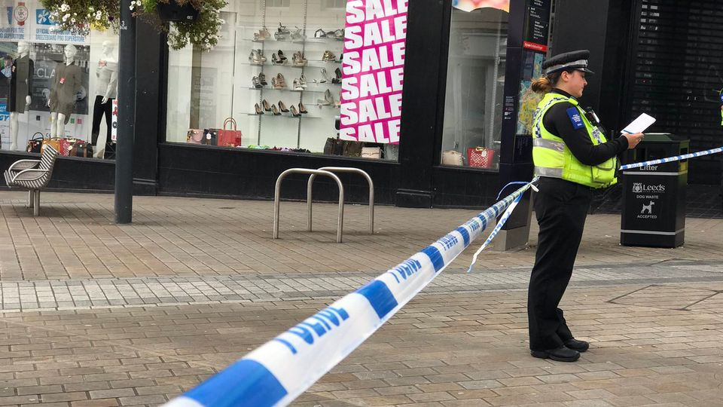
Part of Leeds City centre has been sealed off after a 25 year old man was stabbed on a busy shopping street.
Cordons are in place on Briggate as forensic tests take place with investigations also focusing on an area around the Headrow.

At 1.22pm today (11/9) police received reports of the incident near to the junction of Briggate and The Headrow in Leeds city centre. Officers attended and found a 25-year-old man with serious injuries. He has been taken to hospital for emergency treatment.
The suspects have been described as two young black males.

Detective Inspector Fiona Gaffney, of Leeds District CID, said: “This is clearly a very serious incident where the victim has been stabbed in the street. We would like to hear from anyone who witnessed the incident or who saw the suspects in the area or leaving the scene. They have been described as two young black males.

Two scenes around the junction of Briggate and The Headrow have been cordoned off and will be undergoing forensic examination. We will be doing everything we can to minimise disruption to the public and we hope people will bear with us while we carry out the necessary investigative work.

The investigation is still in the very early stages and we are still trying to establish the circumstances surrounding this incident and the motive behind it. Officers from the local neighbourhood policing team will be ensuring a high-visibility presence in the area to reassure people.”

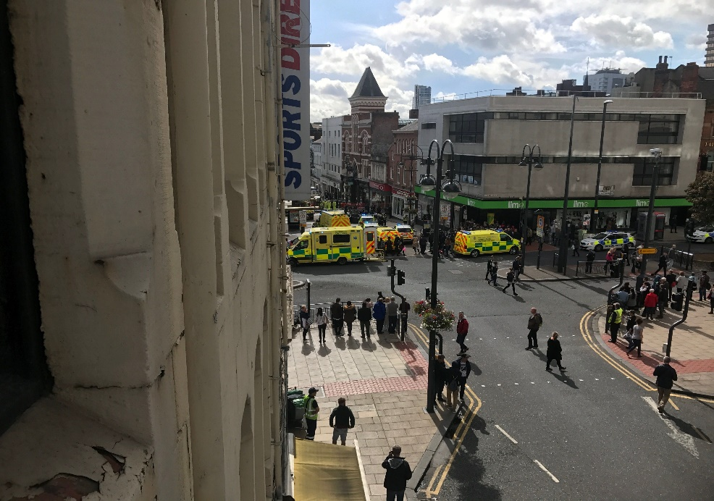

This text contains features of an article to make it interesting for the reader. For example, it contains photographs and is written in paragraphs like a narrative.
Reports do not need to be interesting; they need to be informative, factual and reliable and organised in a way that makes them easy to read.
Task 1 (Green) Using the planning sheet below, plan to rewrite the article above in the style of a police report (revise the checklist on page 16). Use this plan, to write your report.
Plan
Write the title of your report

----------------------------------------------------------------------------

Plan the introductory paragraph outlining the key incident
----------------------------------------------------------------------------
----------------------------------------------------------------------------
----------------------------------------------------------------------------
----------------------------------------------------------------------------
----------------------------------------------------------------------------
----------------------------------------------------------------------------
--------------------------------------------------------------------------

Plan the first subheading (think about the key facts of the case e.g. where, when, who?)
----------------------------------------------------------------------------
----------------------------------------------------------------------------
----------------------------------------------------------------------------
----------------------------------------------------------------------------
----------------------------------------------------------------------------
----------------------------------------------------------------------------
--------------------------------------------------------------------------

Plan the second subheading (think about what happened)
----------------------------------------------------------------------------
----------------------------------------------------------------------------
----------------------------------------------------------------------------
----------------------------------------------------------------------------
----------------------------------------------------------------------------
----------------------------------------------------------------------------
--------------------------------------------------------------------------

Plan either a) a third paragraph if needed
b) a conclusion/summary of the case and further recommendations
----------------------------------------------------------------------------
----------------------------------------------------------------------------
----------------------------------------------------------------------------
----------------------------------------------------------------------------
----------------------------------------------------------------------------
----------------------------------------------------------------------------
--------------------------------------------------------------------------

Using the success criteria below, write your report.
Success Criteria
- A title
- An introduction
- At least one subheading
- A conclusion
- An attempt to use some formal language
- Capital letters and full stops in correct places

Task 2 (Amber) Using the planning sheet for task 1, plan to rewrite the article above in the style of a police report (revise the checklist on page 16). Use this plan, to write your report while adhering to the success criteria below.
Success Criteria
- A title
- An introduction
- At least two subheadings
- A conclusion containing a summary of actions and recommendations for future action required
- Some formal and subject specific language e.g. suspects, victim
- Correct basic punctuation (capital letters, full stops, commas)
- Correct basic spelling and all words contained in the source article

Task 3 (Red) Using the planning sheet for task 1, plan to rewrite the article above in the style of a police report (revise the checklist on page 16). Use this plan, to write your report while adhering to the success criteria below.

Success Criteria
- A clear, informative title
- A clear, concise and informative introduction
- At least two subheadings
- A conclusion containing a summary of actions and recommendations for future action required
- Formal and subject specific language and an attempt to include some sophisticated vocabulary for precision
- Correct basic punctuation and an attempt to include bullet points
- Correct basic spelling, all homophones and all words contained in the source article

(All) Use your planning to write your report below.
Remember to read your report on completion to evaluate and edit.
------------------------------------------------------------------------------------------------------------------------------------------------------------------------------------------------------------------------------------------------------------------------------------------------------------------------------------------------------------------------------------------------------------------------------------------------------------------------------------------------------------------------------------------------------------------------
------------------------------------------------------------------------------------------------------------------------------------------------------------------------------------------------------------------------------------------------------------------------------------------------------------------------------------------------------------------------------------------------------------------------------------------------------------------------------------------------------------------------------------------------------------------------
------------------------------------------------------------------------------------------------------------------------------------------------------------------------------------------------------------------------------------------------------------------------------------------------------------------------------------------------------------------------------------------------------------------------------------------------------------------------------------------------------------------------------------------------------------------------
------------------------------------------------------------------------------------------------------------------------------------------------------------------------------------------------------------------------------------------------------------------------------------------------------------------------------------------------------------------------------------------------------------------------------------------------------------------------------------------------------------------------------------------------------------------------
------------------------------------------------------------------------------------------------------------------------------------------------------------------------------------------------------------------------------------------------------------------------------------------------------------------------------------------------------------------------------------------------------------------------------------------------------------------------------------------------------------------------------------------------------------------------
--------------------------------------------------------------------------------------------------------------------------------------------------------------------------------------------------------------------------------------------------------------------------------------------------------------------------------------------------------------------------------

