Year 8
English Work Pack
30/3/20 – 3/4/20

Welcome to this week’s English topic!

Whales

We will have fun learning to:

- Answer reading comprehension questions by skimming for key words
- Answer reading comprehension questions by using presentational features
- Use presentational features in our own writing
- Plan and write a persuasive advert using presentational features
- Evaluate and edit our adverts to make them BRILLIANT!

Choose your own task level (green = easy, amber = slightly harder, red = challenge)

30 - 31/3/20 LO: To be able to answer reading comprehension questions by skimming for key words

Skimming is a reading technique used to understand the main points of a text quickly.

To skim:
Don’t read every word.

Move your eyes quickly over the text, looking for key words.

Key words are words that tell you who, what, where, when, why and how.

Underline any key words you find.

This technique will give you the gist (the main point or purpose) of a text. You can then go back and read it carefully.
Before reading the following text carefully, practise this technique to give you an overview of Humpback whales. When considering the questions, underline the key words in them, and then skim to find them in the text. This should help you find the answers successfully.
Remember to choose one task (green, amber or red). The text is coloured to help you.

Task 1 (Green) Read the following information about Humpback whales, then answer the questions. Use the glossary to help you with any difficult words.

Humpback Whales

The Humpback whale is a large, endangered animal with a unique hump positioned in front of its small dorsal fin. They are often found in large groups, called pods, and are well-known for their singing abilities and being the noisiest of whales.
What do they look like?
- Colour: usually dark grey.
- Length: grow to around 14 to 19 metres long.
- Weight: around 36,000kg.
Features: white belly, long flippers and a tail fin called the fluke.
The whales use their flippers and their fluke to slap the surface of the water and to push themselves through it. They also use them when they want to leap out of the water. Scientists are still unsure if the whales do this for enjoyment or if it is actually helping the whale to do a job.
Where do they live?
Humpback whales are usually found near the coastline and travel thousands of miles when they migrate. In the summer months, they can be found near to the Arctic and Antarctic where there is plenty of food for them to eat. In the winter months, they move to warmer climates found nearer to the equator. This is where they go to find a mate and breed.
What do they eat?
Humpback whales are baleen whales. Baleen whales have baleen plates instead of teeth. This means they hunt and eat their food differently to other whales which have teeth. They eat their food by filtering it. These large predators open their mouths as they head towards their prey and filter enormous amounts of krill, shrimp, anchovies, small fish and numerous crustaceans from the sea. They then push the water out of their mouths leaving just their food behind. Humpback whales have also been seen trapping their prey inside a ‘bubble net’. The whale dives into the ocean and then swims back up in a spiralling motion while it slowly releases bubbles from its blow hole. These bubbles form a sort of net around the prey causing them to be stuck within the bubbles. The whale then swims up through the net and feeds on what has been caught.
Do they have babies?
Female humpback whales will have a calf (baby whale) about every two to four years and their pregnancy lasts for around 11 to 12 months. Once the calf is born, it will tend to stay very close to its mother so close that it can touch its mother with its flippers. The female will provide the calf with milk for about the first year of its life but it will not be a fully grown adult until it reaches ten years old.
Why are they endangered?
These amazing, beautiful mammals are unfortunately currently listed as endangered. In the 19th and early 20th century they were devastated by commercial fishing. In 1966, the Whaling Commission issued a ban on the commercial fishing of humpback whales in a move to prevent the extinction of these spectacular creatures. The ban worked and, today, the numbers of whales found in our oceans has risen. Let’s hope these intelligent, splendid whales continue to be protected.

Glossary of difficult words
Migrate | Move from one region or habitat to another according to the seasons.
Inhabit | To live in.
Equator | An imaginary line on the surface of the Earth, equal distance from the North and South Poles, dividing the Earth into northern and southern hemispheres.
Crustaceans | An animal which has a body covered with a hard shell or crust.
Predator | An animal that hunts, catches and eats other animals
Extinction | When there are no more of the species alive anywhere in the world - the species has died out.
Commercial | To make money e.g. Commercial fishing – fishing to make money.

Questions

- What length do Humpback whales usually grow to?

10 to 13 metres
14 to 19 metres
20 to 21 metres
- o 23 metres

- What is the name given to the Humpback whale’s tail fin?
--------------------------------------------------------------------------------------------------------------------------------------------

- Fill in the missing words in this sentence:

Humpback whales are usually found near the coastline and -----------------------------------------------------------------------------------------------------------------------------------------------------------------------------------------------

- In the winter months, the whales move to warmer climates. Why do they do this?

-----------------------------------------------------------------------------------------------------------------------------------------------------------------------------------------------------------------------------------------------------------------------------------------------------------------------------------------------------------------------------

- Find and copy a word from the text which explains that the whales naturally prey on other animals.
---------------------------------------------------------------------------------------------------------------------------------------------------------------------------------------------------------------------------

- The humpback whale has no teeth. Explain how they eat their food.
-----------------------------------------------------------------------------------------------------------------------------------------------------------------------------------------------------------------------------------------------------------------------------------------------------------------------------------------------------------------------------

- Has the commercial fishing of humpback whales ban helped increase their numbers? Explain your answer.
-----------------------------------------------------------------------------------------------------------------------------------------------------------------------------------------------------------------------------------------------------------------------------------------------------------------------------------------------------------------------------
--------------------------------------------------------------------------------------------------------------------------------------------------

- Why do you think the author decided to write about Humpback whales? Explain your answer.
------------------------------------------------------------------------------------------------------------------------------------------------------------------------------------------------------------------------------------------------------------------------------------------------------------------------------------------------------------------------------------------------------------------------------------------------------
Task 2 (Amber) Read the following information about Humpback whales, then answer the questions.

Humpback Whales

The Humpback whale is an enormous, endangered mammal with a distinctive hump situated in front of its small dorsal fin. They are often found in large groups, called pods and are wellknown for their singing capabilities and being the noisiest of whales. Appearance
Humpback whales are usually dark grey in colour and on average, grow to around 14 to 19 metres long and weigh around 36,000kg. They have white bellies, long flippers and a tail fin called the fluke. The whales use these flippers and their fluke to slap the surface of the water and to propel themselves through it. They also use them when they want to leap out of the water. Scientists are still unsure if the whales do this for amusement or if it is actually helping the whale to do a job.
Habitat
Humpback whales are typically found near the coastline and travel thousands of miles when they migrate. In the summer months, they can be found near to the Arctic and Antarctic where there is a copious amount of food for them to eat. In the winter months, they inhabit warmer climates found nearer to the equator. This is where they will go to find a mate and breed.
Diet
Humpback whales are baleen whales. Baleen whales have baleen plates instead of teeth. This means they hunt and eat their food differently to other whales which do have teeth. They consume their food by filtering it. These large predators open their mouths as they head towards their prey and filter enormous amounts of krill, shrimp, anchovies, small fish and numerous crustaceans from the sea. They then push the water out of their mouths leaving just their food behind. Humpback whales have also been seen trapping their prey inside a ‘bubble net’. The whale dives into the ocean and then swims back up in a spiralling motion while it slowly releases bubbles from its blow hole. These bubbles form a sort of net around the prey causing them to be imprisoned within the bubbles. The whale then swims up through the net and feeds on what has been snared.
Breeding
Female humpback whales will have a calf (baby whale) about every two to four years and their pregnancy lasts for around 11 to 12 months. Once the calf is born, it will tend to stay very close to its mother so close that it can touch its mother with its flippers. As the calf matures, it develops a layer of blubber. This protects the newborn and allows it to follow its mother back to the cold waters of the Antarctic. The female will provide the calf with milk for about the first year of its life, but it will not be a fully grown adult until it reaches ten years old.
Protection
These amazing, beautiful mammals are unfortunately currently listed as endangered. In the 19th and early 20th century they were decimated by commercial fishing. In 1966, the Whaling Commission issued a ban on the commercial fishing of humpback whales in a move to prevent the extinction of these spectacular creatures. The ban worked and, today, the numbers of whales found in our oceans has risen. Let’s hope these intelligent, splendid whales continue to be protected.

Questions
- Which of these would not be found on a Humpback whale?
- fluke
- blow hole
- teeth
- flippers

- What name is given to a group of humpback whales?
------------------------------------------------------------------------------------------------------------------------------------------------------------------

- Find and copy a word which shows that the humpback whale is easy to identify.
------------------------------------------------------------------------------------------------------------------------------------------------------------------

- Name a place the humpback whale can be found in the summer and winter months.
---------------------------------------------------------------------------------------------------------------------------------------------------------------------------------------------------------------------------------------------------

- Fill in the missing words from this sentence.

These large------------------------------------------------------------------ as they head towards their prey and filter enormous amounts of krill, shrimp, anchovies, small fish and-------------------------------------------------------------------------------------------------------------

6. Why do you think the author places the words ‘bubble net’ inside inverted commas?
------------------------------------------------------------------------------------------------------------------------------------------------------------------------------------------------------------------------------------------------------------------------------------------------------------------------
- ‘I think humpback whales jump out of the water for fun.’ Do you agree with this statement? Explain your answer.
---------------------------------------------------------------------------------------------------------------------------------------------------------------------------------------------------------------------------------------------------------------------------------------------------------------------------------------------------------------------------------------------------------------------

- Explain why you think a calf would stay close to its mother?
------------------------------------------------------------------------------------------------------------------------------------------------------------------------------------------------------------------------------------------------------------------------------------------------------------------------------------------------------------------------------------------------------

- In the final paragraph why does the author choose to use the words decimated, extinction and spectacular?
---------------------------------------------------------------------------------------------------------------------------------------------------------------------------------------------------------------------------------------------------------------------------------------------------------------------------------------------------------------------------------------------------------------------

Task 3 (Red) Read the following information about Humpback whales, then answer the questions.

Humpback Whales

The humpback whale is an immense, endangered mammal with a distinctive hump situated in front of its small dorsal fin. They are often found in large groups, called pods, and are well-known for having an aptitude for singing and being the noisiest of whales. Appearance
Humpback whales are usually dark grey in colour and on average, grow to around 14 to 19 metres long and weigh around 36,000kg. They have white bellies, long flippers and a tail fin called the fluke. The whales use these flippers and their fluke to slap the surface of the water and to propel themselves through it. They also use them when they want to leap out of the water. Scientists are still unsure if the whales do this for amusement or if it is actually being intentionally done by the whale for a particular job.
Habitat
Humpback whales are a migratory species and can be typically found near the coastline. They travel thousands of miles when they migrate. In the summer months, they can be found near to the Arctic and Antarctic where there is an abundance of food for them to eat. In the winter months, they inhabit warmer climates located nearer to the equator. This is where they will acquire a mate and breed.
Diet
Humpback whales are baleen whales. Baleen whales have baleen plates instead of teeth. This means they hunt and eat their food differently to other whales that have teeth. They consume their food by filtering it. These colossal predators open their mouths as they head towards their prey and filter enormous quantities of krill, shrimp, anchovies, small fish and copious amounts of crustaceans from the sea. They then force the water out of their mouths leaving just their food behind. Humpback whales have also been seen capturing their prey inside a ‘bubble net’. The whale dives into the ocean and then swims back up in a spiralling motion while it slowly releases bubbles from its blow holes. These bubbles form a sort of net around the prey causing them to be imprisoned within the bubbles. The whale then swims up through the net and feeds on what has been caught.
Breeding
Female humpback whales will give birth to a calf (baby whale) about every two to four years and their pregnancy lasts for approximately 11 to 12 months. Once the calf is born, it will tend to stay in close proximity to its mother – often touching her with its flippers. As the calf matures, it develops a layer of blubber. This protects the newborn and allows it to follow its mother back to the cold waters of the Antarctic. The female will provide the calf with milk, which has a high fat content, for about the first year of its life but it will not be a fully-grown adult until it reaches ten years old. Protection
These amazing, beautiful mammals are unfortunately currently listed as endangered. In the 19th and early 20th century they were decimated by commercial fishing. In 1966, the Whaling Commission issued a ban on the commercial fishing of humpback whales in a move to prevent the extinction of these spectacular creatures. The ban worked and today the numbers of whales found in our oceans has risen. Although the number of humpback whales has increased, they are still under threat from entanglement in fishing equipment, plastic pollution found in our oceans and accidents with shipping vessels. Let’s hope these intelligent, splendid whales continue to be protected.

Questions

- What does aptitude mean?

- natural ability to do something
- dislike for something
- a hobby
- a strong liking for something

- Which of these statements is true?

- Humpback whales are usually dark blue in colour.
- Humpback whales are usually dark grey in colour.
- Humpback whales are usually dark green in colour.
- Humpback whales are usually dark brown in colour.

- ‘Scientists are still unsure if the whales do this for amusement or if it is actually being intentionally done by the whale for a particular job.’

Write a synonym for the word ‘intentionally’.
---------------------------------------------------------------------------------------------------------------------------------------------------------------------------------------------------------------------------------------------------

- What do humpback whales eat?
------------------------------------------------------------------------------------------------------------------------------------------------------------------------------------------------------------------------------------------------------------------------------------------------------------------------------------

- Find and copy one sentence from the text which shows that the calves feel vulnerable after they are born?
------------------------------------------------------------------------------------------------------------------------------------------------------------------------------------------------------------------------------------------------------------------------------------------------------------------------------------

- Why do you think humpback whales jump out of the water? Explain your answer.
---------------------------------------------------------------------------------------------------------------------------------------------------------------------------------------------------------------------------------------------------------------------------------------------------------------------------------------------------------------------------------------------------------------------------------------------------------------------------------------------------------------------------------------------------------------------------------------

- In your own words explain how Humpback whales capture their prey?
------------------------------------------------------------------------------------------------------------------------------------------------------------------------------------------------------------------------------------------------------------------------------------------------------------------------------------------------------------------------------------------------------------------------------------------------------------------------------------------------------------------------------------------------------------------------------------------------------------------------------------------------------------------------

- What do you think could be done to improve the chances of the number of humpback whales rising?
---------------------------------------------------------------------------------------------------------------------------------------------------------------------------------------------------------------------------------------------------------------------------------------------------------------------------------------------------------------------------------------------------------------------------------------------------------------------------------------------------------------------------------------------------------------------------------------
- Summarise how you think the author feels about humpback whales. Explain your answer.
---------------------------------------------------------------------------------------------------------------------------------------------------------------------------------------------------------------------------------------------------------------------------------------------------------------------------------------------------------------------------------------------------------------------------------------------------------------------------------------------------------------------------------------------------------------------------------------------------------------------------------------------------------------------------------------------------------------------------------------------------------------------------------------------------------------------------------------------------------------------------------------------------------------------------------------------------------------------------------------------------------------------------------------------------------------------------------------------

1/4/20 LO: To be able to identify presentational features in a text.

Presentational features help the reader to understand the text.
They help to organise the text to make it easier to read. Below are examples of presentational features:

Headlines | Larger font (lettering) to stand out and grab the reader’s attention.
Subheadings | To separate information to make it easier to read.  To summarise the information of the following paragraph.
Columns/ Boxes | To separate information to make it easier to read.
Paragraphs | To organise information by separating into chunks.
Bullet Points | To highlight and separate information to make it easier to read.
Pictures | To provide a visual image to help explain what something is like.
Bold/Coloured Font | To draw attention to specific words/ sentences.

Task 1 (Green) Look through a range of texts in your house (newspapers, magazines, takeaway leaflets, adverts, holiday brochures or non-fiction books). Complete the table by finding presentational features within the texts.

Heading | Subheadings | Columns | Bullet Points | Pictures

Type of text | Presentational Feature | Why it is used

Task 2 (Amber) Look through a range of texts in your house (newspapers, magazines, takeaway leaflets, adverts, holiday brochures or non-fiction books). Complete the table by finding presentational features within the texts.

Headings | Subheadings | Columns | Bullet Points
Pictures | Paragraphs | Bold Font | Coloured Font

Type of text | Presentational Feature | Why it is used

Task 3 (Red) Look through a range of texts in your house (newspapers, magazines, takeaway leaflets, adverts, holiday brochures or non-fiction books). Complete the table by finding presentational features within the texts.

Headings | Subheadings | Columns | Bullet Points
Glossaries | Paragraphs | Bold Font | Coloured Font
Numbered Lists | Graphics | Diagrams/Charts | Images

Type of text | Presentational Feature | Why it is used
1/4/20 LO: To be able to identify presentational features in others’ writing.

Task 1 (Green) Examine the following advert. Annotate (label) the advert to identify its presentational features.

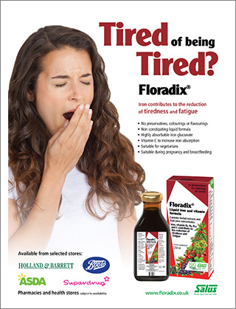

Choose three features and write three sentences about why they have been used. How do the features help the reader?
---------------------------------------------------------------------------------------------------------------------------------------------------------------------------------------------------------------------------------------------------------------------------------------------------------------------------------------------------------------------------------------------------------------------
Task 2 (Amber) Examine the following advert. Annotate (label) the advert to identify its presentational features.

Write a paragraph about several presentational features used in this advert. Why has the writer chosen to include them?
------------------------------------------------------------------------------------------------------------------------------------------------------------------------------------------------------------------------------------------------------------------------------------------------------------------------------------------------------------------------------------------------------------------------------------------------------------------------------------------------------------------------------------------------------------------------------------------------------------------------------------------------------------------------------------------------------------------------------------------------------------------------------------------------------------------------------------------
Task 3 (Red) Examine the following advert. Annotate the advert to identify its presentational features.

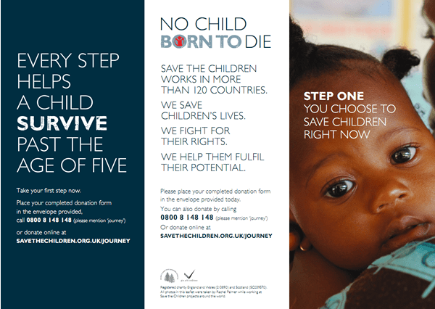

Write three detailed paragraphs about the presentational features used in this advert. Why has the writer chosen to include them?
Begin by explaining the purpose of this advert.
--------------------------------------------------------------------------------------------------------------------------------------------------------------------------------------------------------------------------------------------------------------------------------------------------------------------------------------------------------------------------------------------------------------------------------------------------------------------------------------------------------------------------------------------------------------------------------------------------------------------------------------------------------------------
---------------------------------------------------------------------------------------------------------------------------------------------------------------------------------------------------------------------------------------------------------------------------------------------------------------------------------------------------------------------------------------------------------------------------------------------------------------------------------------------------------------------------------------------------------------------------------------

---------------------------------------------------------------------------------------------------------------------------------------------------------------------------------------------------------------------------------------------------------------------------------------------------------------------------------------------------------------------------------------------------------------------------------------------------------------------------------------------------------------------------------------------------------------------------------------

2/4/20 LO: To be able to plan a persuasive advert using presentational features.
You are going to create an advert asking for money to save the Humpback whale.

Task 1 (Green), 2 (Amber) and 3 (Red) Choose your layout. Which layout would catch the reader’s attention?
- 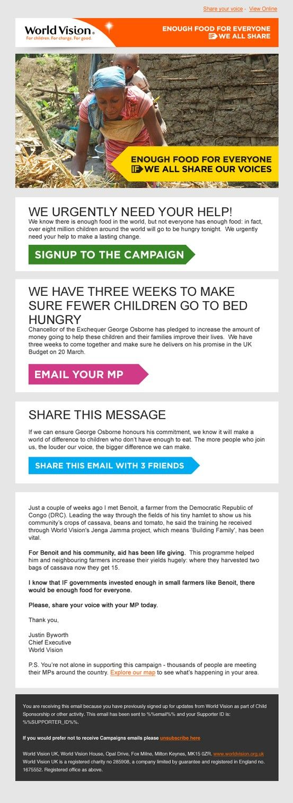2.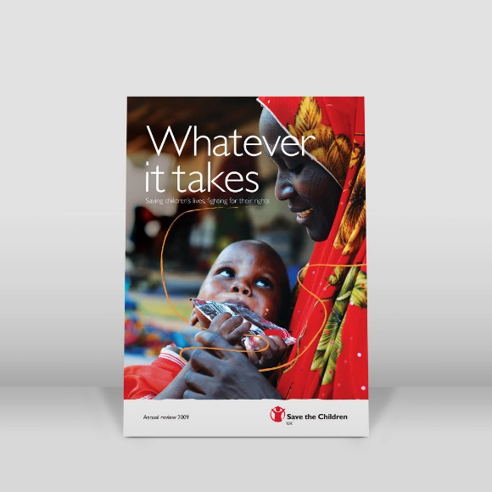 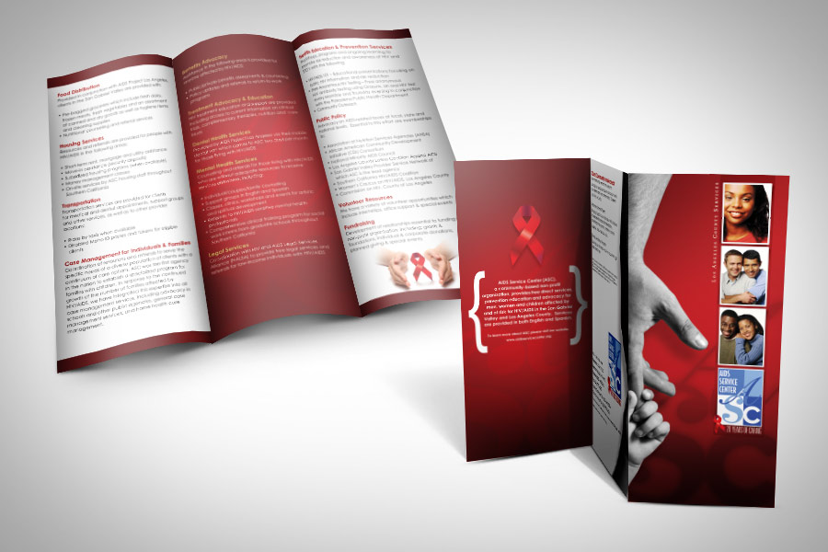
3.
Now choose what sort of presentational features you will use.

Headings | Subheadings | Columns | Bullet Points
Images | Paragraphs | Bold Font | Coloured Font
Numbered Lists | Graphics | Diagrams/Charts

Task 1 (Green) Cut and stick the information and pictures on the following page to a piece of blank paper in the layout you chose.

Create an attractive advert to raise money for Humpback whales.

Include some writing of your own to include:
- An eye-catching title
- A sentence saying how much needs to be donated
- A sentence saying how the money will be used
- Advice on where to send the money

Try using some of the persuasive/ emotive words in the box below:

Urgent | Desperate | Appeal | Survival
Outrage | Hopeless | Defenceless | Beg

The Humpback whale is a large, endangered animal with a unique hump positioned in front of its small dorsal fin.

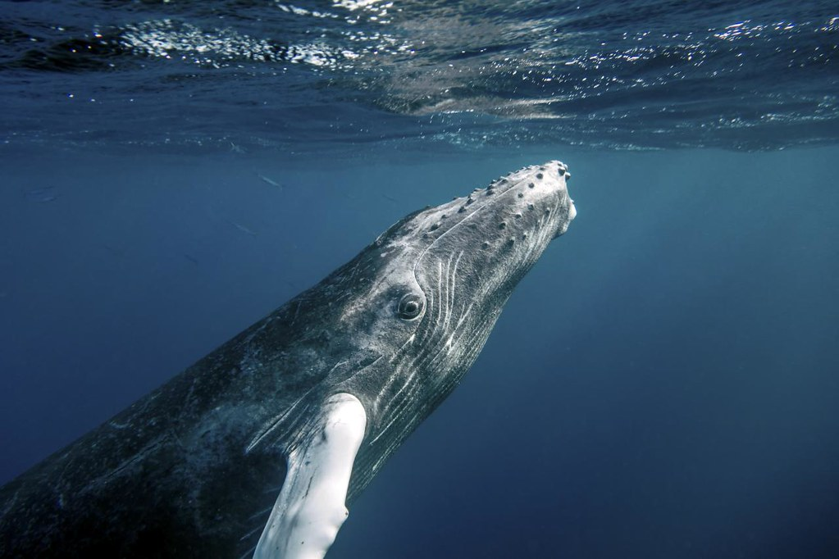
- Colour: usually dark grey.
- Length: grow to around 14 to 19 metres long.
- Weight: around 36,000kg.

Why are they endangered?
These amazing, beautiful mammals are unfortunately currently listed as endangered. In the 19th and early 20th century they were devastated by commercial fishing. In 1966, the Whaling Commission issued a ban on the commercial fishing of humpback whales in a move to prevent the extinction of these spectacular creatures. The ban worked and, today, the numbers of whales found in our oceans has risen. Let’s hope these intelligent, splendid whales continue to be protected.
Task 2 (Amber) Cut and stick the picture from Task 1 to a piece of blank paper in the layout you chose.

Create an attractive advert to raise money for Humpback whales.

Organise your writing to include:
- some introductory sentences about Humpback whales
- a paragraph explaining why they are endangered
- information about how much money is needed to save the whales
- information about how people can donate

Don’t forget to include presentational features to organise your writing effectively e.g. bullet points, coloured writing, bold writing, columns.

Task 3 (Red) Cut and stick the picture from Task 1 to a piece of blank paper in the layout you chose.

Create an attractive advert to raise money for Humpback whales.

Organise your writing to include:

- A detailed introduction about Humpback whales
- A detailed paragraph about why they are endangered
- information about how much money is needed to save the whales and how people can donate
- Imperative verbs (command words to stress the importance of donating) e.g. Donate now! Send immediately! Examine the plight!

3/4/20 LO: To be able to evaluate and edit my writing to improve.

Look at the following definitions:
Evaluate | Assess your work to decide how good it is
Edit | Correct or modify your work to make it better

Task 1 (Green) Read and check your advert to make sure you have included the following:
- An eye-catching title
- A sentence saying how much needs to be donated
- A sentence saying how the money will be used
- Advice on where to send the money
- Some presentational features

Edit by correcting anything you’ve missed.

Task 2 (Amber) Read and check your advert to make sure you have included the following:
- Some introductory sentences about Humpback whales
- A paragraph explaining why they are endangered
- Information about how much money is needed to save the whales
- Information about how people can donate
- Several presentational features

Edit by correcting anything you’ve missed.

Task 3 (Red) Read and check your advert to make sure you have included the following:
- A detailed introduction about Humpback whales
- A detailed paragraph about why they are endangered
- Information about how much money is needed to save the whales and how people can donate
- Many Presentational features
- Imperative verbs
Edit by correcting anything you’ve missed.

All (Green), (Amber) and (Red)
Remember - To make your advert BRILLIANT, you also need to check your spelling, punctuation and grammar.

