Year 8
English Work Pack 2
Parents/Carers – only complete as much, or as little, of these booklets as your circumstances allow at this difficult time.

Welcome to this week’s English topic!

Creative Writing - Imagination

We will have fun learning to:

- Identify ideas to get us started
- Write short stories using a range of prompts
- Identify narrative perspective or ‘point of view’
- Improve our skills by ‘showing not telling’

Choose your own task level (green = easy, amber = slightly harder, red = challenge)

LO: To be able to identify story ideas through newspaper headlines

Have you got an idea for a story you’d like to write? Brilliant! That makes things much easier. However, sometimes imagination needs a little help. Below are different sources from which you can draw ideas:

External Sources – These are things that are all around you, such as newspaper headlines, music, overheard conversations, nature, observing people (on buses, cafes etc …), photos and pictures, articles, conversations with family and friends or travel to new places.

Task 1 (Green) Create a story plot (the main ideas for a story) from each of the following newspaper headlines.
Remember, a story must have a structure e.g. at least, a beginning, a middle and an ending.

Extension – Choose one of your plot plans and write the story.

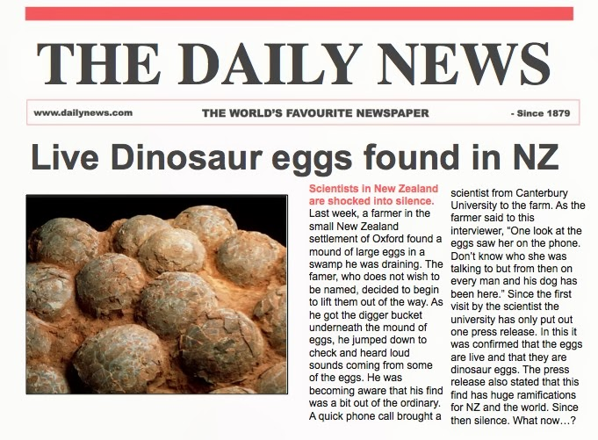 | Beginning  Middle  Ending.
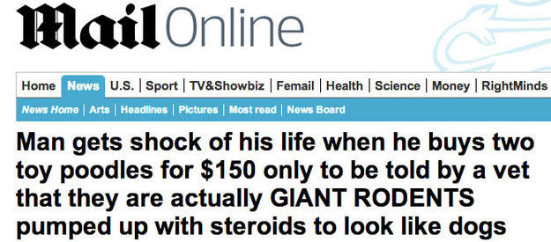 | Beginning  Middle  Ending.
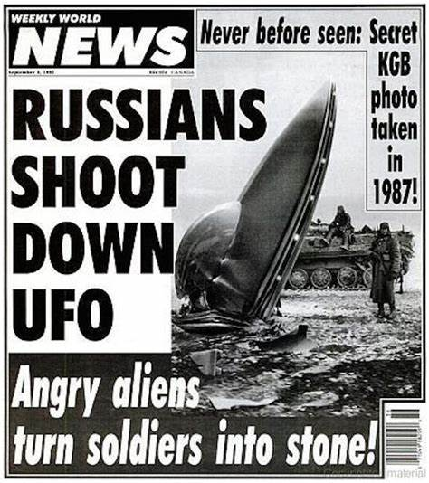 | Beginning  Middle  Ending.
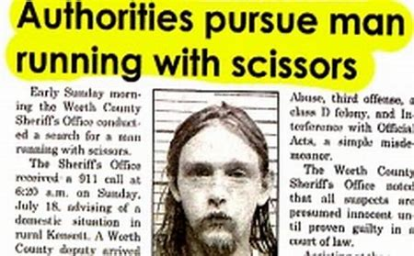 | Beginning  Middle  Ending.

Task 2 (Amber) Create a story plot from each of the following newspaper headlines. Remember, a story must have a structure e.g. a beginning, the build up to a problem, a problem, an answer to the problem and an ending.

Extension – Choose one of your plot plans and write the story.

Beginning

Build up

Problem

Answer to the problem

Ending

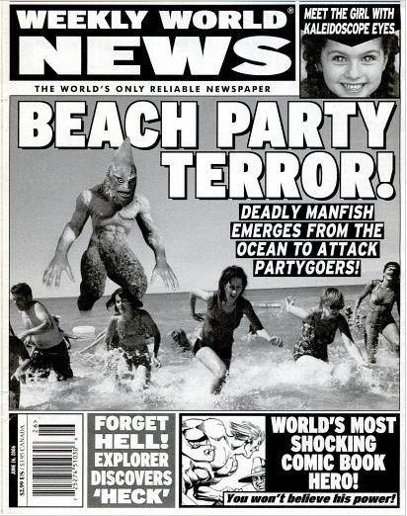 | Beginning  Build up  Problem  Answer to the problem  Ending
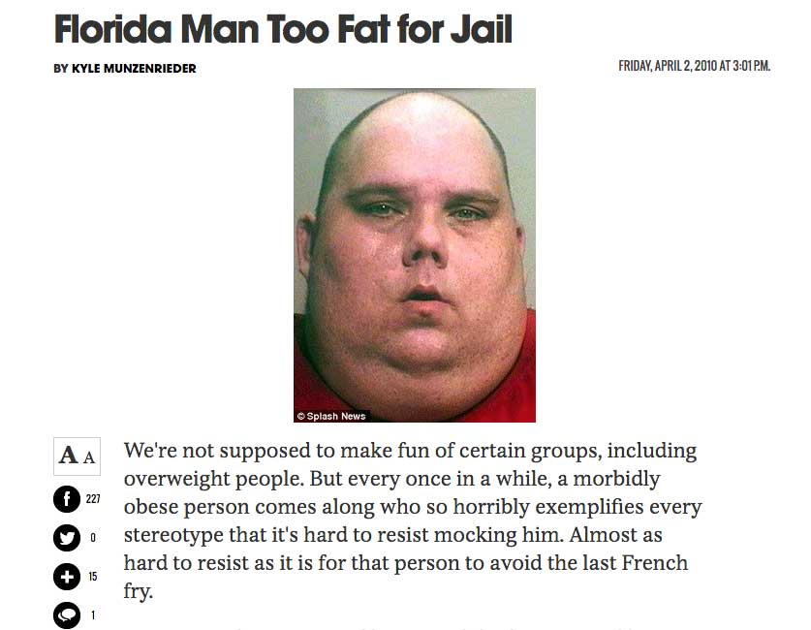 | Beginning  Build up  Problem  Answer to the problem  Ending

Task 3 (Red) Using any of the headlines from task two, complete the plot planning on the right-hand side of the picture.

In addition, think about the sort of characters you want to include.

On the writing side under the picture, plan how the physical description of your character could suggest the personality you have in mind e.g. an evil personality will stereotypically match an ugly physical description.
Choose one of your plot plans and write the story.

Story writing space for task one, two or three

--------------------------------------------------------------------------------------------------------------------------------------------------------------------------------------------------------------------------------------------------------------------------------------------------------------------------------------------------------------------------------------------------------------------------------------------------------------------------------------------------------------------------------------------------------------------------------------------------------------------------------------------------------------------------------------------------------------------------------------------------------------------------------------------------------------------------------------------------------------------------------------------------------------------------------------------------------------------------------------------------------------------------------------------------------------------------------------------------------------------------------------------------------------------------------------------------------------------------------------------------------------------------------------------------------------------------------------------------------------------------------------------------------------------------------------------------------------------------------------------------------------------------------------------------------------------------------------------------------------------------------------------------------------------------------------------------------------------------------------------------------------------------------------------------------------------------------------------------------------------------------------------------------------------------------------------------------------------------------------------------------------------------------------------------------------------------------------------------------------------------------------------------------------------------------------------------------------------------------------------------------------------------------------------------------------------------------------------------------------------------------------------------------------------------------------------------------------------------------------------------------------------------------------------------------------------------------------------------------------------------------------------------------------------------------------------------------------------------------------------------------------------------------------------------------------------------------------------------------------------------------------------------------------------------------------------------------------------------------------------------------------------------------------------------------------------------------------------------------------------------------------------------------------------------------------------------------------------------------------------------------------------------------------------------------------------------------------------------------------------------------------------------------------------------------------------------------------------------------------------------------------------------------------------------------------------------------------------------------------------------------------------------------------------------------------------------------------------------------------------------------------------------------------------------------------------------------

LO: To be able to identify how music lyrics, like good stories, create emotive responses in the listener

Like music, stories have the power to create specific moods in the reader. In fact, this is the aim of many musicians. Similarly, successful writers should aim to move the emotions/ feelings of their readers through the vocabulary they choose.

Task 1 (Green) Look at the following song lyrics. Pick out the emotive or meaningful words (words intended to create specific feelings in the listener) and explain how the listener may feel while listening to the song.
“And when you smile, the whole world stops and stares for awhile, cause you’re amazing, just the way you are.” Bruno Mars (Just The Way You Are) | Important words:  ------------------------------------------------------------------------------------------------------------------------------------------------------------------------------------------------  How the listener may feel:  ---------------------------------------------------------------------------------------------------------------------------------------------------------------------------------------------------------------------------------------------------------------------------------------------------------------------------------------------------------------------------------------------------------------------------------------------------------------------------------------------------------------------------------------------------------------------------------------------------------------------------------------------------------------------------------------------------------------------------------------------------------------------------------------------------------------------------------------------------------------------------------------------------------------------------------------------------------------------------------------------------------------------------------------------------------------------------
“When you need some shelter from the rain, when you need a healer for your pain, I will be there time and time again.” Leona Lewis (Here I Am)  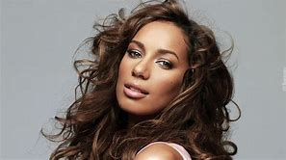 | Important words:  ------------------------------------------------------------------------------------------------------------------------------------------------------------------------------------------------  How the listener may feel:  ---------------------------------------------------------------------------------------------------------------------------------------------------------------------------------------------------------------------------------------------------------------------------------------------------------------------------------------------------------------------------------------------------------------------------------------------------------------------------------------------------------------------------------------------------------------------------------------------------------------------------------------------------------------------------------------------------------------------------------------------------------------------------------------------------------------------------------------------------------------------------------------------------------------------------------------------------------------------------------------------------------------------------------------------------------------------------
“And I can’t help but stare, cause I see truth somewhere in your eyes.” Justin Timberlake (Mirrors) | Important words:  ------------------------------------------------------------------------------------------------------------------------------------------------------------------------------------------------  How the listener may feel:  ---------------------------------------------------------------------------------------------------------------------------------------------------------------------------------------------------------------------------------------------------------------------------------------------------------------------------------------------------------------------------------------------------------------------------------------------------------------------------------------------------------------------------------------------------------------------------------------------------------------------------------------------------------------------------------------------------------------------------------------------------------------------------------------------------------------------------------------------------------------------------------------------------------------------------------------------------------------------------------------------------------------------------------------------------------------------------

Task 2 (Amber) Look at the following song lyrics. Pick out the emotive or unusual words (words intended to create specific feelings in the listener) and explain how the listener may feel while listening to the song. Under the picture, write the next line using the most emotive words you can think of and ensuring it rhymes. If you know the song, ignore the ‘real’ lines and write your own.
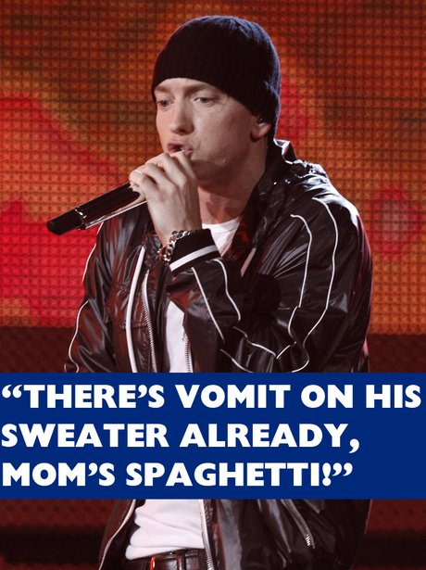  Next line…  ------------------------------------------------------------------------------------------------------------------------------------------------------------------------------------------------------------------------------------------------------------------------------------------------------------------------------------------------------------------------------------------------ | Important words:  ------------------------------------------------------------------------------------------------------------------------------------------------------------------------------------------------  How the listener may feel:  ----------------------------------------------------------------------------------------------------------------------------------------------------------------------------------------------------------------------------------------------------------------------------------------------------------------------------------------------------------------------------------------------------------------------------------------------------------------------------------------------------------------------------------------------------------------------------------------------------------------------------------------------------------------------------------------------------------------------------------------------------------------------------------------------------------------------------------------------------------------------------------------------------------------------------------------------------------------------------------------------------------------------------------------------------------------------------------------------------------------------------------------------------------------------------------------------------------------------------------------------------------------------------------------------------------------------------------------------------------------------------------------------------------------------------------------------------------------------------------------------
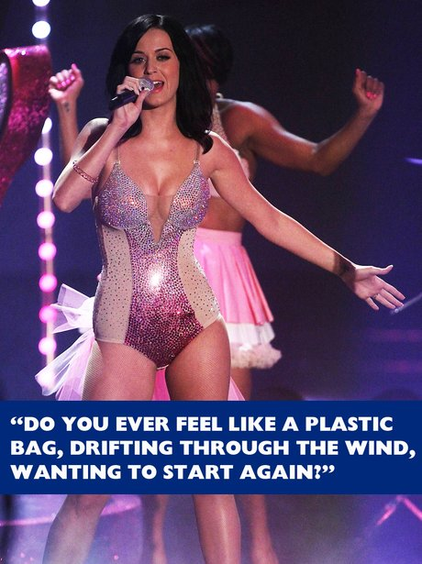  Next line…  ------------------------------------------------------------------------------------------------------------------------------------------------------------------------------------------------------------------------------------------------------------------------------------------------------------------------------------------------------------------------------------------------------------------------------------------------------------------------------------------------ | Important words:  ------------------------------------------------------------------------------------------------------------------------------------------------------------------------------------------------  How the listener may feel:  ---------------------------------------------------------------------------------------------------------------------------------------------------------------------------------------------------------------------------------------------------------------------------------------------------------------------------------------------------------------------------------------------------------------------------------------------------------------------------------------------------------------------------------------------------------------------------------------------------------------------------------------------------------------------------------------------------------------------------------------------------------------------------------------------------------------------------------------------------------------------------------------------------------------------------------------------------------------------------------------------------------------------------------------------------------------------------------------------------------------------------------------------------------------------------------------------------------------------------------------------------------------------------------------------------------------------------------------------------------------------------------------------------------------------------------------------------------------------------------------------------------------------------------------------------------------------------------------------------------------------------------------------------------------------------------------------------------------------------------------------------------------------------------------------------------------------------------------------------------------------------------------------------------------
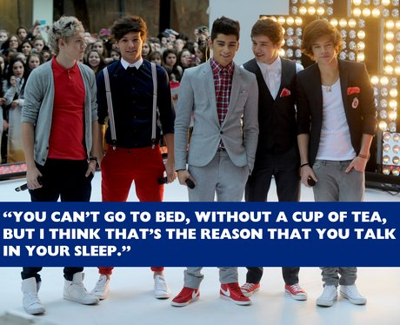  Next line…  ------------------------------------------------------------------------------------------------------------------------------------------------------------------------------------------------------------------------------------------------------------------------------------------------------------------------------------------------------------------------------------------------ | Important words:  ----------------------------------------------------------------------------------------------------------------------------------------------------------------------------------------------------------------------------  How the listener may feel:  --------------------------------------------------------------------------------------------------------------------------------------------------------------------------------------------------------------------------------------------------------------------------------------------------------------------------------------------------------------------------------------------------------------------------------------------------------------------------------------------------------------------------------------------------------------------------------------------------------------------------------------------------------------------------------------------------------------------------------------------------------------------------------------------------------------------------------------------------------------------------------------------------------------------------------------------------------------------------------------------------------------------------------------------------------------------------------------------------------------------------------------------------------------------------------------------------------------------------------------------------------------------------------------------------------------------------------

Task 3 (Red) Look at the following song lyrics. Some are a little obscure. What is the writer inferring and how might they make the listener feel? Can you spot any metaphors? What are they implying? What other techniques are used to engage the listener?
The blacker the berry, the sweeter the juice  The kid dies, the blacker the killer, the sweeter the news  And if he's white, you'll give him a chance, he's ill and confused  If he's black he's probably armed, you see and you shoot  Next line…  ------------------------------------------------------------------------------------------------------------------------------------------------------------------------------------------------------------------------------------------------------------------------------------------------------------------------------------------------------------------------------------------------------------------------------------------------------------------------------------------------------------------------------------------------------------------------------------------------------------------------------------------------------ | Metaphors and inference:  ------------------------------------------------------------------------------------------------------------------------------------------------------------------------------------------------------------------------------------------------------------------  How the listener may feel:  ---------------------------------------------------------------------------------------------------------------------------------------------------------------------------------------------------------------------------------------------------------------------------------------------------------------------------------------------------------------------------------------------------------------------------------------------------------------------------------------------------------------------------------------------------------------------------------------------------------------------------------------------------------------------------------------------------------------------------------------------------------------------------------------------------------------------------------------------------------------------------------------------------------------------------------------------------------------------------------------------------------------------------------------------------------------------------------------------------------------------------------------------------------------------------------------------------------------------------------------------------------------------------------------------------------------------------------------------------------------------------
You're getting way too big for your boots  You're never too big for the boot  I've got the big size twelves on my feet  Your face ain't big for my boot  Kick up the youth  Man know that I kick up the youth  Dem boy dere tried twist up the truth  How dare you twist up the truth, look  You're getting way too big for your boots  You're never too big for the boot  I got the big size twelves on my feet  Your face ain't big for my boot  Kick up the youth  Next line…  ------------------------------------------------------------------------------------------------------------------------------------------------------------------------------------------------------------------------------------------------------------------------------------------------------------------------------------------------------------------------------------------------------------------------------------------------------------------------------------------------------------------------------------------------------------------------------------------------------------------------------------------------------ | Metaphors and inference:  ------------------------------------------------------------------------------------------------------------------------------------------------------------------------------------------------------------------------------------------------------------------  How the listener may feel:  ---------------------------------------------------------------------------------------------------------------------------------------------------------------------------------------------------------------------------------------------------------------------------------------------------------------------------------------------------------------------------------------------------------------------------------------------------------------------------------------------------------------------------------------------------------------------------------------------------------------------------------------------------------------------------------------------------------------------------------------------------------------------------------------------------------------------------------------------------------------------------------------------------------------------------------------------------------------------------------------------------------------------------------------------------------------------------------------------------------------------------------------------------------------------------------------------------------------------------------------------------------------------------------------------------------------------------------------------------------------------------------------------------------------------------------------------------------------------------------------------------------------------------------------------------------------------------------------------------------------------------------------
Crashing, hit a wall  Right now I need a miracle  Hurry up now, I need a miracle  Stranded, reaching out  I call your name but you're not around  I say your name but you're not around  I need you, I need you, I need you right now  Yeah, I need you right now  So don't let me, don't let me, don't let me down  I think I'm losing my mind now  It's in my head, darling I hope  That you'll be here, when I need you the most  So don't let me, don't let me, don't let me down  Don't let me down  Next line…  ------------------------------------------------------------------------------------------------------------------------------------------------------------------------------------------------------------------------------------------------------------------------------------------------------------------------------------------------------------------------------------------------------------------------------------------------------------------------------------------------------------------------------------------------------------------------------------------------------------------------------------------------------------------------------------------------------------------------------------------------------------------------------------------------------------------------------------------ | Metaphors and inference:  ------------------------------------------------------------------------------------------------------------------------------------------------------------------------------------------------------------------------------------------------------------------  How the listener may feel:  ------------------------------------------------------------------------------------------------------------------------------------------------------------------------------------------------------------------------------------------------------------------------------------------------------------------------------------------------------------------------------------------------------------------------------------------------------------------------------------------------------------------------------------------------------------------------------------------------------------------------------------------------------------------------------------------------------------------------------------------------------------------------------------------------------------------------------------------------------------------------------------------------------------------------------------------------------------------------------------------------------------------------------------------------------------------------------------------------------------------------------------------------------------------------------------------------------------------------------------------------------------------------------------------------------------------------------------------------------------------------------------------------------------------------------------------------------------------------------------------------------------------------------------------------------------------------------------------------------------------------------------------------------------------------------------------------------------------------------------------------------------------------------------------------------------------------------------------------------------------------------------------------------------------------------------------------------------------------------------------------------------------------------------------------------------------------------------------------
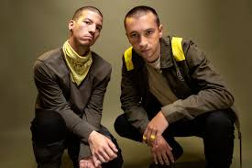  I wish I found some better sounds no one's ever heard  I wish I had a better voice that sang some better words  I wish I found some chords in an order that is new  I wish I didn't have to rhyme every time I sang  I was told when I get older all my fears would shrink  But now I'm insecure and I care what people think  My name's Blurryface and I care what you think  My name's Blurryface and I care what you think  Next line…  --------------------------------------------------------------------------------------------------------------------------------------------------------------------------------------------------------------------------------------------------------------------------------------------------------------------------------------------------------------------------------------------------------------------------------------------------------------------------------------------------------------- | Metaphors and inference:  ------------------------------------------------------------------------------------------------------------------------------------------------------------------------------------------------------------------------------------------------------------------  How the listener may feel:  ------------------------------------------------------------------------------------------------------------------------------------------------------------------------------------------------------------------------------------------------------------------------------------------------------------------------------------------------------------------------------------------------------------------------------------------------------------------------------------------------------------------------------------------------------------------------------------------------------------------------------------------------------------------------------------------------------------------------------------------------------------------------------------------------------------------------------------------------------------------------------------------------------------------------------------------------------------------------------------------------------------------------------------------------------------------------------------------------------------------------------------------------------------------------------------------------------------------------------------------------------------------------------------------------------------------------------------------------------------------------------------------------------------------------------------------

LO: To be able to use music lyrics to generate creative writing ideas

First person perspective | Narrator relays events from their own point of view using the words ‘I’ or ‘We’
Protagonist | The leading character
Identify | Being able to relate to someone/something

In the previous task, we learned how powerful music lyrics can be in creating emotive responses in listeners. When words are carefully chosen, powerful images can be produced.
In this task, we shall aim to mirror this technique while using song lyrics as the stimulus for our own emotive narrative.

All of the lyrics from the tasks in the last lesson are written from a first person perspective (the singer is singing about himself/herself).
The feelings aroused in the listener will be similar to the singer because the listener will begin to identify with the words.

Task 1 (Green) – choose one set of lyrics from the previous task (or your own) and imagine you are that person. Use the lyrics to plan (and then write) a story where you are the protagonist e.g.

“And I can’t help but stare, cause I see truth somewhere in your eyes.”
Justin Timberlake (Mirrors)

Begin by answering some basic questions about the lyrics:

- Who are the words talking about (story characters)? Is it a friend, a parent a girlfriend/boyfriend?
- Think about the reasons behind the words (beginning). Why would the singer doubt the truth? What experiences have led him/her to being mistrustful and being surprised enough to ‘stare, cause I see truth…’
- What led up to this statement (build up - middle):
- An event?
- Some hurtful words?
- Nothing, the person is a stranger but is very open and honest from the start e.g. someone you start chatting with at school, the bus stop, in the local shop?
- What did the statement lead to (story ending):
- Are questions that you had about someone else answered?
- Are you ‘saved’ from an awkward situation because of a misunderstanding?
- Does the truthful person become a life-long friend you can trust?
- Do you become a more confident person?

Planning
Name of song:

Story characters
Who are the words talking about?
Beginning
What are the reasons behind the lyrics?
Build-up - middle
What led up to the main statement in the lyrics?
Story ending
What did the statement lead to?
How did it end?

Success Criteria
Clear beginning, middle and end
Capital letters at the beginning of each sentence
Full stop, question mark or exclamation mark at the end of each sentence
Some emotive words (powerful words that make the reader feel something)

----------------------------------------------------------------------------------------------------------------------------------------------------------------------------------------------------------------------------------------------------------------------------------------------------------------------------------------------------------------------------------------------------------------------------------------------------------------------------------------------------------------------------------------------------------------------------------------------------------------------------------------------------------------------------------------------------------------------------------------------------------------------------------------------------------------------------------------------------------------------------------------------------------------------------------------------------------------------------------------------------------------------------------------------------------------------------------------------------------------------------------------------------------------------------------------------------------------------------------------------------------------------------------------------------------------------------------------------------------------------------------------------------------------------------------------------------------------------------------------------------------------------------------------------------------------------------------------------------------------------------------------------------------------------------------------------------------------------------------------------------------------------------------------------------------------------------------------------------------------------------------------------------------------------------------------------------------------------------------------------------------------------------------------------------------------------------------------------------------------------------------------------------------------------------------------------------------------------------------------------------------------------------------------------------------------------------------------------------------------------------------------------------------------------------------------------------------------------------------------------------------------------------------------------------------------------------------------------------------------------------------------------------------------------------------------------------------------------------------------------------------------------------
Task 2 (Amber) – choose one set of lyrics from the previous task (or your own) and imagine you are that person. Use the lyrics to plan (and then write) a story where you are the protagonist. Include the new verse you wrote, re-written as narrative.

Planning
Name of song:

Story characters
Who are the words talking about?
Beginning
What are the reasons behind the lyrics?
Build-up - middle
What led up to the main statement in the lyrics?
Story ending
What did the statement lead to?
How did it end?

Success Criteria
Clear beginning, build-up, middle and end
Capital letters at the beginning of each sentence
Full stop, question mark or exclamation mark at the end of each sentence
Check SPaG
Emotive words

----------------------------------------------------------------------------------------------------------------------------------------------------------------------------------------------------------------------------------------------------------------------------------------------------------------------------------------------------------------------------------------------------------------------------------------------------------------------------------------------------------------------------------------------------------------------------------------------------------------------------------------------------------------------------------------------------------------------------------------------------------------------------------------------------------------------------------------------------------------------------------------------------------------------------------------------------------------------------------------------------------------------------------------------------------------------------------------------------------------------------------------------------------------------------------------------------------------------------------------------------------------------------------------------------------------------------------------------------------------------------------------------------------------------------------------------------------------------------------------------------------------------------------------------------------------------------------------------------------------------------------------------------------------------------------------------------------------------------------------------------------------------------------------------------------------------------------------------------------------------------------------------------------------------------------------------------------------------------------------------------------------------------------------------------------------------------------------------------------------------------------------------------------------------------------------------------------------------------------------------------------------------------------------------------------------------------------------------------------------------------------------------------------------------------------------------------------------------------------------------------------------------------------------------------------------------------------------------------------------------------------------------------------------------------------------------------------------------------------------------------------------------------
----------------------------------------------------------------------------------------------------------------------------------------------------------------------------------------------------------------------------------------------------------------------------------------------------------------------------------------------------------------------------------------------------------------------------------------------------------------------------------------------------------------------------------------------------------------------------------------------------------------------------------------------------------------------------------------------------------------------------------------------------------------

Task 3 (Red) – choose one set of lyrics from the previous task (or your own) and imagine you are that person. Use the lyrics to plan (and then write) a story where you are the protagonist. Include the new verse you wrote, re-written as narrative.

Planning
Name of song:

Story characters
Who are the words talking about?
Beginning
What are the reasons behind the lyrics?
Build-up - middle
What led up to the main statement in the lyrics?
Story ending
What did the statement lead to?
How did it end?

Success Criteria
Clear beginning, build-up, middle and end
Capital letters at the beginning of each sentence
Full stop, question mark or exclamation mark at the end of each sentence
Check SPaG
Emotive words
Some metaphors or similes

----------------------------------------------------------------------------------------------------------------------------------------------------------------------------------------------------------------------------------------------------------------------------------------------------------------------------------------------------------------------------------------------------------------------------------------------------------------------------------------------------------------------------------------------------------------------------------------------------------------------------------------------------------------------------------------------------------------------------------------------------------------------------------------------------------------------------------------------------------------------------------------------------------------------------------------------------------------------------------------------------------------------------------------------------------------------------------------------------------------------------------------------------------------------------------------------------------------------------------------------------------------------------------------------------------------------------------------------------------------------------------------------------------------------------------------------------------------------------------------------------------------------------------------------------------------------------------------------------------------------------------------------------------------------------------------------------------------------------------------------------------------------------------------------------------------------------------------------------------------------------------------------------------------------------------------------------------------------------------------------------------------------------------------------------------------------------------------------------------------------------------------------------------------------------------------------------------------------------------------------------------------------------------------------------------------------------------------------------------------------------------------------------------------------------------------------------------------------------------------------------------------------------------------------------------------------------------------------------------------------------------------------------------------------------------------------------------------------------------------------------------------------------
----------------------------------------------------------------------------------------------------------------------------------------------------------------------------------------------------------------------------------------------------------------------------------------------------------------------------------------------------------------------------------------------------------------------------------------------------------------------------------------------------------------------------------------------------------------------------------------------------------------------------------------------------------------------------------------------------------------------------------------------------------------
------------------------------------------------------------------------------------------------------------------------------------------------------------------------------------------------------------------------------------------------------------------------------------------------------------------------------------------------------------------------------------------------------------------------------------------------------------------------------------------------------------------------------------------------------------------------------------------------------------------------------------------------------------------------------------------------------------------------------------------------------------------------------------------------------------------------------------------------------------------------------------------------------------------------------------------------------------------------------------------------------------------------------------------------------------------------------------------------------------------------------------------------
LO: To be able to improve our narratives by ‘showing not telling’

‘Show don’t Tell’

This technique is used to show the reader what is happening in the story (through action, dialogue and feelings) without explicitly telling them (through a series of boring information sentences).

Look at this example of ‘telling’:

Emily watched Garrett pace in front of the window. She was worried about the children, what would happen to them in the overnight cold. From his expression, Garrett didn’t seem to have any more idea than she did about how to proceed with the search.

Compared to this example of showing:

Emily bit her lip. ‘So what do you think we should do?’

Garrett grimaced at the view out the window. ‘It’s nearly sundown. If we go back out now we’ll never find them in the dark’.

Emily hugged her arms around herself. ‘Cleo’s only three, Garrett.’

‘I know that.’ He worried a thumbnail, staring through glass.

‘She’s never been outside after dark before. She’s never even been for a sleepover. And she’s only wearing her pyjamas. The police said it’ll reach minus-two degrees tonight-‘

‘Emily, I know, all right?’

Telling is sometimes necessary, if you need to condense a lot of narrative into a short chapter or section. However, showing a character in action, or getting them to speak some dialogue or experience an emotion, is definitely more effective for engaging the reader than explaining things with long monologues or descriptions.

How to ‘show’ not ‘tell’

Describe body language
e.g. She was shaking, her face was red and her palms were sweaty (she was nervous)

Use strong verbs
e.g. She thrust out her hand and snatched the money (she was impatient)

Focus on describing senses
e.g. The smell of stale alcohol lingered on his breath as he lay on the floor that morning (he had been drunk the night before)

Task 1 (Green) Look at the emotions in each of the boxes in the table below. How could you show these emotions without explicitly stating them?

Tired | Shocked | Cold | Nervous  Butterflies in my stomach
Happy | Excited | Angry | Embarrassed
Hot  Sweaty palms and red face | Sad | Shy | Afraid
Extension: Choose two of your descriptions and write a paragraph about a character who feels this way.

Task 2 (Amber) Read the ‘telling’ descriptive sentences below. Rewrite the sentences to show what is happening (or how the character is feeling).

- The night was cold and moonlit. The sleigh moved fast through the forest.

------------------------------------------------------------------------------------------------------------------------------------------------------------------------------------------------------------------------------------------------------------------------------------------------------------------------------------------------------------------------------------------------------------------------------------------------------------------------------------------------------------------------------------------------------------------------------------------------------------------------------------------------------------------------------------------------------------------------------------------------------------------

- She felt sad because her dog had just died.

----------------------------------------------------------------------------------------------------------------------------------------------------------------------------------------------------------------------------------------------------------------------------------------------------------------------------------------------------------------------------------------------------------------------------------------------------------------------------------------------------------------------------------------------------------------------------------------------------------------------------------------------------------------------------------------------------------------------------------------------------------------------------------------------------------------------------------------------------
----------------------------------------------------------------------------------

c) “I heard footsteps creeping behind me and it made the whole situation scarier.”

----------------------------------------------------------------------------------------------------------------------------------------------------------------------------------------------------------------------------------------------------------------------------------------------------------------------------------------------------------------------------------------------------------------------------------------------------------------------------------------------------------------------------------------------------------------------------------------------------------------------------------------------------------------------------------------------------------------------------------------------------------------------------------------------------------------------------------------------------------------------------------------------------------------------------------------------------------------------------------------------------------------------------------------------------------------------------------------------------------

Task 3 (Red) Read the ‘telling’ descriptive sentences below. Rewrite and extend them to write a paragraph that shows what is happening. In addition, aim to use some metaphors and similes in your paragraph e.g. shaking like a leaf in a breeze.

“I heard footsteps creeping behind me and it made the whole situation scarier.”

----------------------------------------------------------------------------------------------------------------------------------------------------------------------------------------------------------------------------------------------------------------------------------------------------------------------------------------------------------------------------------------------------------------------------------------------------------------------------------------------------------------------------------------------------------------------------------------------------------------------------------------------------------------------------------------------------------------------------------------------------------------------------------------------------------------------------------------------------------------------------------------------------------------------------------------------------------------------------------------------------------------------------------------------------------------------------------------------------------

“She was my best friend. I could tell her almost anything.”

----------------------------------------------------------------------------------------------------------------------------------------------------------------------------------------------------------------------------------------------------------------------------------------------------------------------------------------------------------------------------------------------------------------------------------------------------------------------------------------------------------------------------------------------------------------------------------------------------------------------------------------------------------------------------------------------------------------------------------------------------------------------------------------------------------------------------------------------------------------------------------------------------------------------------------------------------------------------------------------------------------------------------------------------------------------------------------------------------------

As I ran towards the door, I heard footsteps behind me. I felt a chill of unease run down my spine. It was terrifying.

----------------------------------------------------------------------------------------------------------------------------------------------------------------------------------------------------------------------------------------------------------------------------------------------------------------------------------------------------------------------------------------------------------------------------------------------------------------------------------------------------------------------------------------------------------------------------------------------------------------------------------------------------------------------------------------------------------------------------------------------------------------------------------------------------------------------------------------------------------------------------------------------------------------------------------------------------------------------------------------------------------------------------------------------------------------------------------------------------------

The parties were dazzling and opulent. They spilled out of the house, into the garden and even the beach.

----------------------------------------------------------------------------------------------------------------------------------------------------------------------------------------------------------------------------------------------------------------------------------------------------------------------------------------------------------------------------------------------------------------------------------------------------------------------------------------------------------------------------------------------------------------------------------------------------------------------------------------------------------------------------------------------------------------------------------------------------------------------------------------------------------------------------------------------------------------------------------------------------------------------------------------------------------------------------------------------------------------------------------------------------------------------------------------------------------

LO: To be able to evaluate and edit my writing to improve.

Revise the following definitions from Booklet One:
Evaluate | Assess your work to decide how good it is
Edit | Correct or modify your work to make it better

Task 1 (Green) Read the story you wrote using song lyrics as your prompt. Use the success criteria to evaluate your effectiveness. Edit by correcting any mistakes then modify by rewriting one paragraph to show, not tell, how your character feels.

Success Criteria
Clear beginning, middle and end
Capital letters at the beginning of each sentence
Full stop, question mark or exclamation mark at the end of each sentence
Some emotive words (powerful words that make the reader feel something)

Re-written paragraph to show, not tell

----------------------------------------------------------------------------------
----------------------------------------------------------------------------------------------------------------------------------------------------------------------------------------------------------------------------------------------------------------------------------------------------------------------------------------------------------------------------------------------------------------------------------------------------------------------------------------------------------------------------------------------------------------------------------------------------------------------------------------------------------------------------------------------------------------------------------------------------------------------------------------------------------------------------------------------------------------------------------------------------------------------------------------------------------------------------------------------------------------------------------------------------------------------------------------------------------

Task 2 (Amber) Read the story you wrote using song lyrics as your prompt. Use the success criteria to evaluate your effectiveness. Edit by correcting any mistakes then modify by rewriting one paragraph to show, not tell, how your character feels.

Success Criteria
Clear beginning, build-up, middle and end
Capital letters at the beginning of each sentence
Full stop, question mark or exclamation mark at the end of each sentence
Check SPaG
Emotive words

Re-written paragraph to show, not tell

----------------------------------------------------------------------------------
----------------------------------------------------------------------------------------------------------------------------------------------------------------------------------------------------------------------------------------------------------------------------------------------------------------------------------------------------------------------------------------------------------------------------------------------------------------------------------------------------------------------------------------------------------------------------------------------------------------------------------------------------------------------------------------------------------------------------------------------------------------------------------------------------------------------------------------------------------------------------------------------------------------------------------------------------------------------------------------------------------------------------------------------------------------------------------------------------------

Task 3 (Red) Read the story you wrote using song lyrics as your prompt. Use the success criteria to evaluate your effectiveness. Edit by correcting any mistakes then modify by rewriting one paragraph to show, not tell, how your character feels.

Success Criteria
Clear beginning, build-up, middle and end
Capital letters at the beginning of each sentence
Full stop, question mark or exclamation mark at the end of each sentence
Check SPaG
Emotive words
Some metaphors or similes

Re-written paragraph to show, not tell

----------------------------------------------------------------------------------------------------------------------------------------------------------------------------------------------------------------------------------------------------------------------------------------------------------------------------------------------------------------------------------------------------------------------------------------------------------------------------------------------------------------------------------------------------------------------------------------------------------------------------------------------------------------------------------------------------------------------------------------------------------------------------------------------------------------------------------------------------------------------------------------------------------------------------------------------------------------------------------------------------------------------------------------------------------------------------------------------------------
------------------------------------------------------------------------------------------------------------------------------------------------------------------------------------------------------------------------------------------------------------------------------------------------------------------------------------------------------------------------------------------------------------------------------------------------------------------------------------------------------------

