Year 7
English Work Pack
30/3/20 – 3/4/20

Welcome to this week’s English topic!

Through the Window

We will have fun learning to:

- Plan an engaging story opener
- Create exciting settings
- Use interesting adjectives
- Identify how similes and metaphors help capture our imagination
- Evaluate and edit our work to make it BRILLIANT!

Choose your own task level (green = easy, amber = slightly harder, red = challenge)

30/3/20 LO: To be able to use interesting adjectives to describe a scene.

Adjectives are words we use to describe something. They make our stories more interesting because they help the reader to imagine what something is like.
For example, we could describe the boys below like this:
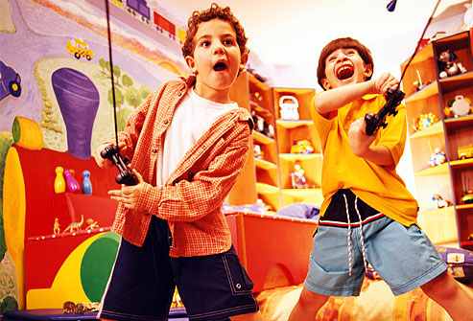
The boys played.

However, that would be very boring! It would be much more exciting to use adjectives to describe the boys and say:

‘Wearing bright and comfortable clothes, the young boys gripped their shiny controllers in their chubby, little hands.
In fierce competition, each was eager to win the new game.’

As you can see, the adjectives (in red) described the colour, size, age and mood of the boys and their controllers. This makes the description much more interesting.

Task 1 (Green): Look at the following pictures of things seen through people’s windows. Describe the pictures by choosing the best words from the word mat. Write them around each picture.
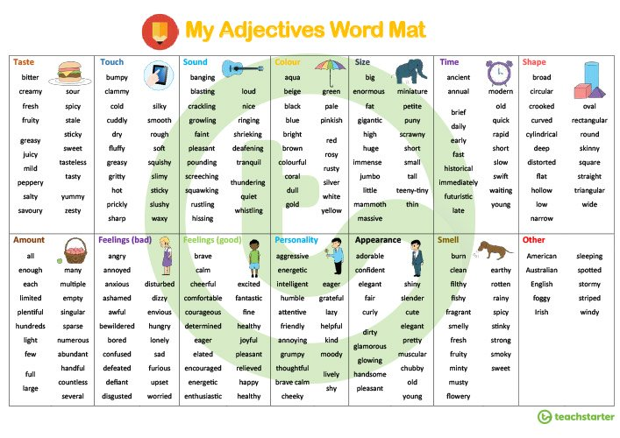
Task 2 (Amber) Using adjectives from the word mat, write one sentence to describe each of the pictures below.
Task 3 (Red) Using the word mat, or adjectives of your own, write a detailed description of one of the pictures below. Use your senses to describe the scene. What can you see and what do you imagine you could hear, smell, taste and feel?

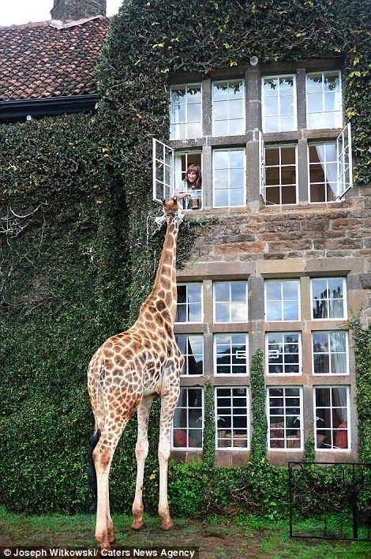
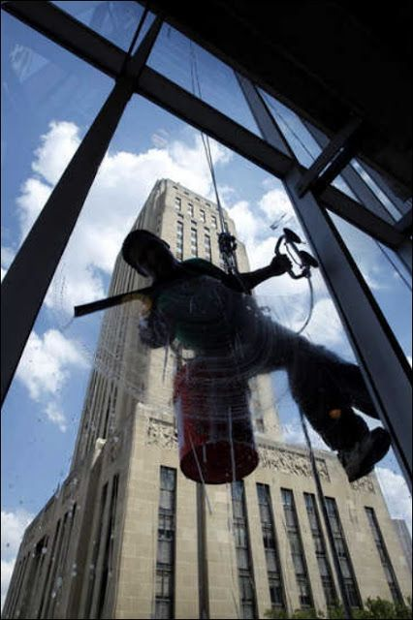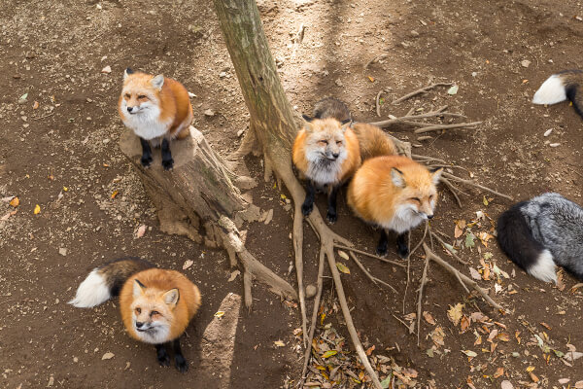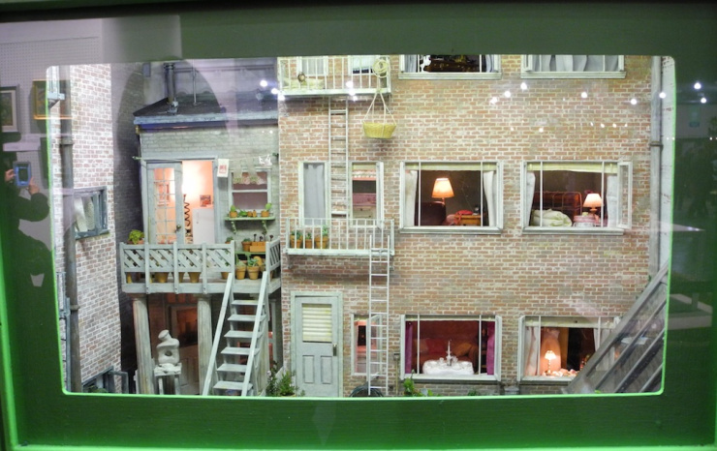
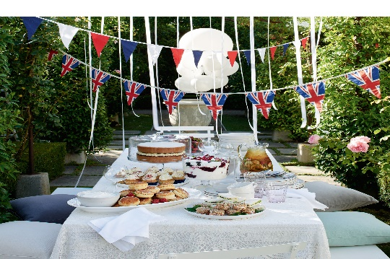
31/3/20 LO: To be able to use similes to capture readers’ imagination
Similes are used to make descriptions more vivid. They help the reader to imagine what something is like. They do this by comparing two things e.g.

‘The boy was as brave as a lion.’
This sentence shows how brave the boy was.

‘The sun shone like a gleaming new penny.’
This sentence shows how bright the sun was.

Notice the words in purple. These words are used to compare. They show us that a simile is being used.

Task 1 (Green): Put a circle around the correct word.

- The boy ran as quick as a slug/fox.
- The coins shone as brightly as the sun/watch.
- Jessie swam as smoothly as a sheep/fish.
- The giant laughed as loud as whispers/thunder.
- The bells tinkled like giants/fairies laughing.
- The man was as tall as a cat/house.
- The baby was as quiet as a mouse/dog.

Task 2 (Amber) Complete these sentences using similes. Use the words in the box to help you.

cheetah the sun thunder fish rain on a tin roof skyscraper flash of lightning mouse

1. The boy ran as quickly as a __________.
2. The coins shone as brightly as ________________.
3. Jessie swam as smoothly as a ___________________.
4. The giant laughed as loud as _________ ______.
5. The bells tinkled like_______________________.
6. The man was as tall as a_______________.
7. The baby was as quiet as a______________.
8. The boy on the skateboard whizzed by like a ___________________.

9. Write your own simile sentence here:
--------------------------------------------------------------------------------------------------------------------------------------------------------------------------------------------------------------------------------------------------------------------------------------------------------------------------------------------------------------------------------------------------------------------- Task 3 (Red) See how many similes you can think of to describe and compare different things.

1. The boy ran ___________like _______________.
2. The coins shone ________as ________________.
3. Jessie swam _______like _____________________.
4. The giant laughed as loud as _________ ______.
5. The bells tinkled _______________________.
6. The man was as tall as _______________.
7. The police sirens wailed like ______________.
8. The boy on the skateboard whizzed by like ____________________.
9. The baby was as quiet as a ____________.

10. Write your own simile sentences here:
---------------------------------------------------------------------------------------------------------------------------------------------------------------------------------------------------------------------------------------------------------------------------------------------------------------------------------------------------------------------------------------------------------------------
1/4/20 LO: To be able to use metaphors to make your stories come alive.

Metaphors are similar to similes because they make descriptions clearer by comparing things.

The main difference is that similes use the words as or like to compare, whereas metaphors use the words ‘was’ or ‘is’ (this makes the thing being described more real) e.g.

‘That child is a bear when he is sleepy.’

This means the child is like a grumpy bear when tired.

‘The dancer was a graceful eagle taking flight.’

This means the dancer was a very elegant dancer.

Task 1 (Green) Finish the sentence using the best metaphor from the box below.

a graceful swan in flight | enormous elephant | powerful hands cruelly grasping the swimmers | hungry shark | watching the world cautiously
a sea of faces | cheetah | an excited puppy | cats and dogs | angry monsters reaching to grab someone

1. She was a ------------------------------------------------------- when she ran.

2. When she danced she was----------------------------------------------------------------------------------------------------------------------------

3. The man was an ---------------------------------------------------------------------------------------------------------------------------------------when he trudged down the road.

4. The waves on the ocean were -----------------------------------------------------------------------------------------------------------------------

5. Dave was a -----------------------------------------------in the water.

6. On the way to her party, Lucy was -----------------------------------------------------------------------------------------------------------------

7. When he looked out from the stage, the audience was------------------------------------------------------------------------------------------------------------------------------------------------------------------------

8. The raindrops were----------------------------------------------------------------------------------------------------------------------------------------------------------------------------------------------------------------------

9. The trees in the storm were-----------------------------------------------------------------------------------------------------------------------------------------------------------------------------------------------------------

10. The moon hung in the night sky-----------------------------------------------------------------------------------------------------------------------------------------------------------------------------------------------------

Task 3 (Red) Put these similes into new sentences where they become metaphors.

1. Simile: She danced like she was floating on air.
Metaphor: ----------------------------------------------------------------------------------------------------------------------------------------------------------------------------------------------------------------------------------------------------------------------------------------------------------------------------------------------------------------------------------------------------------------------------------------------------------------------------------------------------------------
2. Simile: The waves crashed on to the beach like charging horses.
Metaphor: ---------------------------------------------------------------------------------------------------------------------------------------------------------------------------------------------------------------------------------------------------------------------------------------------------------------------------------------------------------------------------------------------------------------------------------------------------------------------------------------------------------------
3. Simile: He was eating like he was shovelling cement into a mixer.
Metaphor: ---------------------------------------------------------------------------------------------------------------------------------------------------------------------------------------------------------------------------------------------------------------------------------------------------------------------------------------------------------------------------------------------------------------------------------------
4. Simile: Katie was as powerful as a train when she crossed the finish line.
Metaphor: ---------------------------------------------------------------------------------------------------------------------------------------------------------------------------------------------------------------------------------------------------------------------------------------------------------------------------------------------------------------------------------------------------------------------------------------------------------------------------------------------------------------
5. Simile: James swam as gracefully as a dolphin.
Metaphor: ----------------------------------------------------------------------------------------------------------------------------------------------------------------------------------------------------------------------------------------------------------------------------------------------------------------------------------------------------------------------------------------------------------------------------------------------------------------------------------------------------------------
6. Simile: Mr. Jones sang like the sound of water going down a drain!
Metaphor: ---------------------------------------------------------------------------------------------------------------------------------------------------------------------------------------------------------------------------------------------------------------------------------------------------------------------------------------------------------------------------------------------------------------------------------------------------------------------------------------------------------------

2/4/20 LO: To be able to create exciting story openings.
Task (Green, Amber and Red): Read the following story openings.
‘Mr Stink stank. He also stunk’.
from Mr Stink by David Walliams

‘There was once a gaggle of mountains, tall and proud, each with a hat of snow.’
from Stone Goblins,
by David Melling

‘A thousand miles ago, in a country east of the jungle and south of the mountains, there lived
a Firework-Maker called Lalchand…..’
From The Firework-Maker’s Daughter
by Phillip Pullman

‘Molllly!’ Maria shouted to her sister.
‘Would you please shut that window….’
from School for Stars: Second Term
at L’Etoile by Holly and Kelly Willoughby

Language Features

Simile Metaphor Adjective

Task 1 (Green) In these story openings, can you pick out the language features used to make them interesting e.g. similes, metaphors or adjectives?
Underline the feature and draw an arrow to the correct feature from the yellow box underneath.

Task 2 (Amber) Can you complete the story openings in the boxes below using a language feature from the yellow box? The first one has been done to help you.
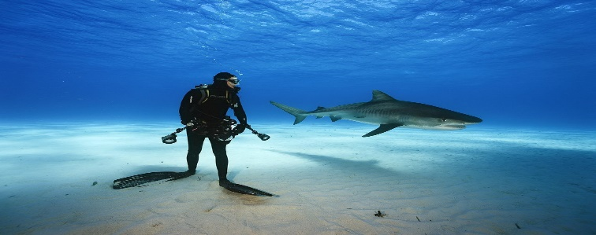 | Alone and afraid, the diver was like a tasty treat for the hungry shark.
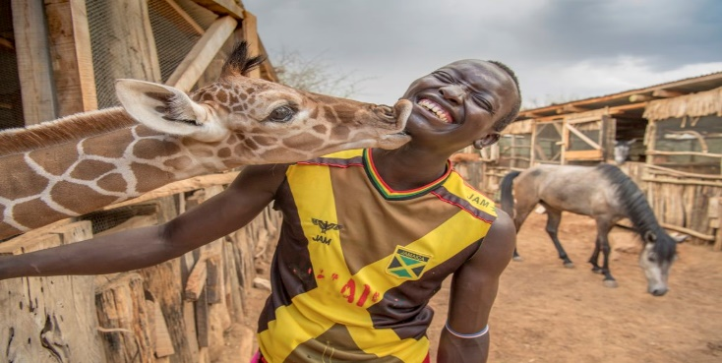 | Smiling, the boy was------------------------------------------------------------------------------------------------------------------------------------------
 | Steadily, the ----------------------------------------------------------------------------------------------------------------------------------------------------
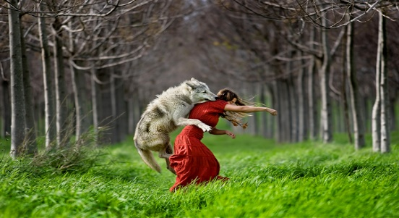 | She was like-----------------------------------------------------------------------------------------------------------------------------------------------------
 | The cat was a proud---------------------------------------------------------------------------------------------------------------------------------------------------------------------------

Task 3 (Red) Can you write your own story openings in the boxes above using a language feature from the yellow box?

Write two more, using the pictures below without any prompts, and continue underneath if you wish.

 | --------------------------------------------------------------------------------------------------------------------------------------------------------------------------------------------------------------------------------------------------------------------------------------------------------------------------------------------------------------------------------------------------------------------------------------------------------
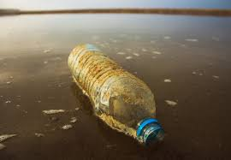 | ------------------------------------------------------------------------------------------------------------------------------------------------------------------------------------------------------------------------------------------------------------------------------------------------------------------------------------------------------------------------------------------------------------

3/4/20 LO: To be able to write a story opener.
To evaluate and edit to improve.

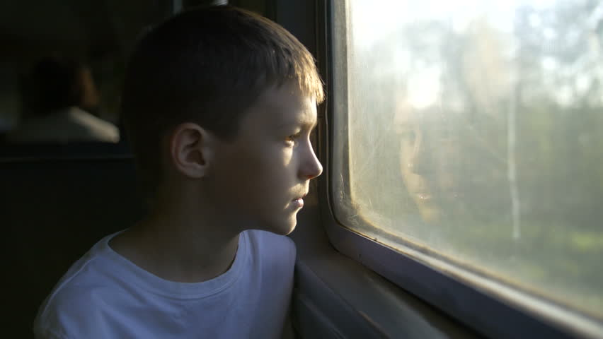
Through the Window
You are going to write the opening for a story based on the scene from a window in your house. The details do not need to be true.
Task 1 (Green) Choose a window in your house and look out.
Answer the following questions using as many adjectives as you can:
- What can you see? I can see…..

- What can you hear? I can hear…..

- What would you be able to feel if you were in the scene you can see? Can you feel anything through the window e.g. a draft?
I can feel…..

- What would you be able to smell if you were in the scene you can see? Can you smell anything through the window e.g. smoke, freshly cut grass?
I can smell….

- Is there anything you would be able to taste if you were in the scene you can see e.g. rain?
I can taste…..

Using the sentences written, put them together to write the short opening to a story that begins like this (continue on a separate sheet if you need to):

Through my window, I can see--------------------------------------------------------------------------------------------------------------------------------------------------------------------------------------------------------------------------------------------------------------------------------------------------------------------------------------------------------------------------------------------------------------------------------------------------------------

Edit and evaluate (to make it brilliant) by doing the following things.
Read your opening aloud to check for:
- missing words
- capital letters at the beginning of each sentence
- full stops at the end of each sentence
- correct spelling (use a dictionary or check using your mobile phone)

Task 2 (Amber) Choose a window in your house and look out. Answer the questions in Task 1, then use the sentences to write an exciting opening for a short story (only write the opening because we will continue the story next week).
Use adjectives, similes and metaphors to describe what you see, hear, feel, taste and smell e.g.

‘Through my misty window, I can see a tiny cat running as fast as the wind through the long grass.’

------------------------------------------------------------------------------------------------------------------------------------------------------------------------------------------------------------------------------------------------------------------------------------------------------------------------------------------------------------------------------------------------------------------------------------------------------------------------------------------------------------------------------------------------------------------------------------------------------------------------------------------------------------------------Continue on a separate sheet if you need to and complete the evaluation and editing of Task 1. For Task 2, include a range of punctuation to end your sentences e.g. try using an exclamation mark (!) or question mark (?).

Task 3 (Red) Complete all work from Task 2 but join your sentences using an appropriate adverbial phrase (of place) from the box below:

High in the trees | Next to the wheelie bin | Behind the rabbit hutch | Alongside the lawn
Beneath the grass | On top of the patio | Below the steps | Right at the back

e.g. High in the trees, I can hear the tiny birds singing.
------------------------------------------------------------------------------------------------------------------------------------------------------------------------------------------------------------------------------------------------------------------------------------------------------------------------------------------------------------------------------------------------------------------------------------------------------------------------------------------------------------------------------------------------------------------------------------------------------------------------------------------------------------------------------------------------------------------------------------------------------------------------------------------------------------------------------------------------------------------------------------------------------------------------------------------------------------------------------------------------------------------------------------------------------------------------------------------------------------------------------------------------------------------------------------------------------------------------------------------------------------------------------------------------------------------------------------------------------------------------------------------------------------------------------------------------------------------------------------------------------------------
Complete the evaluation and editing of Task 1 and 2. For Task 3, check that you have used a comma after each adverbial phrase.

Congratulations for completing this week’s work!

