Year 10
English Work Pack
30/3/20 – 3/4/20

Welcome to this week’s English topic!

Transactional
Writing

We will have fun learning to:

- Identify transactional texts
- Identify the persuasive features in these texts
- Plan and write a transactional/persuasive speech
- Evaluate and edit our speeches to make them BRILLIANT!

Choose your own task level (green = easy, amber = slightly harder, red = challenge)

30/3/20 LO: To be able to identify a transactional text
Transactional writing is writing that is part of a chain of written communication intended to communicate, persuade or inform.

When we pay money into a bank account, we exchange money for a receipt. This process is called a transaction. The money becomes part of a chain of actions resulting in the payment of bills or savings.

In the same way, writing that is transactional is part of a process. It has a clear purpose and is intended to result in action by the reader.

Task 1 (Green) Read the definition and example above then look at the different text types below. Which ones do you think are transactional? Answer using the table on the next page.
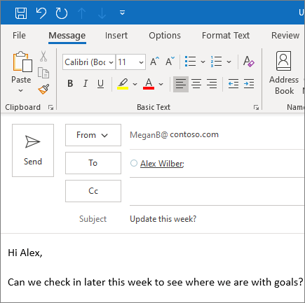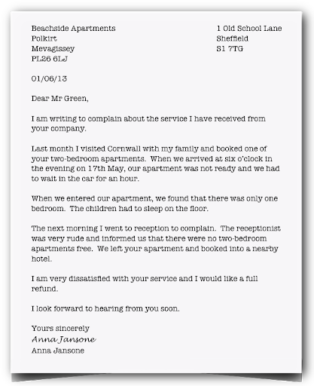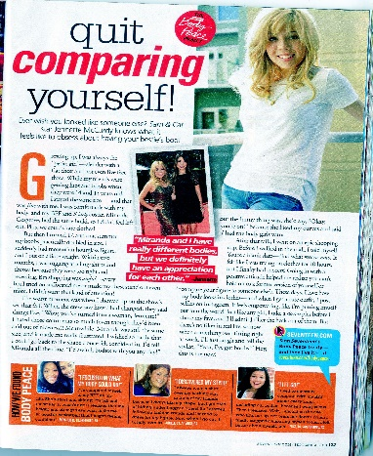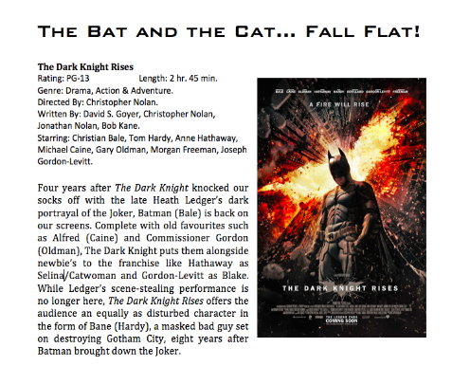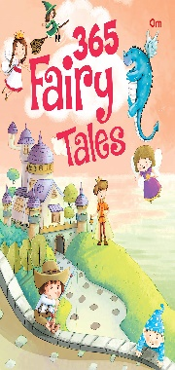
Text Type | What is the purpose of the text? Is the text designed to persuade the reader to do anything?
Email
Formal Letter
Magazine Article
Film Review
Fairy Tale Book
Adverts

Task 2 (Amber) Read the definition and example of ‘transactional writing’ on page 2 and look at the pictures of different text types. Which ones do you think are transactional? What techniques are used to communicate clearly and effectively? Answer using the table below.

Text Title | What is the purpose of the text? Is the text designed to persuade the reader to do anything? | What techniques are used to communicate clearly and effectively e.g. layout features?
Email
Formal Letter
Magazine Article
Film Review
Fairy Tale Book
Adverts

Task 3 (Red) Read the definition and example of ‘transactional writing’ on page 2 and look at the pictures of different text types. Which ones do you think are transactional? What techniques are used to communicate clearly and effectively? Answer using the table for task 2 then complete the additional task below:

GCSE Assessment Objective AO5 – Select and adapt tone, style and register for different forms, purposes and audiences.

Define the terms in this objective using a dictionary.
Tone | Style | Register
Look again at the formal letter and film review examples considered earlier.
What do you notice about the tone, style and register used by the writers? Why are they different and how does this relate to their different purposes?

------------------------------------------------------------------------------------------------------------------------------------------------------------------------------------------------------------------------------------------------------------------------------------------------------------------------------------------------------------------------------------------------------------------------------------------------------------------------------------------------------------------------------------------------------------------------------------------------------------------------------------------------------------------------------------------------------------------------------------------------------------------------------------------------------------------------------------------------------------------------------------------------------------------------------------------------------------------------------------------------------------------------------------------------------------------------------------------------------------------------------------------------
------------------------------------------------------------------------------------------------------------------------------------------------------------------------------------------------------------------------------------------------------------------------------------------------------------------------------------------------------------------------------------------------------------------------------------------------------------------------------------------------------------------------------------------------------------------------------------------------------------------------------------------------------------------------------------------------------------------------------------------------------------------------------------------------------------------------------------------------------------------------------------------------------------------------------------------------------------------------------------------------------------------------------------------------------------------------------------------------------------------------------------------------

31/3/20 LO: To be able to identify how writers use varied sentence types to make texts more effective.

Below is an extract from a speech defending wolves.

I am here tonight to change your minds about one of the most misunderstood and maligned animals in the world. Like us, this animal lives in close families and loves playing and having fun. Any idea who this creature can be? Yes, the wolf.
Evil and vicous? Not so. The wolf is a clever and loving animal, nothing like the way he is presented in Little Red Riding Hood and the Three Little Pigs. When we were little we all enjoyed such stories. Now we have grown up we can understand the truth behind the fiction.

There are three main types of sentences. These are:
Simple- one main independent clause. They have a subject and one verb and give one piece of information e.g.

I went to the shop.

Compound- Two independent clauses joined by a connective or semi colon. These sentences have two (or more) verbs and give two (or more) pieces of information e.g.

I went to the shop and I bought some bread.

Complex- At least one main clause and a subordinate clause. These sentences have two(or more) verbs and give two (or more) pieces of information. The difference is that the second part of the sentence either depends on or refers back to the first part e.g.

I went to the shop and I bought some bread, although I was tired.

Using a variety of sentences makes our writing clearer and more effective. They allow us to add detail where needed, and help our writing become more fluent.
Task (Green), (Amber), (Red) Look at the sentences below. Can you identify what sort of sentences they are? Write alongside.

- The little girl sobbed because she couldn’t have any sweets.
- She threw a tantrum.
- She screamed like a banshee.
- When she finally stopped crying, her mother was relieved.
- Her mother took her indoors and let her watch her favourite television programme.
- Peace at last!

Task 1 (Green) Read the speech on wolves. Pick out the simple sentences and write them in the table below. How does their length and simplicity make the speech more effective?

Simple sentences | Effect

Task 2 (Amber) Read the speech on wolves.

Identify the simple and compound sentences and write them in the table below. What effect do they create for the reader?

Simple sentences | Effect

Compound sentences | Effect

Task 3 (Red) Read the speech on wolves.

Identify the simple and compound sentences and write them in the table for task 2. What effect do they create for the reader?

In addition, identify the complex sentences and their effects and record in the table below.

Complex sentences | Effect

Task (Green), (Amber), (Red) Look at the following piece of writing by a student.

Guilt. I never liked that feeling. The feeling that almost made you sick to the stomach. I knew I was wrong and I shouldn’t be doing it, but I couldn’t face what was waiting for me. I just couldn’t stay and let them do that to me. Although I had to run, I wondered what would happen when they found me.

Task 1 (Green) How many types of sentences can you find here? Write them below stating what sort of sentence they are.
----------------------------------------------------------------------------------------------------------------------------------------------------------------------------------------------------------------------------------------------------------------------------------------------------------------------------------------------------------------------------------------------------------------------------------------------------------------------------------------------------------------------------------------------------------------------------------------------------------------------------------------------------------------------------------------------------------------------------------------------------------------

Task 2 (Amber) Which sentence do you think has the biggest effect on the reader? Explain your reason.
--------------------------------------------------------------------------------------------------------------------------------------------------------------------------------------------------------------------------------------------------------------------------------------------------------------------------------------------------------------------------------------------------------------------------------------------------------------------------------------------------------------------------------------------------------------------------------------------------------------------------------------------------------------------------------------------------------------------------------------------------------------------------------------------------------------------------------------------------------------------------------------------------------------------------------------------------------------------------------------------------------------------------------------------------------------------------------------------------------------------------------------------------------------------------------------------------------------------------------------------

Task 3 (Red) Write about half a page to continue the story using a range of different types of sentence.
--------------------------------------------------------------------------------------------------------------------------------------------------------------------------------------------------------------------------------------------------------------------------------------------------------------------------------------------------------------------------------------------------------------------------------------------------------------------------------------------------------------------------------------------------------------------------------------------------------------------------------------------------------------------------------------------------------------------------------------------------------------------------------------------------------------------------------------------------------------------------------------------------------------------------------------------------------------------------------------------------------------------------------------------------------------------------------------------------------------------------------------------------------------------------------------------------------------------------------------------------------------------------------------------------------------------------------------------------------------------------------------------------------------------------------------------------------------------------------------------------------------------------------------------------------------------------------------------------------------------------------------------------------------------------------------------------------------------------------------------------------------------------------------------------------------------------------------------------------------------------------------------------------------------------------------------------------------------------------------------------------------------------------------------------------------------------------------------------------------------------------------------------------------------------------------------------------------------------------------------------------------------------------------------------------------------------------------------------------------------------------------------

1/04/20 LO: To be able to identify persuasive features in a speech.

In addition to being clear, transactional writing needs to be effective if the purpose of the writing is to persuade the reader. There are special techniques the writer can use to achieve this.

Task (All) Using a dictionary (or your mobile phone if you don’t have one) look up the definition of the persuasive techniques in the table above. What effect do you think these techniques would have on a reader?

Persuasive technique | Definition and effect
Rhetorical Questions | A question asked in order to create a dramatic effect or to make a point rather than to get an answer.  Rhetorical questions help to engage the reader personally with the topic making them more likely to act on it.
Exclamations
Ellipsis
Statistics
Expert opinions/ Examples
Emotive words
Personal pronouns
Repitition

Read the persuasive speech below:

‘I Have a Dream’ (Martin Luther King)
‘I have a dream that one day on the red hills of Georgia sons of former slaves and the sons of former slave-owners will be able to sit down together at the table of brotherhood. I have a dream that one day even the state of Mississippi, a state sweltering with the heat of injustice, sweltering with the heat of oppression, will be transformed into an oasis of freedom and justice. I have a dream that my four little children will one day live in a nation where they will not be judged by the colour of their skin but by the content of their character! I have a dream . . . I have a dream that one day in Alabama, with its vicious racists, with its governor having his lips dripping with the words of interposition and nullification, one day right there in Alabama little black boys and black girls will be able to join hands with little white boys and white girls as sisters and brothers. I have a dream today . . .’

Task 1 (Green) In the table below, identify three persuasive techniques used by Martin Luther King in his speech above. How would these techniques have persuaded his listeners to agree with his opinions on equality?

Persuasive technique (write the sentence) | Effect on the listener

Task 2 (Amber) Identify all the persuasive techniques used by Martin Luther King in his speech and record in the table below.

Persuasive technique (write the sentence) | Effect on the listener

Task 3 (Red) Complete task 2. In addition, explain the effect of Martin Luther King’s use of a range of sentence types. How do these make his speech clearer and more persuasive?

Sentence Type (write the sentence) | Effect on the listener

2/4/20 LO: To be able to plan and write a persuasive speech.

Task 1 (all) You are going to write a persuasive speech on the following topic:

‘Is Social Media Harmless or Harmful?’

Begin by planning each separate point you would like to raise using the spider diagram below:

‘Is social media harmless or harmful?’

Task 1 (Green) Begin to write your speech using your spider plan to help you separate each point into a clear, thought-provoking paragraph.

Remember to include the following:

- An introduction – a paragraph to hook your listener into your overall topic using at least one persuasive technique e.g. Social media. A waste of time and a dangerous snare, or a harmless pastime for young people to enjoy? What do you think?
Plan this below:
----------------------------------------------------------------------------------------------------------------------------------------------------------------------------------------------------------------------------------------------------------------------------------------------------------------------------------------------------------------------------------------------------------------------------------------------------------------------------------------------------------------------------------------------------------------------------------------------------------------------------------------------------------------------------------------------------------------------------------------------------------------------------------------------------------------------------------------------------------------------------------------------------------------------------------------------------------------------------------------------------------------------------------------------------------------------------------------------------------------------------------------------------------------------------------------------------------------------------------------------------------------------------------------------------------------------------------------------------------------------------------------------------------------------------------------------------------------------------------------------------------------------------------------------------------------------------------------------------------------------------------------------------------------------------------------------------------------------------------------------------------------------------

- Discuss only one clear point at a time in each paragraph, and try to include:
- a persuasive feature
- simple and compound sentences
Plan the first topic sentence for each paragraph below:
1)-----------------------------------------------------------------------------------------------------------------------------------------------------------------------------------------------------------------------------------------------------------------------------------------------------------------------------------------------------------------------------
2)---------------------------------------------------------------------------------------------------------------------------------------------------------------------------------------------------------------------------------------------------------------------------------------------------------------------------------------------------------------------------------------------------------------------------------------------------------------------------------------------------------------------------------------------------------------------
3)---------------------------------------------------------------------------------------------------------------------------------------------------------------------------------------------------------------------------------------------------------------------------------------------------------------------------------------------------------------------------------------------------------------------------------------------------------------------------------------------------------------------------------------------------------------------

- Support each point with examples

- Include an emotive, powerful conclusion e.g. As I have clearly shown, there are very serious consequences for young people who become addicted to social media…
Plan this below:
------------------------------------------------------------------------------------------------------------------------------------------------------------------------------------------------------------------------------------------------------------------------------------------------------------------------------------------------------------------------------------------------------------------------------------------------------------------------------------------------------------------------------------------------------------------------------------------------------------------------------------------------------------------------------------------------------------------------------------------------------------------------------------------------------------------------------------------------------------------------------------------------------------------------------------------------------------

Use your planning to write up your speech. Begin with your introduction, extend your topic sentences into clear paragraphs and finish with your planned conclusion.

Task 2 (Amber) Begin to write your speech using your spider plan to help you separate each point into a clear, thought-provoking paragraph.

Remember to include the following:

- An introduction – a paragraph to hook your listener into your overall topic using several persuasive techniques e.g. Social media. A waste of time and a dangerous snare, or a harmless pastime for young people to enjoy? What do you think?

- Discuss only one clear point at a time in each paragraph, and try to include:
- Two persuasive features
- Simple, compound and complex sentences

- Support each point with examples

- Include an emotive, powerful conclusion e.g. As I have clearly shown, there are very serious consequences for young people who become addicted to social media…
Use your planning to write up your speech.

Task 3 (Red) Begin to write your speech using your spider plan to help you separate each point into a clear, thought-provoking paragraph.

Remember to include the following:

- An introduction – a paragraph to hook your listener into your overall topic using several persuasive techniques e.g. Social media. A waste of time and a dangerous snare, or a harmless pastime for young people to enjoy? What do you think?

- Discuss only one clear point at a time in each paragraph, and try to include:
- Several persuasive features
- Simple, compound and complex sentences

- Support each point with examples, statistics, expert opinions.

- Include an emotive, powerful conclusion e.g. As I have clearly shown, there are very serious consequences for young people who become addicted to social media…

Use your planning to write up your speech.

3/4/20 LO: To be able to evaluate and edit my writing to improve.

Look at the following definitions:
Evaluate | Assess your work to decide how good it is
Edit | Correct or modify your work to make it better

Task 1 (Green) Read and check your speech for missing words and the following:
- Only one clear point discussed in each paragraph
- Each point supported with examples and a persuasive technique
- A range of simple and compound sentences
- An emotive, powerful concluding sentence included

Edit by correcting anything you’ve missed.

Task 2 (Amber) Read and check your speech for missing words and the following:
- Only one clear point discussed in each paragraph
- Each point supported with evidence e.g. expert opinion/ examples of your own
- Included several rhetorical questions
- Included a powerful exclamation
- Included some ellipsis appropriately
- Included some statistics
- Included an emotive, powerful conclusion

Edit by correcting anything you’ve missed.

Task 3 (Red) Read and check your speech for missing words and the following:
- Began with a thought-provoking introduction
- Discussed only one clear point at a time
- Included a range of simple, compound and complex sentences
- Supported each point with evidence e.g. expert opinion/ examples of your own
- Included several rhetorical questions
- Included a powerful exclamation
- Included some ellipsis appropriately
- Included some statistics
- Included an emotive, powerful conclusion
Edit by writing a second draft correcting anything you’ve missed.

All (Green), (Amber) and (Red)
Remember - To make your speech BRILLIANT, you also need to check your spelling, punctuation and grammar.

