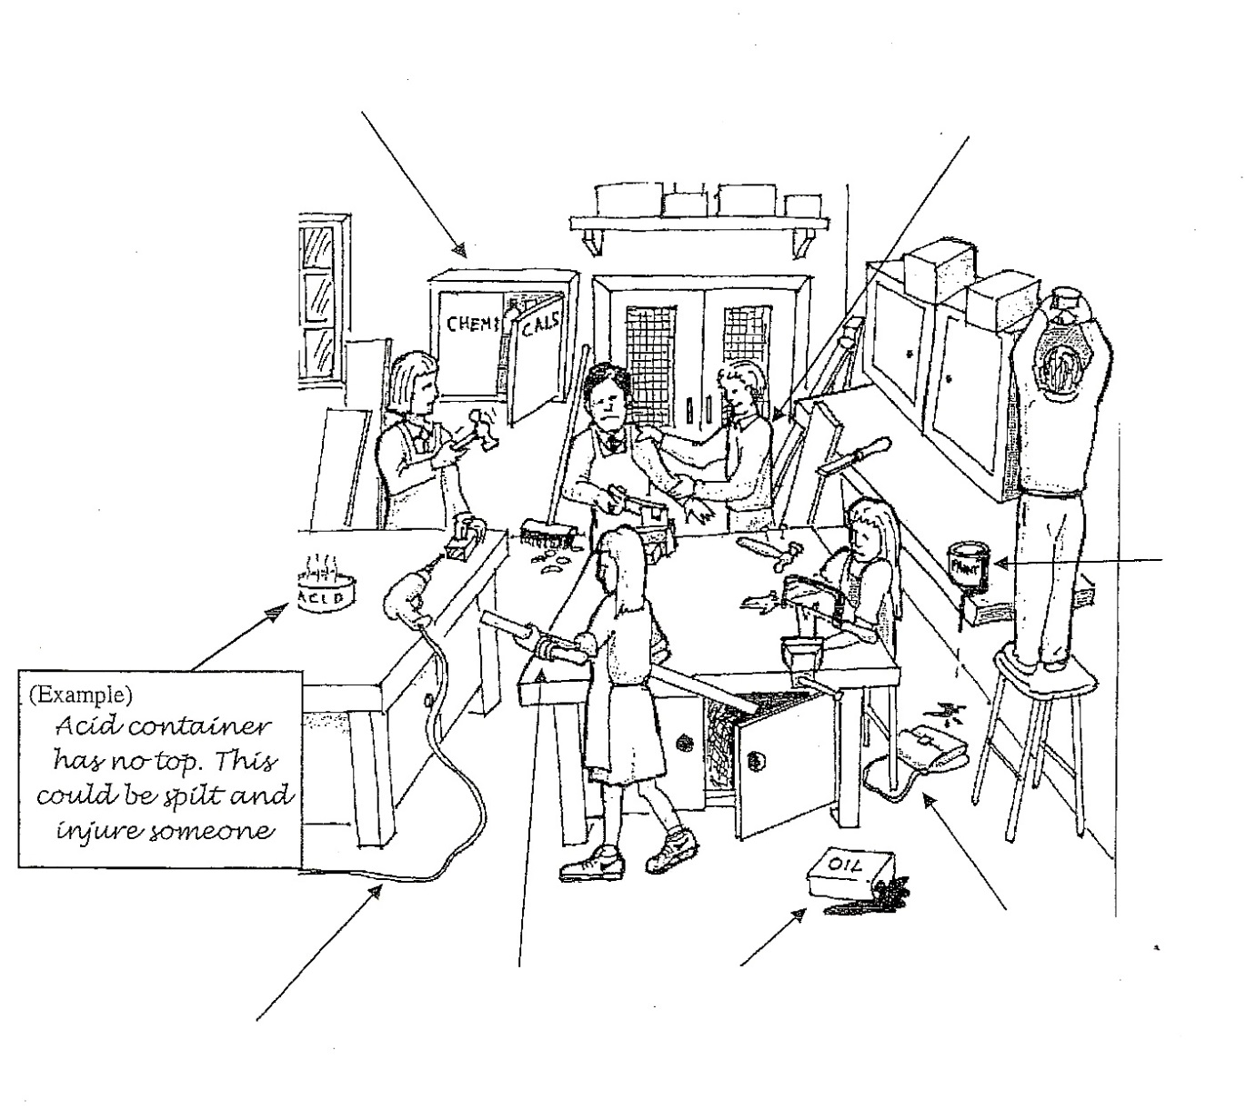

Name___________________________________________________

Complete the health and safety worksheet by identifying as many hazards as you can in the picture of a school. workshop.