Post Title: Senior Site Operative
Department: Estate Management
Reporting to: Estate Manager
Salary: point 22-25 (£20,661 to £22,658) All year around - Dependent on qualifications and experience

Springwell Leeds Academy is recruiting a Senior Site Operative to join the Academy Estates Team. The Academy is in a period of growth and requires an experienced site operative who is capable of ensuring that sites are both fully compliant and fit for each working day, ensuring that the best possible environment is provided for staff and students.

About Springwell Leeds Academy
Springwell Leeds is a new provision for children and young people with Social, Emotional and Mental Health (SEMH) needs for the city of Leeds, which we will be developing across on a number of different sites between now and September 2018. Our aim is to provide the best possible care and education that we can for children and young people with SEMH needs. Unconditional Positive Regard is at the centre of what we do and we are creating an academy that is welcoming, caring, safe, warm and believes that all its pupils can be supported and empowered to succeed.
We are creating individual and personalised pathways for our students that are built around their varied needs that will help them achieve positive outcomes and prepare them for their onward destinations into continuing education, work or training. In order to achieve this we are developing a curriculum that provides opportunities for academic progression as well as vocational learning, whilst being engaging, creative, and innovative.
We see strong relationships with students, parents, carers and the wider community as the key to our success –and we ensure that our academies are welcoming safe places for children to learn and prosper. We believe in working closely with our families and carers and welcome their support, but also realise that at times they will need our support too. We work closely with Leeds City Council and other agencies and schools to make sure we do all we can to make learning and life the best it possibly can be.
We will eventually be an Academy for 340 5-16 year olds on four sites across the city. Our Primary site at Oakwood, has been significantly refurbished and upgraded to provide a high quality specialist setting. Our KS3 and KS4 students are currently accommodated in 5 temporary sites around Leeds.
Between January 2017 and September 2018, our KS3 and KS4 provision will be moving to three, brand new, purpose built settings across the city. These will be at Seacroft (Jan 18), Middleton (Easter 18) and Tinshill (Sept 18). Wellspring has worked for the past 2 years with Leeds City Council to ensure that these new designs meet the requirements of our children and that they are world class facilities.
An Architect’s drawings of one of the completed buildings.

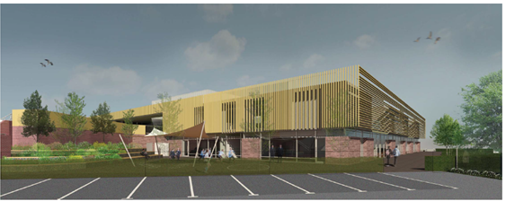
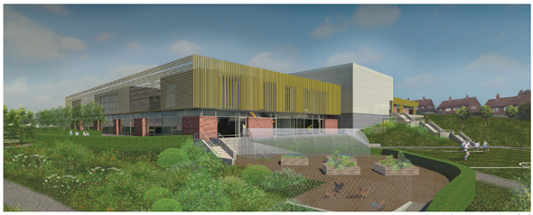

We value our people; collegial working at all levels is central to our culture. High quality induction training and ongoing professional development support are guaranteed.

We are interested in hearing from people who:

- Are self-motivated, customer-focused and organised.
- Enjoy working as part of an inclusive team.
- Have a commitment to supporting the work of education leaders and who are passionate about learning.
- Have a sense of pride in their work and are for which they are responsible
- Passionate about what we are here to do? Enhance the teaching and learning environments in our academy and enable our pupils to achieve through our facilitation

Springwell Academy Leeds is committed to safeguarding and promoting the welfare of our pupils. All posts are offered subject to enhanced DBS checks.

HOW TO APPLY

Please complete the application form sent as a separate attachment. Along with this, you may submit a covering letter of no more than two sides of A4 outlining your suitability for this role.

Applications should be e-mailed to Sarah Reeder, PA to Executive Principal at s.reeder@springwellacademyleeds.org

Reporting to Estates Manager
Duration of Post Permanent
Work Commitment Full time – 52 weeks
Salary £20,661.00 to £22,658.00
Start Date 1st September 2017 or earlier?
Closing Date Noon 30th June 2017
Shortlisting date Friday 30th June2017
Interview date W/C Monday 3rd July2017

References will be take up prior to interview.

www.wellspringacademytrust.co.uk
www.springwellacademyleeds.org

